Acid dyeing of polyamide-6,6 fabric with carbon black nano particle for camouflage textiles in Vis-NIR Spectrums
Md. Anowar Hossain
School of Fashion and Textiles, RMIT University, 25 Dawson Street, Brunswick, Melbourne, VIC 3056,
Australia (engr.anowar@yahoo.com)
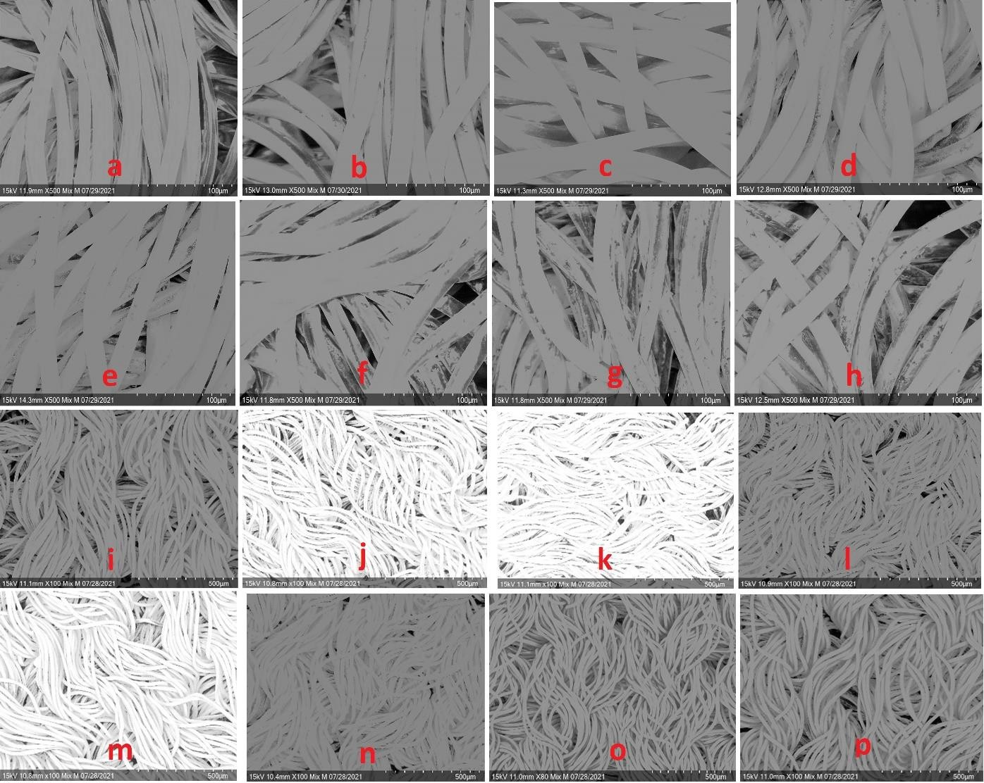
Figure 1, SEM scanned image of CBNP undyed (a) and dyed (i) PA-6,6 fabric; Carbon coated samples with sputter coater (a-h); without carbon coated samples with sputter coater (i-p).

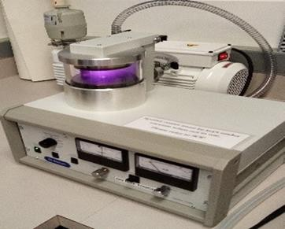
Figure 2, front view of sputter coater used for this experimentation

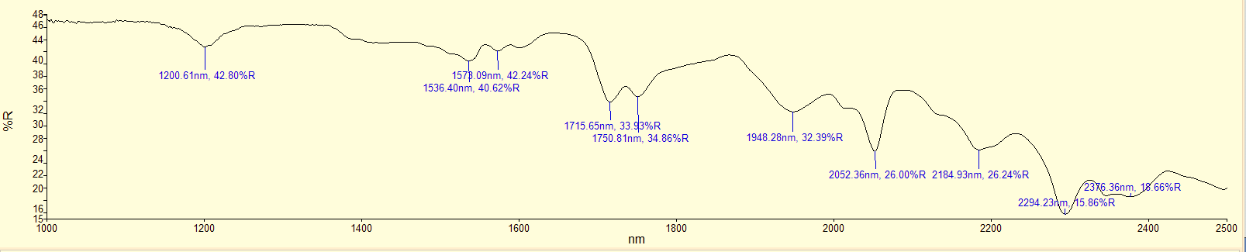
Figure 3, untreated PA-6,6 fabric; original graph of reflection (%) in NIR spectrum from 1000 nm to 2500 nm
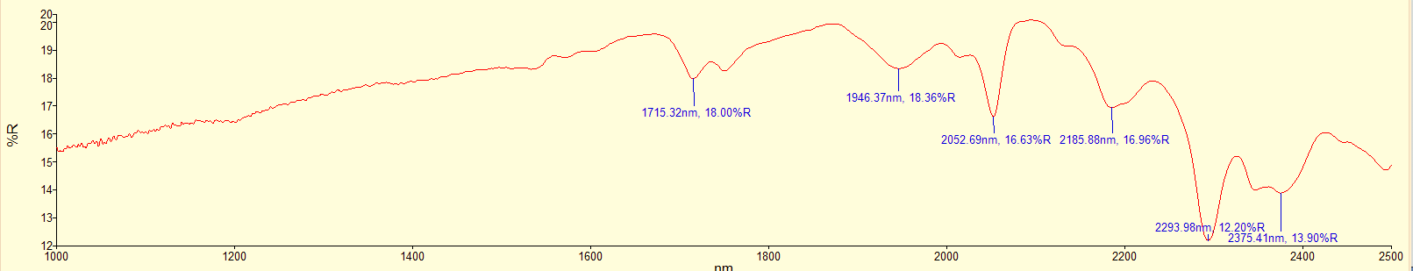
Figure 4, CBNP dyed PA-6,6 fabric with formulation-01; original graph of reflection (%) in NIR spectrum from 1000 nm to 2500 nm
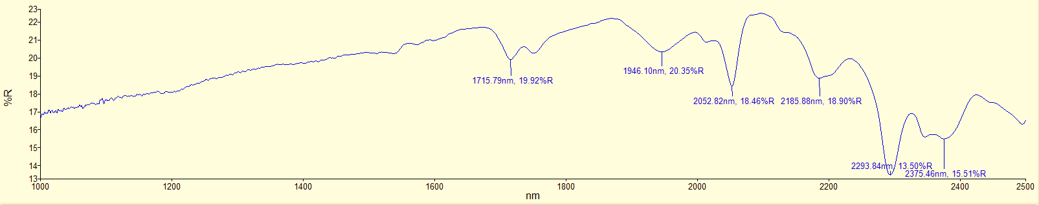
Figure 5, CBNP dyed PA-6,6 fabric with formulation-02; original graph of reflection (%) in NIR spectrum from 1000 nm to 2500 nm

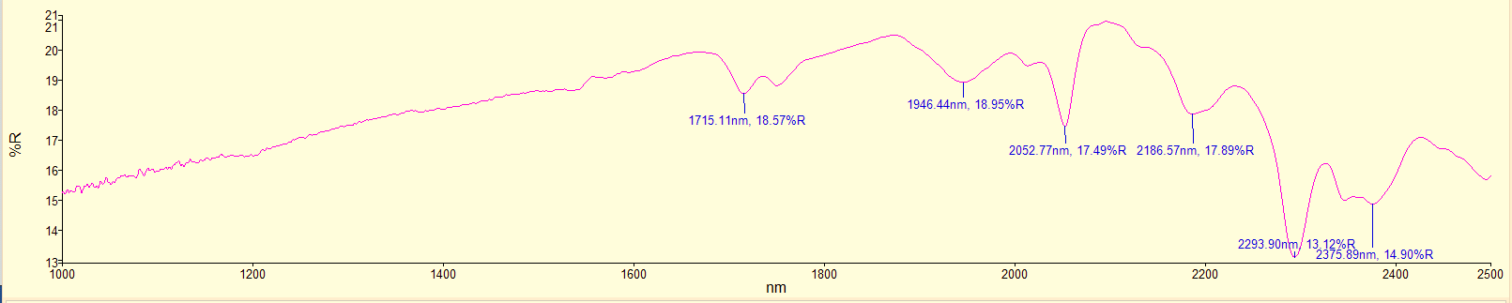
Figure 6, CBNP dyed PA-6,6 fabric with formulation-03; original graph of reflection (%) in NIR spectrum from 1000 nm to 2500 nm
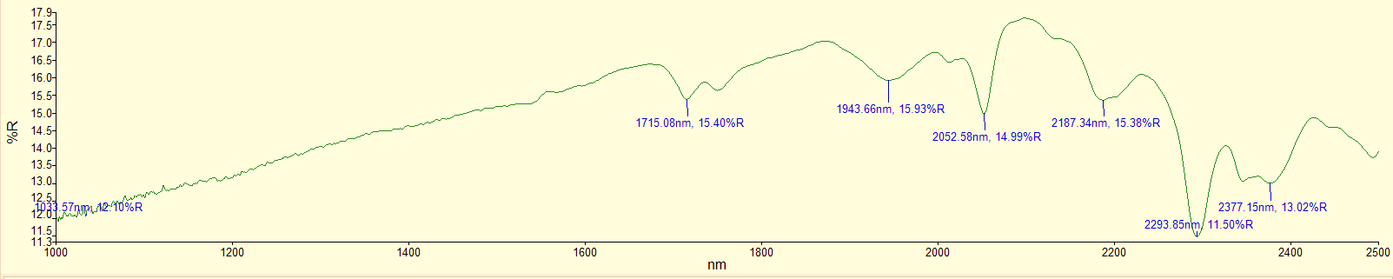
Figure 7, CBNP dyed PA-6,6 fabric with formulation-04; original graph of reflection (%) in NIR spectrum from 1000 nm to 2500 nm

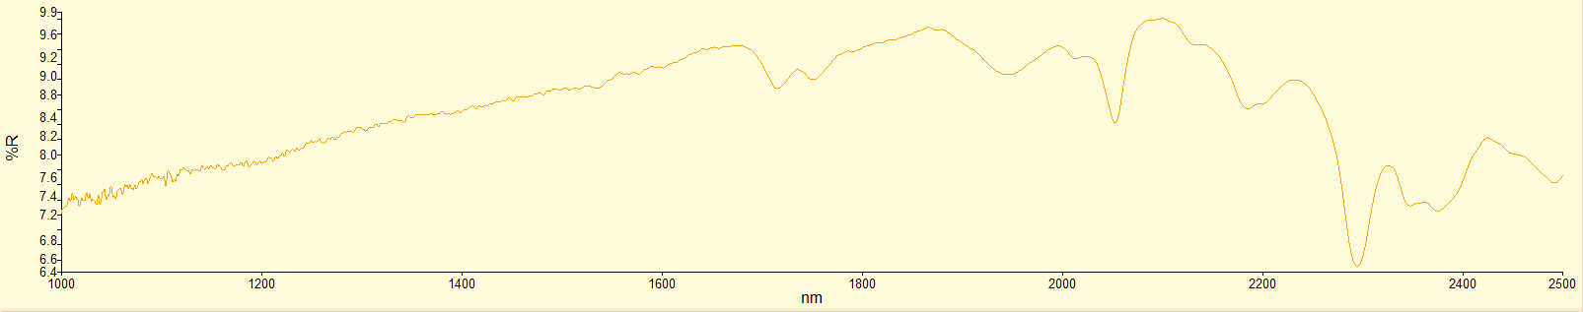
Figure 8, CBNP dyed PA-6,6 fabric with formulation-05; original graph of reflection (%) in NIR spectrum from 1000 nm to 2500 nm
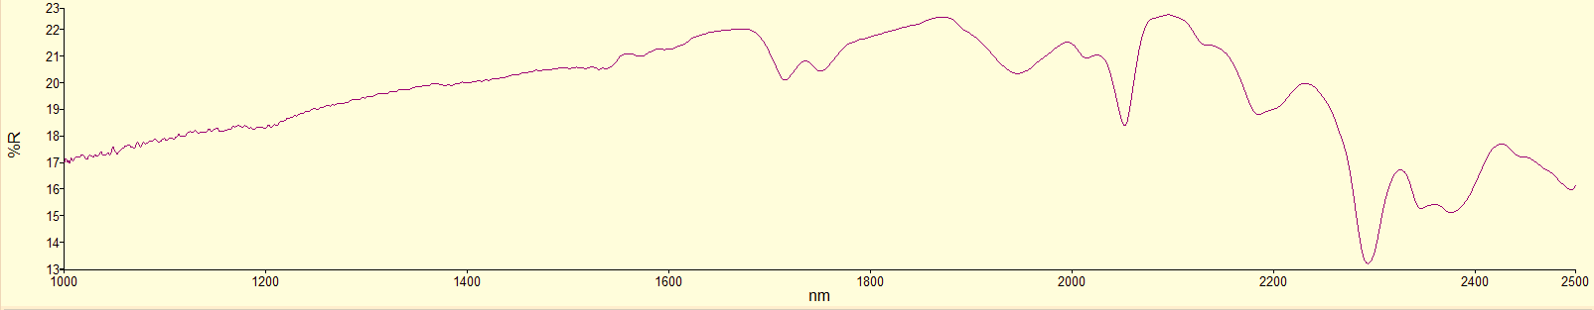
Figure 9, CBNP dyed PA-6,6 fabric with formulation-06; original graph of reflection (%) in NIR spectrum from 1000 nm to 2500 nm

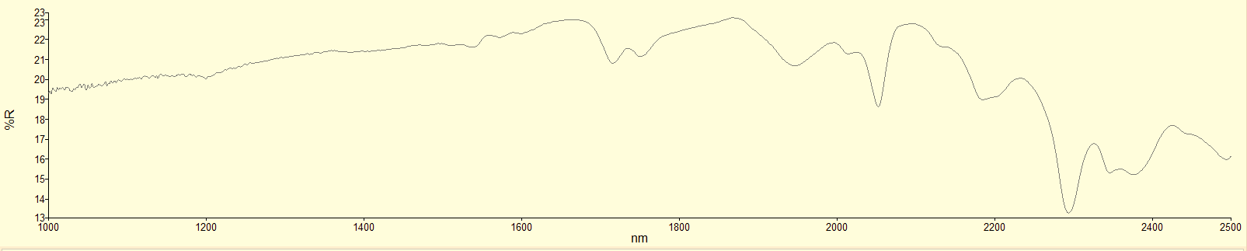
Figure 10, CBNP dyed PA-6,6 fabric with formulation-07; original graph of reflection (%) in NIR spectrum from 1000 nm to 2500 nm

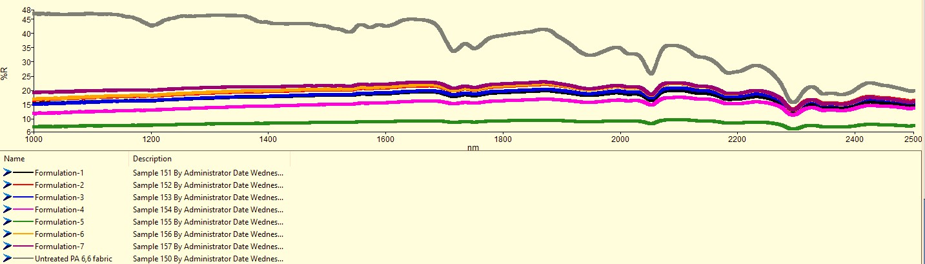
Figure 11, comparison of reflection % of CBNP dyed PA-6,6 fabric with original graph of reflection (%) in NIR spectrum from 1000 nm to 2500 nm; dyed PA-6,6 fabric with formulation-1, P^{H}:0; Formulation-2, P^{H}:1 Formulation-3, P^{H}:2 Formulation-4, P^{H}:3
Formulation-5, P^{H}:4 Formulation-6, P^{H}:5; Formulation-7, P^{H}:6 (1-7) and untreated PA 6,6 fabric

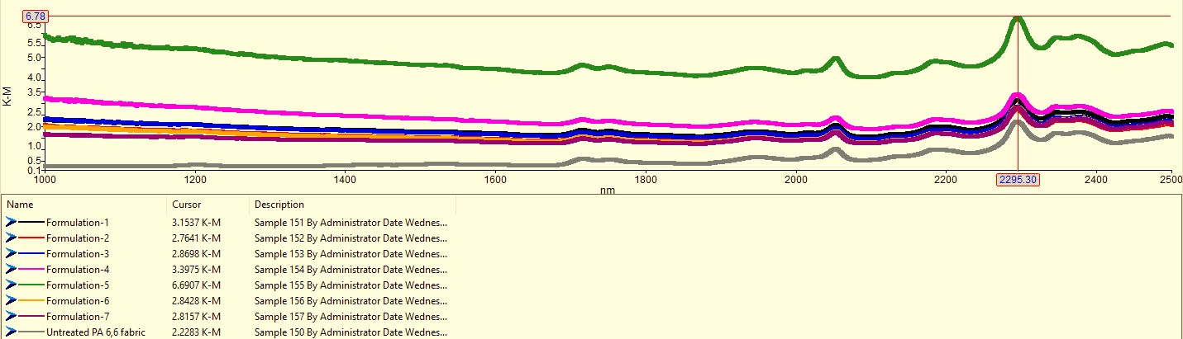
Figure 12, comparison of K-M reflection of CBNP dyed PA-6,6 fabric with original graph of reflection (%) in NIR spectrum from 1000 nm to 2500 nm; dyed PA-6,6 fabric with formulation-1, P^{H}:0; Formulation-2, P^{H}:1 Formulation-3, P^{H}:2 Formulation-4, P^{H}:3
Formulation-5, P^{H}:4 Formulation-6, P^{H}:5; Formulation-7, P^{H}:6 (1-7) and untreated PA 6,6 fabric

