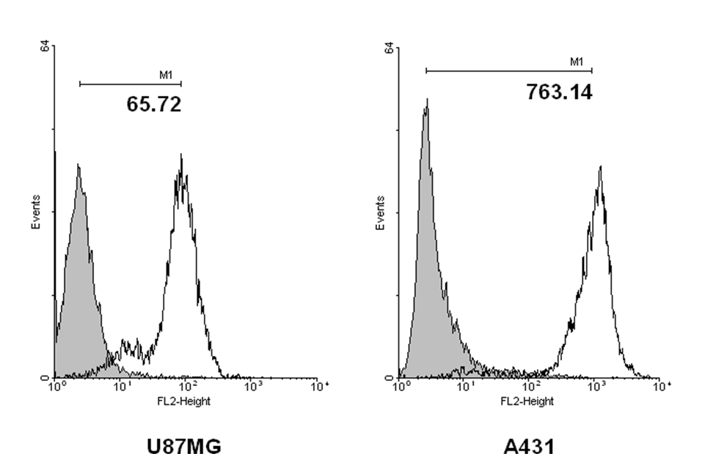
Supplementary Figure 1: Cell-surface EGFR expression measured by flow cytometry in U87MG cells. Representative cell samples of individual cell lines U87MG (left panel) or A431 (right panel) were treated with the specific anti-human EGFR monoclonal antibody ior egf/r3 for 30 min at 4°C followed by a 30-min incubation step with a FITC-conjugated secondary antibody, and subjected to flow cytometry analysis. The levels of EGFR expression are shown for each cell line. Values in the histograms indicate the mean fluorescence intensity for cell samples of individual cell lines. For a reference, an isotype-matched control antibody was used (shaded histograms).

