Appendix

Table 1: Work Characteristics
Parameter | Exercise Session |  | p-value
 | LBNP (n=18) | Control (n=18)
RMS Amplitude (µV) | 40.23 ± 30.05 | 31.00 ± 25.23 | 0.036
MPF (Hz) | 43.97 ± 27.33 | 33.39 ± 20.29 | 0.006
HRDiff | 54.16 ± 12.70 | 38.61 ± 11.42 | <0.001
Borg Scale | 3.44 ± 1.29 | 1.88 ± 0.90 | <0.001
Table 1: Work Characteristics; Values are means ± SD. LBNP = Lower body negative pressure, RMS = Root mean square (μV), MPF = Mean power frequency (Hz), HRDiff = Heart rate difference is the difference between Heart Rate during rest and Heart Rate during the 10th minute of each trial.

Graf 1: Work Characteristics. Values are means. HRDiff is the difference between Heart Rate during rest and Heart Rate during the 10th minute of each trial.
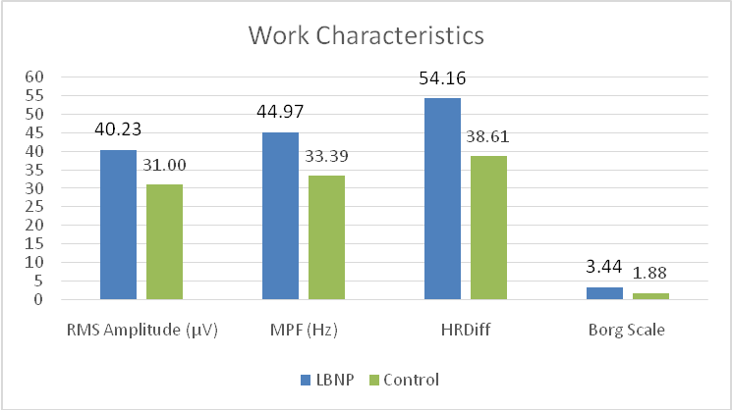

Table 2: Hemodynamic Characteristics
Parameter | Exercise Session |  | p-value
 | LBNP (n=18) | Control (n=18)
O₂Hb (μmol/L) | 37.67 ± 6.32 | 40.08 ± 7.10 | <0.001
HHB (μmol/L) | 25.85 ± 3.99 | 24.60 ± 4.13 | <0.001
tHB (μmol/L) | 63.36 ± 10.12 | 64.68 ± 10.95 | 0.007
HbDiff (μmol/L) | 11.98 ± 3.45 | 15.48 ± 3.89 | <0.001
TSI% | 99.94 ± 0.07 | 99.93 ± 0.05 | 0.668
Values are means ± SD. O₂Hb= Oxyhemoglobin concentration, HHb= Deoxyhemoglobin concentration, tHb= total hemoglobin concentration, HbDiff= Difference between O2Hb and HHb, TSI %= Tissue Saturation Index %.

Figure 2: Hemodynamic Characteristics.Values are means. O2Hb= Oxyhemoglobin concentration, HHb= Deoxyhemoglobin concentration, tHb= total hemoglobin concentration, HbDiff= Difference between O2Hb and HHb.
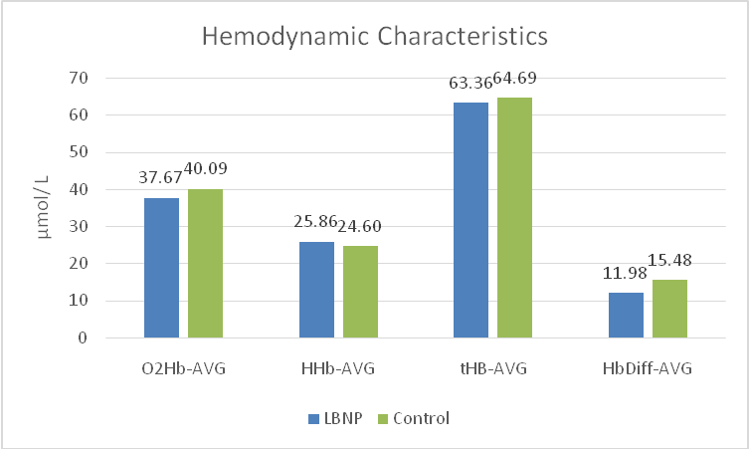

Table 3: LBNP Phase Characteristics
Parameter | LBNP Phase |  |  | p-value
 | tHb- Phase 1 (-15mbar) | tHb- Phase 2 (-25mbar) | tHb- Phase 3 (-30mbar)
LBNP | 61.93± 9.91 | 63.13± 10.05 | 63.92± 10.14 | 0.948
Control | 64.19± 10.87 | 64.79± 11.11 | 65.32± 10.97 | 0.992
Values are means ± SD. tHb= total Hemoglobin.

