ANNEXES

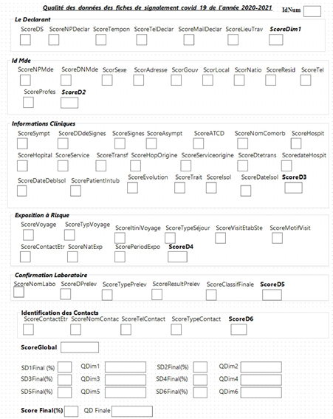

Figure 1: Observation grid.

