Supplementary Information
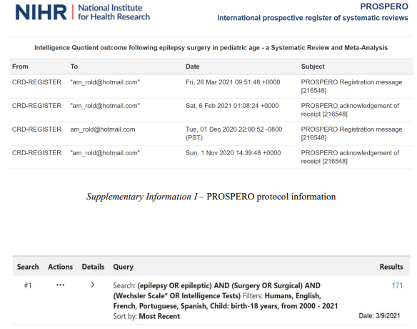
Supplementary Information I – PROSPERO protocol information

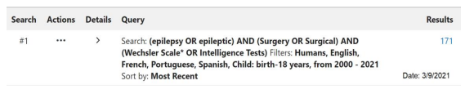
Supplementary Information II – PubMed search strategy

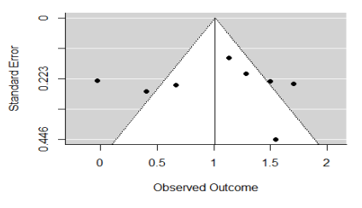
Supplementary Information III – Funnel plot

