Appendix. Supplementary material




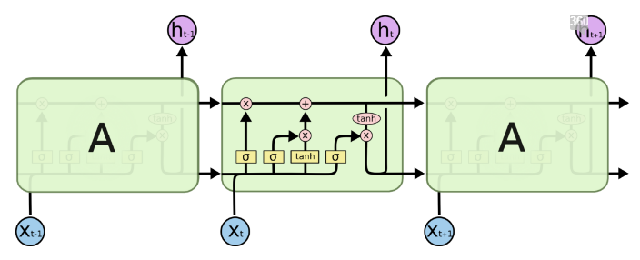
Copy
Pointwise operation
i_{t}
f_{t}
O_{t}
Vector Transfer
Neural network layer

Figure 1 Module in an LSTM contains four interacting layers

f_{t}=σ(Wf*[h_{t-1},x_{t}]+b_{f})
i_{t}=σ(W_{i}*[h_{t-1},x_{t}]+b_{i})
$${\tilde{C}}_{t}=tanh⁡\left(w_{c}∗\left[h_{t−1},x_{t}\right]+b_{c}\right)$$
O_{t}=σ(W_{o}[h_{t-1},x_{t}]+b_{o})
Ht=O_{t}*tanh(C_{t})
C_{t}=f_{t}*C_{t-1}+it*${\tilde{C}}_{t}$

S Table 1 Hyperparameters of LSTM
Dropout | 0.2
Batch | 72
Loss | Mean Absolute Error (MAE)
Optimization method | Adaptive moment (Adam)
Epochs | 30

S Table 2 The value of variables in Logistic regression model
Variable | Value
Primary MDD | Primary MDD=1, Secondary MDD= 0
Insomnia | Yes=1, No=0
Anxiety | Yes=1, No=0
Marital status | Married=0, Single=1, Divorced=2
Course of disease | “0-2years” =0, “2-5years”=1, “5-10years”=2, “>10years”=3
complications | “0”=0, “1”=1,“2”=2, “3”=3, “>4”=4
Smoking | Yes=1, No=2
Alcohol | Yes=1, No=2
Sex | Male=1, Female=2

S Table 3 Compared Different disease prevalence among different population (%)
 | Prevalence in USA | Total n (%) |  | Single MDD |  | Recurrent MDD
Anxiety state | 33.7 | 57850 | 41.2 | 50521 | 40.3 | 7329 | 48.5
Hypertensive | 29.0 | 78586 | 55.9 | 71456 | 57.0 | 7130 | 47.2
Obesity | 36.5 | 48322 | 34.4 | 42283 | 33.7 | 6039 | 40.7
Diabetes | 9.4 | 39971 | 28.5 | 36284 | 28.9 | 3687 | 24.4
Hypothyroidism | 2.4 | 23633 | 16.8 | 21484 | 17.1 | 2149 | 14.2
Insomnia | 6.0 | 15149 | 10.8 | 13211 | 10.5 | 1938 | 12.8
Heart Disease | 36.5 | 22995 | 16.3 | 21357 | 17.0 | 1638 | 10.8
Cancer | 6.8 | 16104 | 11.5 | 15048 | 12.0 | 1056 | 7.0
Alzheimer | 1.6 | 1999 | 1.4 | 1879 | 1.5 | 120 | 0.8
Parkinson | 0.3 | 561 | 0.4 | 491 | 0.4 | 70 | 0.5

S Table 4 Recurrence MDD distribution among different complications (%)
Complications |  | Total | Single | Recurrence | % | x2 | P
Hypertensive | No | 61911 | 53931 | 7980 | 12.9 | 525.16 | <0.001
Hypertensive | Yes | 78586 | 71456 | 7130 | 9.1 | 525.16 | <0.001
Anxiety | No | 82647 | 74866 | 7781 | 9.4 | 375.13 | <0.001
Anxiety | Yes | 57850 | 50521 | 7329 | 12.7 | 375.13 | <0.001
Diabetes | No | 100526 | 89103 | 11423 | 11.4 | 136.11 | <0.001
 | Yes | 39971 | 36284 | 3687 | 9.2 | 136.11 | <0.001
Insomnia | No | 125348 | 112176 | 13172 | 10.5 | 73.258 | <0.001
 | Yes | 15149 | 13211 | 1938 | 12.8 | 73.258 | <0.001
Alzheimer | No | 138498 | 123508 | 14990 | 10.8 | 47.202 | <0.001
 | Yes | 1999 | 1879 | 120 | 6.0 | 47.202 | <0.001
Obesity | No | 92175 | 83104 | 9071 | 9.8 | 232.79 | <0.001
 | Yes | 48322 | 42283 | 6039 | 12.5 | 232.79 | <0.001
Hypothyroidism | No | 116864 | 103903 | 12961 | 11.1 | 81.51 | <0.001
Hypothyroidism | Yes | 23633 | 21484 | 2149 | 9.1 | 81.51 | <0.001
Parkinson | No | 139936 | 124896 | 15040 | 10.7 | 1.56 | 0.211
Parkinson | Yes | 561 | 491 | 70 | 12.5 | 1.56 | 0.211

