APPENDIX

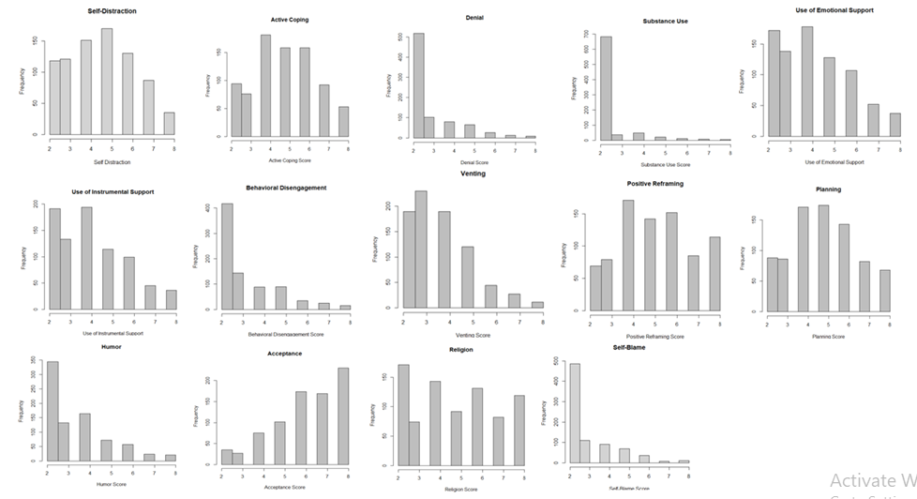

Figure 2: Bar chart of scores of every variable in Coping Styles.

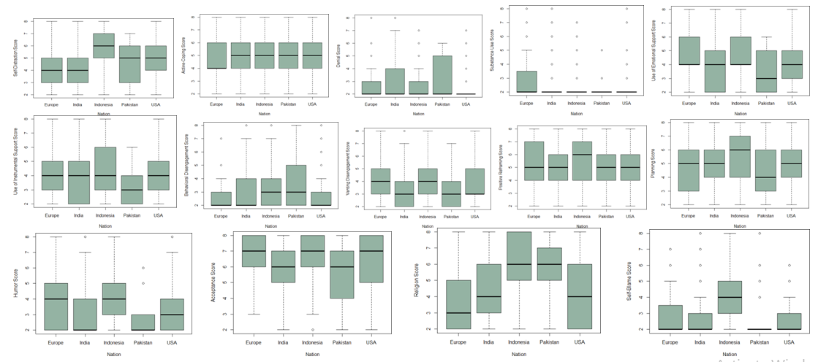

Figure 3: Boxplots of Coping Style Scores of Every Nation.

Table 6: Overview of Used Terminology for Data Analysis of Coping Strategies.

