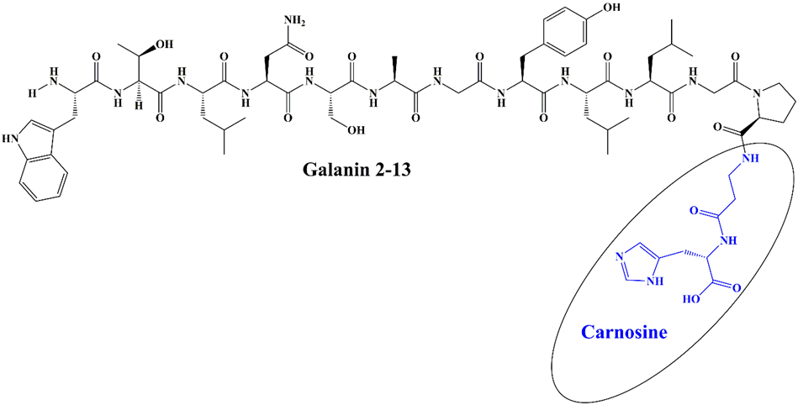
Figure S1: Chemical structure of Gal peptide.
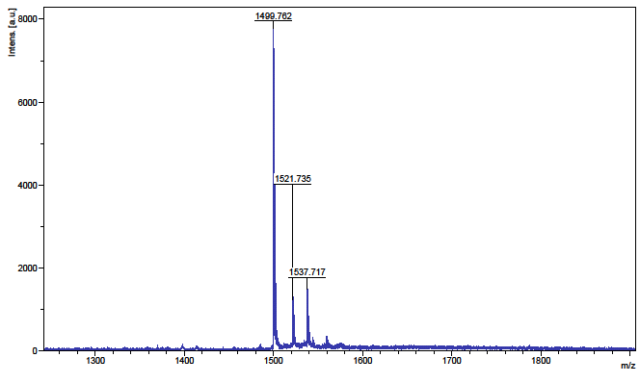
Figure S2: Mass spectrum of Gal peptide. M_{calc.} = 1499.67; m/z 1499.762, 1521.735 [M+Na]⁺, 1537.717 [M+K]⁺.
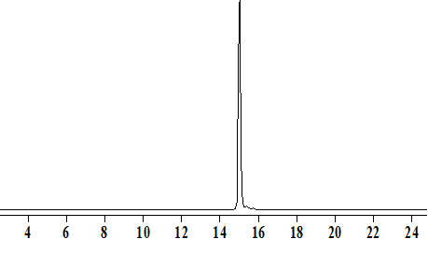
Figure S3: HPLC of Gal peptide (x-axis time in min). HPLC conditions: column Kromasil-C18-100 4.6 x 250mm, 5 μm; 1ml/min with detection at λ= 220 nm. The mobile phase was 0.1% Trifluoroacetic Acid (TFA) (Buffer A) and Buffer A additionally containing 80% acetonitrile (Buffer B); linear gradient (30 min) from 20% to 80% B in Buffer A.
Figure S4: EPR spectrum of the spin adduct DMPO-OH in cardiac dialysate.

