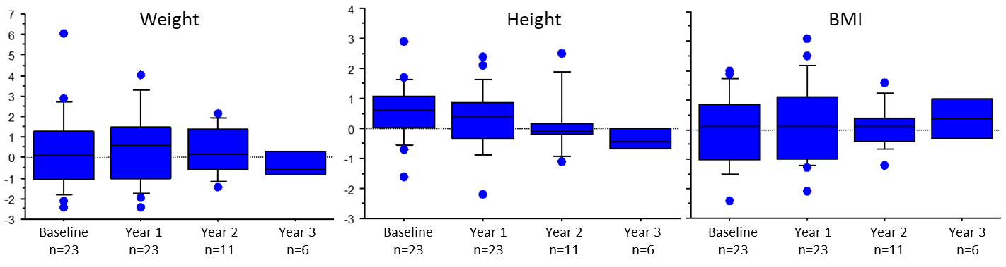
Supplementary Figure 1: Supplementary data: Evolution of anthropometric (weight, height and body mass index expressed in z-score) data during the three years of treatment by CoQ10.
Legend: No parameter showed any statistical difference between baseline and the data obtained at 1, 2 or 3 years after the beginning of treatment by CoQ10.

Supplementary Table 1: Evolution of anthropometric data (weight, height and BMI) expressed in z-score during the three years of treatment by CoQ10.
 |  | Baseline (n=23) | Year 1 (n=23) | Year 2 (n=11) | Year 3 (n=6)
Weight | Median | 0.13 | 0.59 | 0.17 | -0.625
Weight | IQR | 1.075 | 1.2 | 0.375 | 0.65
Height | Median | 0.6 | 0.4 | -0.1 | -0.45
Height | IQR | 2.34 | 2.48 | 1.97 | 1.11
BMI | Median | 0.1 | 0.1 | 0.1 | 0.35
BMI | IQR | 1.875 | 2.125 | 0.8 | 1.35

Legend: The data are expressed in z-score, BMI: Body Mass Index; IQR: Interquartile Range.

