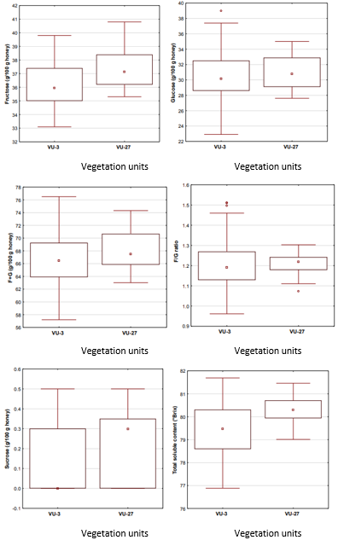
Figure S1: Box and whiskers plots for the content of Fructose (F), Glucose (G), sucrose and total soluble solids, F+G and F/G ratio of Argentinian honeys according to the vegetation units of the Phytogeographical Provinces located in Misiones.
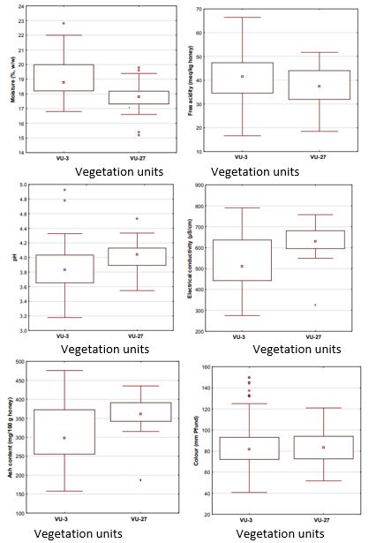
Figure S2: Box and whiskers plots for moisture, free acidity, pH, electrical conductivity, ash content and colour of Argentinian honeys according to the vegetation units of the Phytogeographical Provinces located in Misiones.
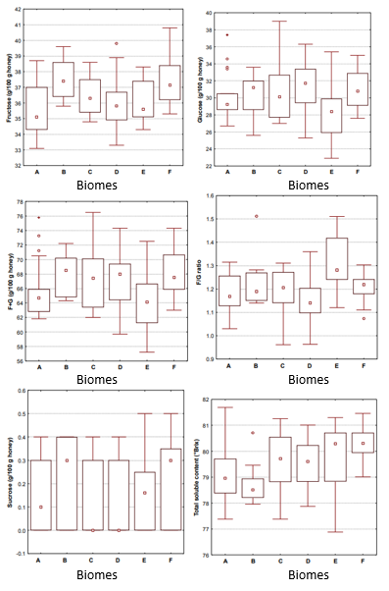
Figure S3: Box and whiskers plots for the content of Fructose (F), Glucose (G), sucrose and total soluble solids, F+G and F/G ratio of Argentinian honeys according to the Biomes of Misiones.

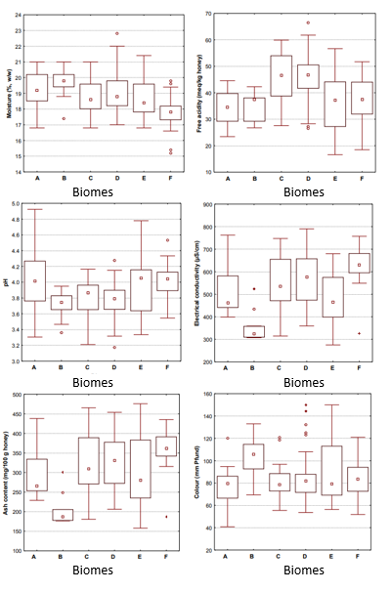
Figure S4: Box and whiskers plots for moisture, free acidity, pH, electrical conductivity, ash content and colour of Argentinian honeys according to the Biomes of Misiones.
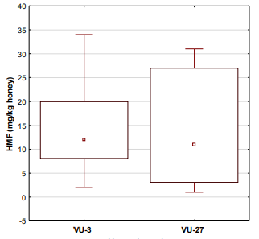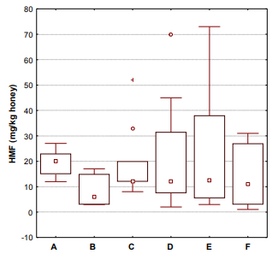
Vegetation units Biomes

Figure S5: Box and whiskers plots of the HMF content of Argentinian honeys according to the vegetation
units of the Phytogeographical Provinces and Biomes of Misiones.

