Supplementary File
Supplementary 1

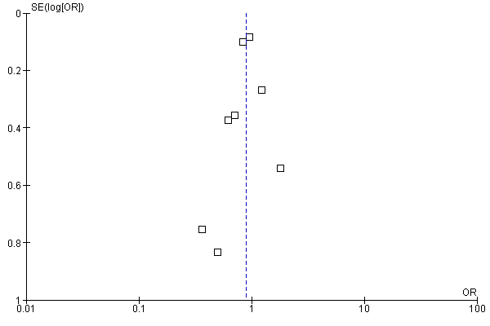
Figure 1a: AKI and Underweight.

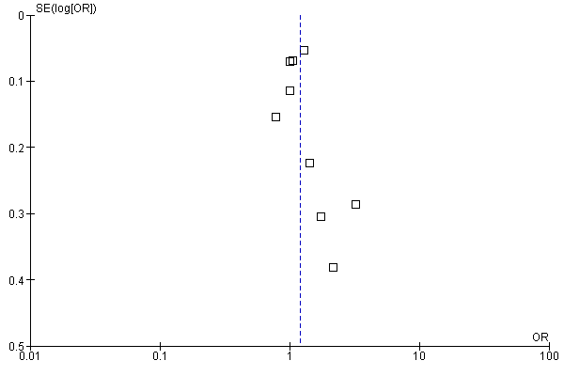
Figure 1b: AKI and Overweight.
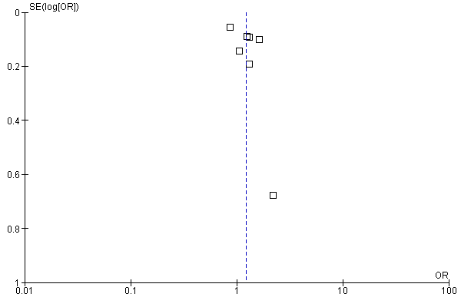
Figure 1c: AKI and Obese.

Supplementary 2

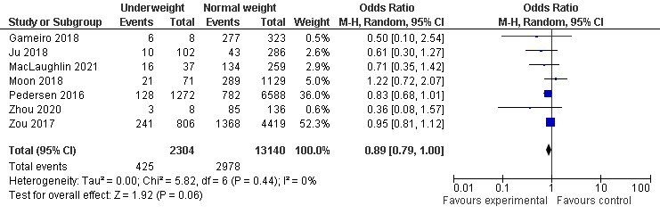
Figure 1a: AKI and Underweight.

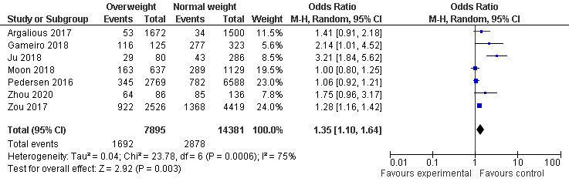
Figure 1b: AKI and Overweight.
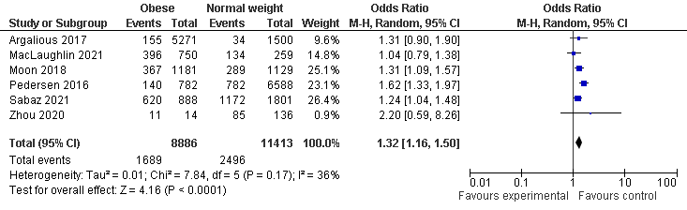
Figure 1c: AKI and Obese.

Supplementary Table 1: Methodological quality of nonrandomized studies included in the meta-analysis.
First author, year (Ref) | Selection |  |  |  | Comparability | Outcome
First author, year (Ref) | Representativeness of exposed cohort | Case definition adequate | Ascertainment of Exposure | Outcome not present at start | Comparability of cases and controls | Assessment of exposure | Follow-up long enough for outcomes to occur | Adequacy of follow-up of cohorts | Total quality scores
Vasquez 2020 [19] | ✵ | ✵ | ✵ | ✵ |  | ✵ | ✵ | ✵ | 7
Zou 2017 [20] | ✵ | ✵ | ✵ | ✵ |  | ✵ | ✵ | ✵ | 8
Ju 2018 [21] | ✵ | ✵ | ✵ | ✵ |  | ✵ | ✵ | ✵ | 7
Argalious 2017 [22] | ✵ | ✵ | ✵ | ✵ |  | ✵ | ✵ | ✵ | 7
Park 2017 [23] | ✵ | ✵ | ✵ | ✵ |  | ✵ | ✵ | ✵ | 8
Kim 2018 [24] | ✵ | ✵ | ✵ | ✵ |  | ✵ | ✵ | ✵ | 7
Wang 2019 [25] | ✵ | ✵ | ✵ | ✵ |  | ✵ | ✵ | ✵ | 7
Kim 2017 [26] | ✵ | ✵ | ✵ | ✵ |  | ✵ | ✵ | ✵ | 7
Liu 2021 [27] | ✵ | ✵ | ✵ | ✵ |  | ✵ | ✵ | ✵ | 6
Liu 2018 [28] | ✵ | ✵ | ✵ | ✵ |  | ✵ | ✵ | ✵ | 8
MacLaughlin 2021 [29] | ✵ | ✵ | ✵ | ✵ |  | ✵ | ✵ | ✵ | 7
Gameiro 2018 [30] | ✵ | ✵ | ✵ | ✵ |  | ✵ | ✵ | ✵ | 8
Sabaz 2021 [13] | ✵ | ✵ | ✵ | ✵ |  | ✵ | ✵ | ✵ | 8
Zhou 2020 [31] | ✵ | ✵ | ✵ | ✵ |  | ✵ | ✵ | ✵ | 7
Wang 2021 [32] | ✵ | ✵ | ✵ | ✵ |  | ✵ | ✵ | ✵ | 8
Moon 2018 [33] | ✵ | ✵ | ✵ | ✵ |  | ✵ | ✵ | ✵ | 6
Pedersen 2016 [35] | ✵ | ✵ | ✵ | ✵ |  | ✵ | ✵ | ✵ | 8

