Supplementary Data
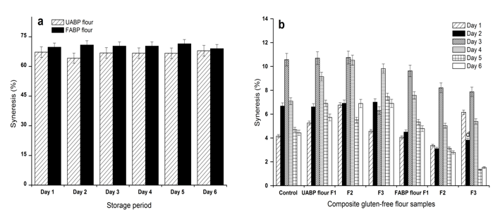
Figure (1a and b): S Syneresis percentage of unfermented Agaricus Bisporus Polysaccharide (UABP) flour, fermented Agaricus Bisporus Polysaccharide (FABP) flour (a), and Composite Gluten-Free (CGF) flours (b) fortified with FABP flour and UABP flour and stored for 6 days at 4°C.
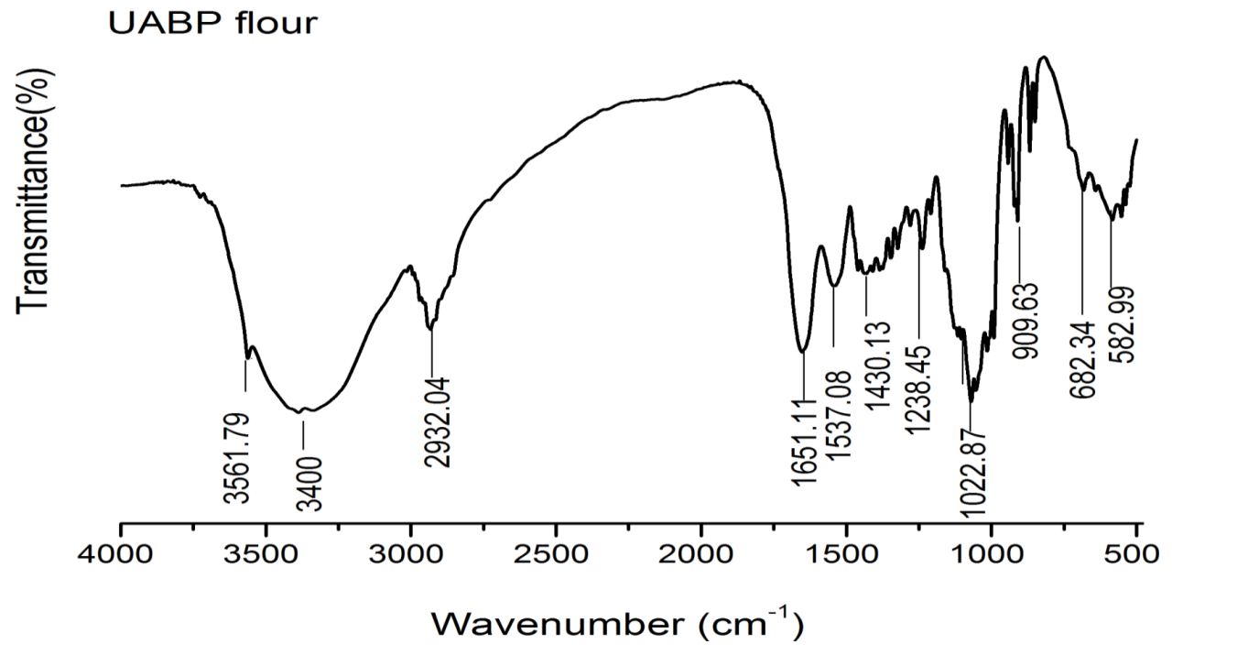
Figure 2: S FTIR spectra of Unfermented Agaricus Bisporus Polysaccharide (UABP) flour.

