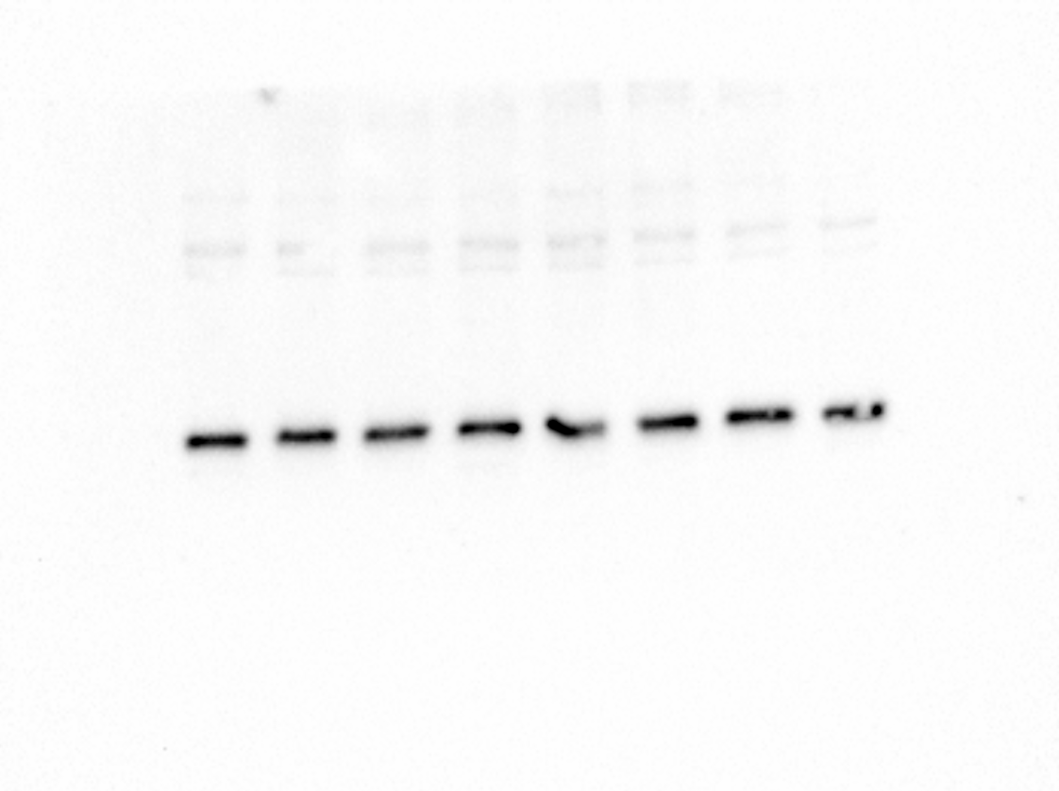
Figure S1: p21 EPA20 DHA10 2.

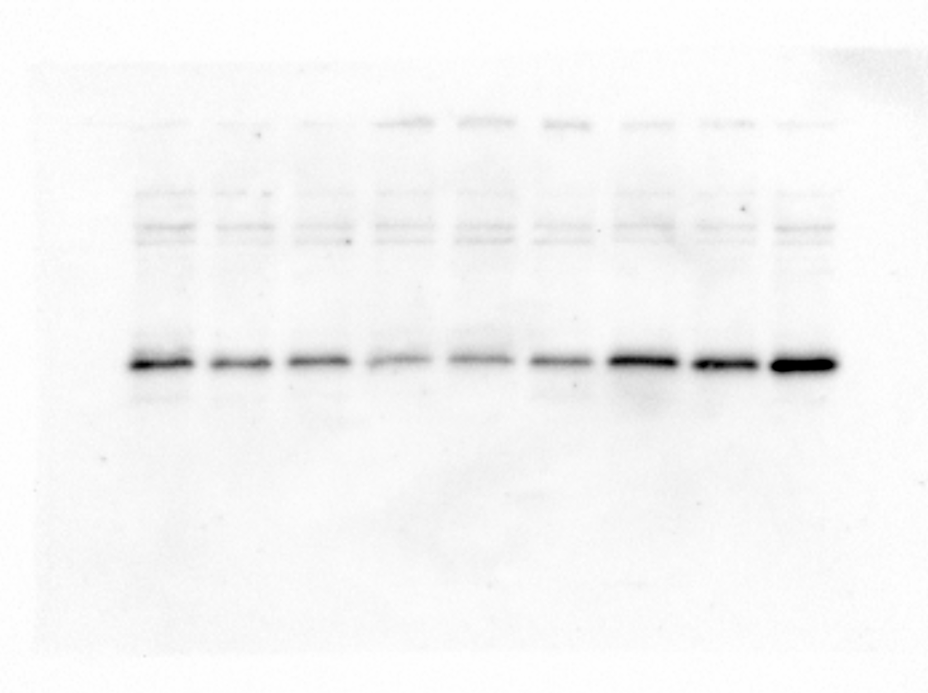
Figure S2: p21 NC vs. PD 1, 2 and 3.
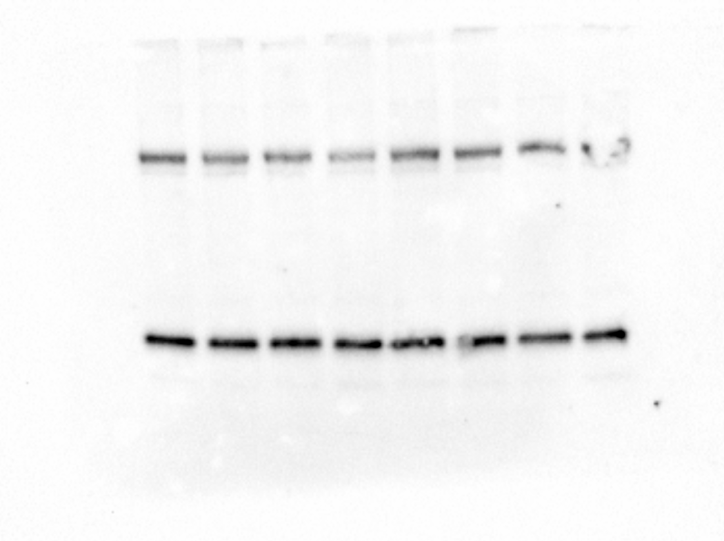
Figure S3: Tubulin and P21 3. EPA20 DHA10
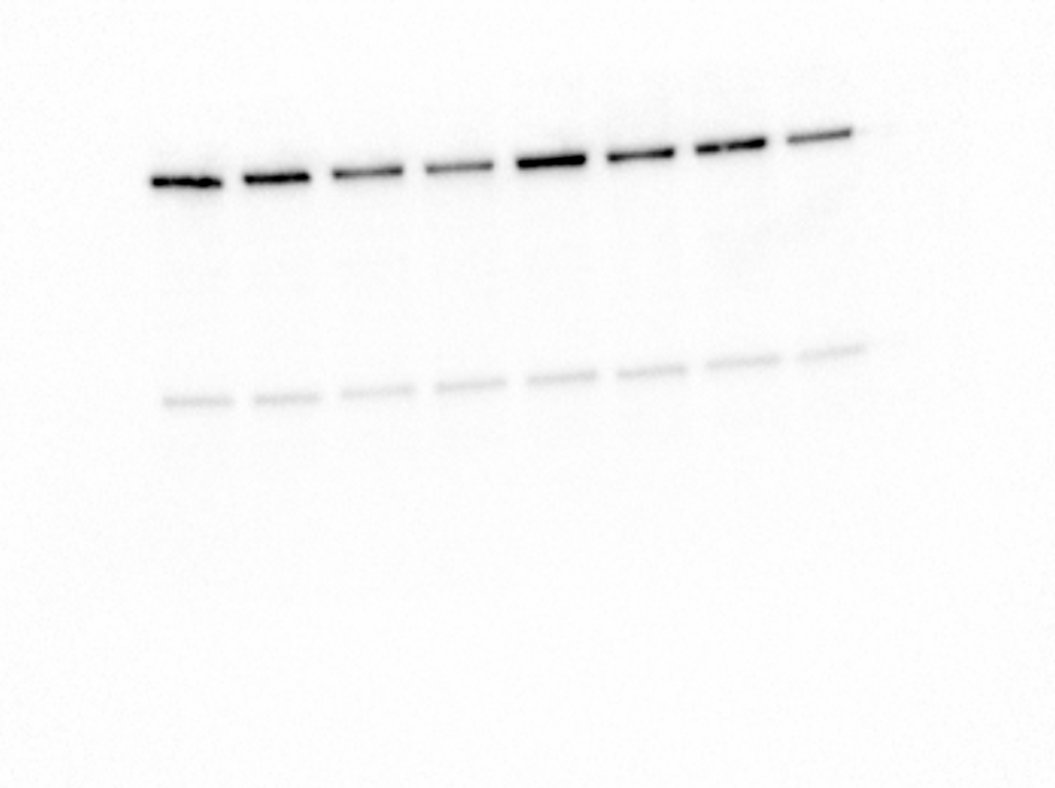
Figure S4: Tubulin EPA20 a DHA10 1.
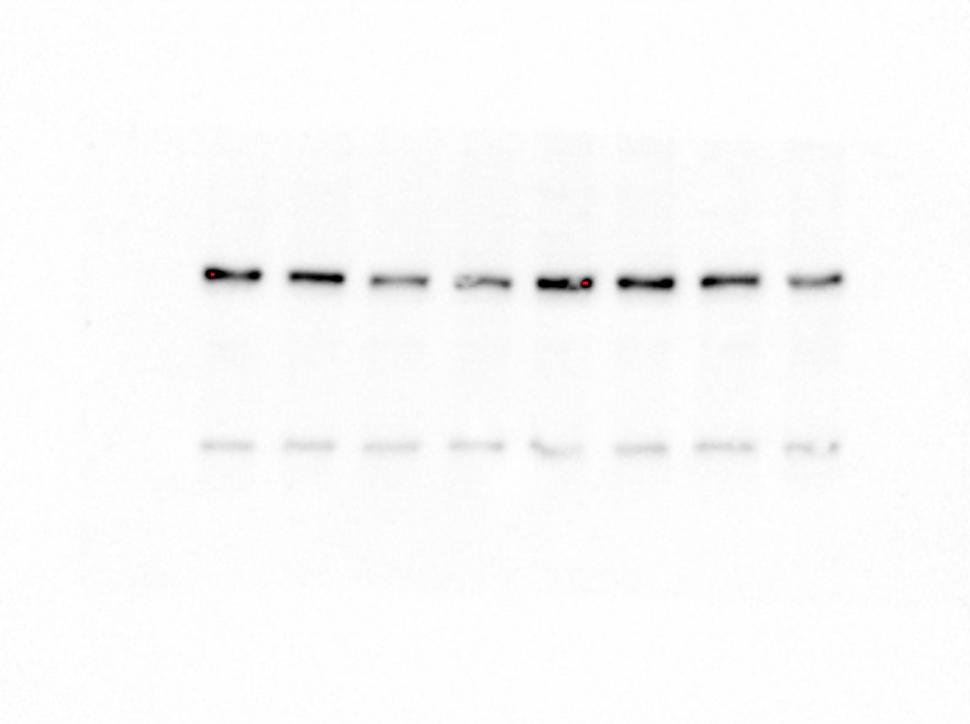
Figure S5: Tubulin EPA20 DHA10 2.

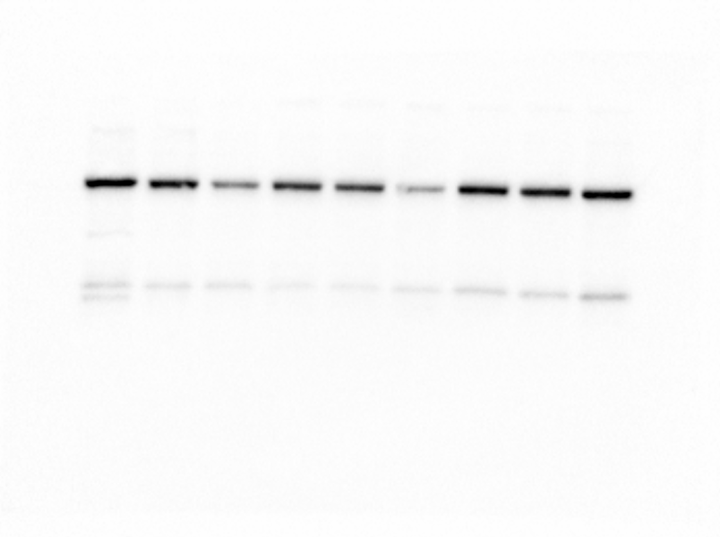

Figure S6: Tubulin NC and PD 1, 2 and 3.

