Supplementary data
All methods and Figures on the changes in various parameters characterizing spontaneous and MOG-induced development of experimental autoimmune encephalomyelitis in EAE prone C57BL/6 male mice possessing T- and B-cells responses are taken [1-4]. These data are presented in “Supplementary Methods and Figures” for comparison with the same Parameters characterizing the development of EAE in Th mice with T-cells answer demonstrated in this work.
1. Doronin VB, Parkhomenko TA, Korablev A, et al. Changes in different parameters, lymphocyte proliferation and hematopoietic progenitor colony formation in EAE mice treated with myelin oligodendrocyte glycoprotein. J Cell Mol Med. 2016; 20: 81-94.
2. Doronin VB, Korablev A, Toporkova LB, Aulova KS, et al. Changes in several disease parameters including abzymes and hematopoietic progenitor colony formation in brain inflammation and demyelination. J. Neurol. Neurol. Disord. 2017; 3: 302.
3. Aulova KS, Toporkova LB, Lopatnikova JA, Alshevskaya AA, et al. Changes in cell differentiation and proliferation lead to production of abzymes in EAE mice treated with DNA-Histone complexes. J. Cell Mol. Med. 2018; 22: 5816-5832.
Рart 1. ELISA of anti-proteins and anti-DNA antibodies
The levels of anti-DNA Abs (sera were diluted 100-fold) were determined using standard ELISA: plates with immobilized double-stranded DNA, horseradish peroxidase-conjugated mouse Abs against human IgG of the test system ORGENTEC Diagnostika (Germany) were used according to the manufacturer's instructions as in [1-3]. The relative content of anti-MBP and anti-MOG IgGs was estimated using purified mouse sera polyclonal electrophoretically homogeneous IgGs. MBP or MOG (0.01mg/ml) in sodium carbonate buffer (50µl, pH 9.6) was added to ELISA strips, which were incubated overnight at 23ºC. The strips were washed with TBS buffer (20mM Tris-HCl containing 0.15М NaCl) supplemented with 0.01% NaN3 and 0.05% Triton Х-100 and three times with the same buffer containing no Triton Х-100. To block the strip surfaces, they were treated for 2.5h at 30ºC using TBS containing 0.2% egg albumin and 0.01% NaN3. The strips were washed 8 times with water and then with TBS
Containing 0.01% NaN₃. The strips were incubated with 100µl of TBS containing 1µg/ml conjugate of monoclonal anti-mice IgGs with horseradish peroxidase for 40min at 30ºC rewashed 10 times with water. After adding 60µl citric-phosphate buffer containing 3,3',5,5'-tetramethylbenzidine, and H₂O₂, the strips were incubated for 14min at 23ºC, and the reaction was stopped by the addition of 60µl of 50% H₂SO₄. The relative concentrations of anti-MBP and anti-MOG IgGs were expressed as an optical density of the solution at 450nm (units А₄₅₀; an average of 3 measurements), which was determined using a Uniskan II plate reader (MTX Lab Systems, USA). Finalconcentrations of anti-MOG and anti-MBP IgGs in the samples were expressed as a difference in the relative А₄₅₀ values of experimental and control samples; controls were without MOG or MBP.
Рart 2. IgG purification
Electrophoretically and immunologically homogeneous mouse IgGs were obtained by sequential chromatography of the serum proteins on Protein G-Sepharose and following Fast Protein Liquid Chromatography (FPLC) gel filtration as described previously [1-3]. The serum protein (0.4-0.6 ml) was loaded onto a 1-ml protein G-Sepharose column equilibrated in buffer a (150mM NaCl, 50mM Tris-HCl, pH 7.5). The column was washed by buffer A to zero optical density (A₂₈₀). Proteins adsorbed non-specifically were eluted with the same buffer (15ml) but containing 1% Triton X-100 and 0.3M NaCl and the column was washed with buffer A to zero optical density. The total IgGs fraction was eluted with 0.1M glycine-HCl (pH 2.6), the column fractions were collected to cooled tubes containing 50ml of 0.5M Tris-HCl (pH 9.0),and finally each fraction was additionally neutralized with this buffer, concentrated for additional purification.The purified IgG was incubated in acidic glycine-HCl buffer (pH 2.6) to disrupt noncovalent interactions and subjected to FPLC gel filtration on a Superdex 200 HR 10/30 column (Pfizer, New York,NY) using the BioCA workstation (Applied Biosystems, Foster City, CA) [1-3]. Abs were incubated for 20 min at 25oC in 0.1 M buffer (pH 2.6) containing 0.3 M NaCl and then subjected to the gel filtration on the column equilibrated in buffer A. The fractions of separated IgGs were collected and dialyzed against 20mM Tris-HCl (pH 7.5) containing 50mM NaCl. In order to protect Abs preparations from bacterial and viral contamination, they were filtered through Millex syringe-driven filter units (0.2µm) and kept in sterilized tubes. Incubation of standard bacterial medium with stored Abs preparations did not lead to the formation of colonies.
Part 3. SDS-PAGE analysis of catalytic activities
Analysis of DNA-, MBP-, MOG, and histones hydrolyzing activities of mice IgGs after SDS-PAGE was performed as described in [1-3]. IgGs were pre-incubated at 25ºC for 30min under nonreducing conditions (50mM Tris-HCl, pH 7.5, 1% SDS, and 10% glycerol). After SDS-PAGE of IgGs to restore the catalytic activities of IgGs, SDS was taken away by the gel incubation for 1h at 20ºC with 4M urea and then washed 10 times (7-10 min) with H₂O. Then the gel 2-4-mm cross-sections of longitudinal slices were cut up thoroughly destroyed and incubated with 50mM Tris-HCl buffer, pH 7.5, containing 50mM NaCl 5 (50µl) for 5-7 days at 4ºC to allow proteins refolding and eluting from the gel. The gel was separated by centrifugation and solution obtained used for assay of DNase and protease activities, as described above. Parallel control longitudinal lanes were used for detecting the position of IgGs on the gel by silver staining.
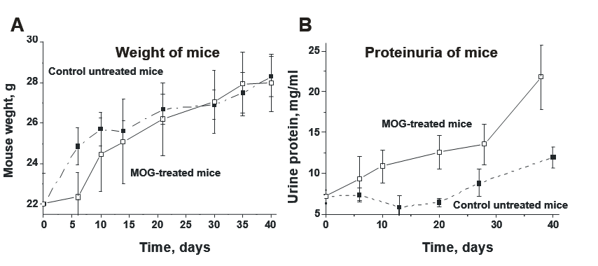

Supplementary Figure S1: In time changes in weight of male C57BL/6 mice (A) and relative concentration of urine protein (B) in mice untreated and treated with MOG [1-3].
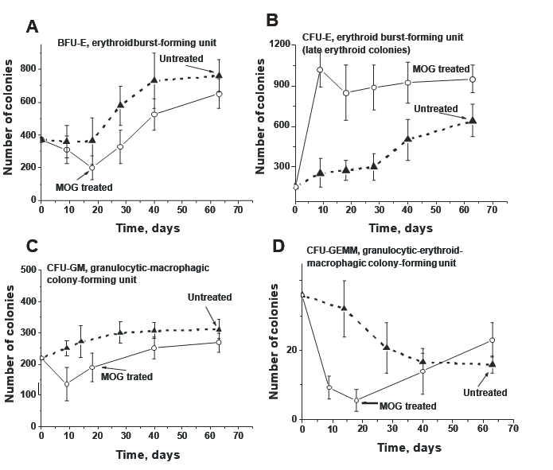
Supplementary Figure S2: In time changes of an average relative content of different colony- forming units of bone marrow progenitor colonies in the case of untreated and MOG-treated male C57BL/6 mice; average number of the colonies corresponding to 7 mice of each group is given and types of progenitor colonies (BFU-E (A), CFU-E (B), CFU-GM (C), and CFU- GEMM (D) are shown [1-3].

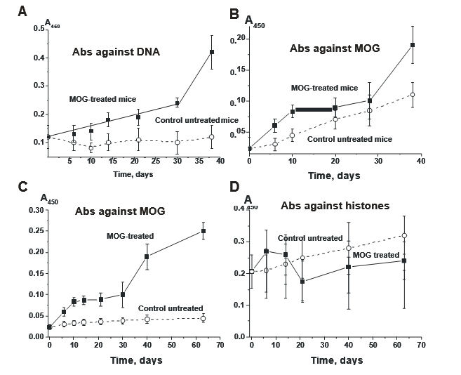
Supplementary Figure S3: The in-time changes in average values of anti-DNA (A), anti-MOG (B), anti-MBP (C), and anti-histones (D) Abs concentration in C57BL/6 male mice before and after their immunization with MOG [1-3].
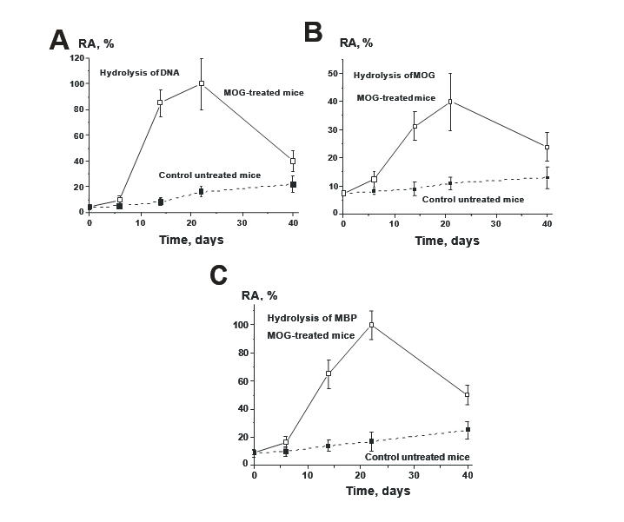
Supplementary Figure S4: The in-time changes in average relative activities (RA) by IgGs from sera of C57BL/6 male mice of DNA (A), MOG (B), and MBP (C) before and after mice immunization with MOG [1-3].

