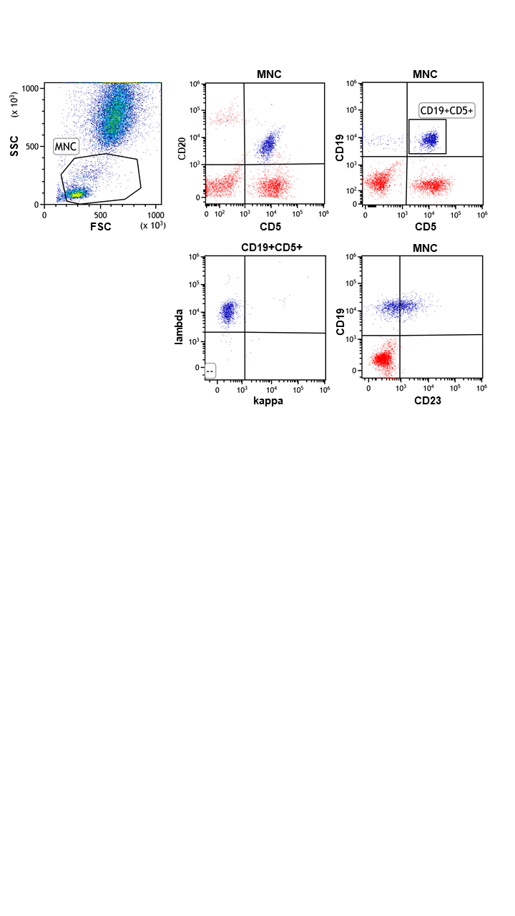

Supplementary Figure 1: Immunophenotypic evaluation of peripheral blood.
Flow cytometric analysis of patient’s peripheral blood mononuclear cells (MNC) at time point of first admission is shown. Monoclonal B-cells with expression of CD19⁺, CD20^{dim}, CD5⁺, CD23^{dim}, and lambda light chain restriction with weak fluorescence intensity were identified.

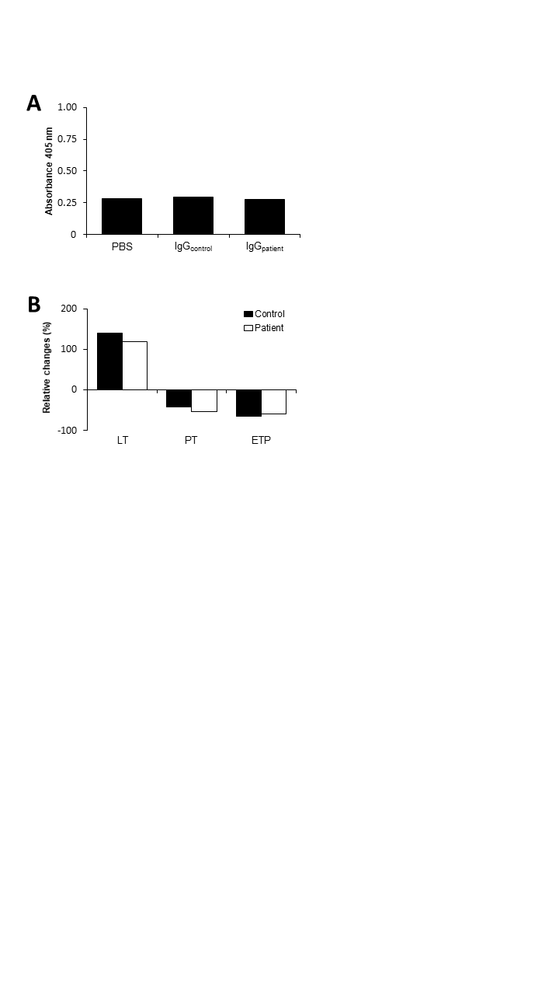
Supplementary Figure 2: Patient IgG did not recognize soluble thrombomodulin (sTM).
A) IgG was purified from the patient or a healthy control and analyzed for the ability to bind to immobilized sTM using an in-house solid-phase ELISA. B) Thrombin generation was recorded in patient and control plasma following addition of 15nM sTM or buffer using a modified fluorogenic thrombin generation assay. Results are shown as relative changes in lag time (LT), peak thrombin (PT) and endogenous thrombin potential (ETP) for sTM-spiked plasma.

