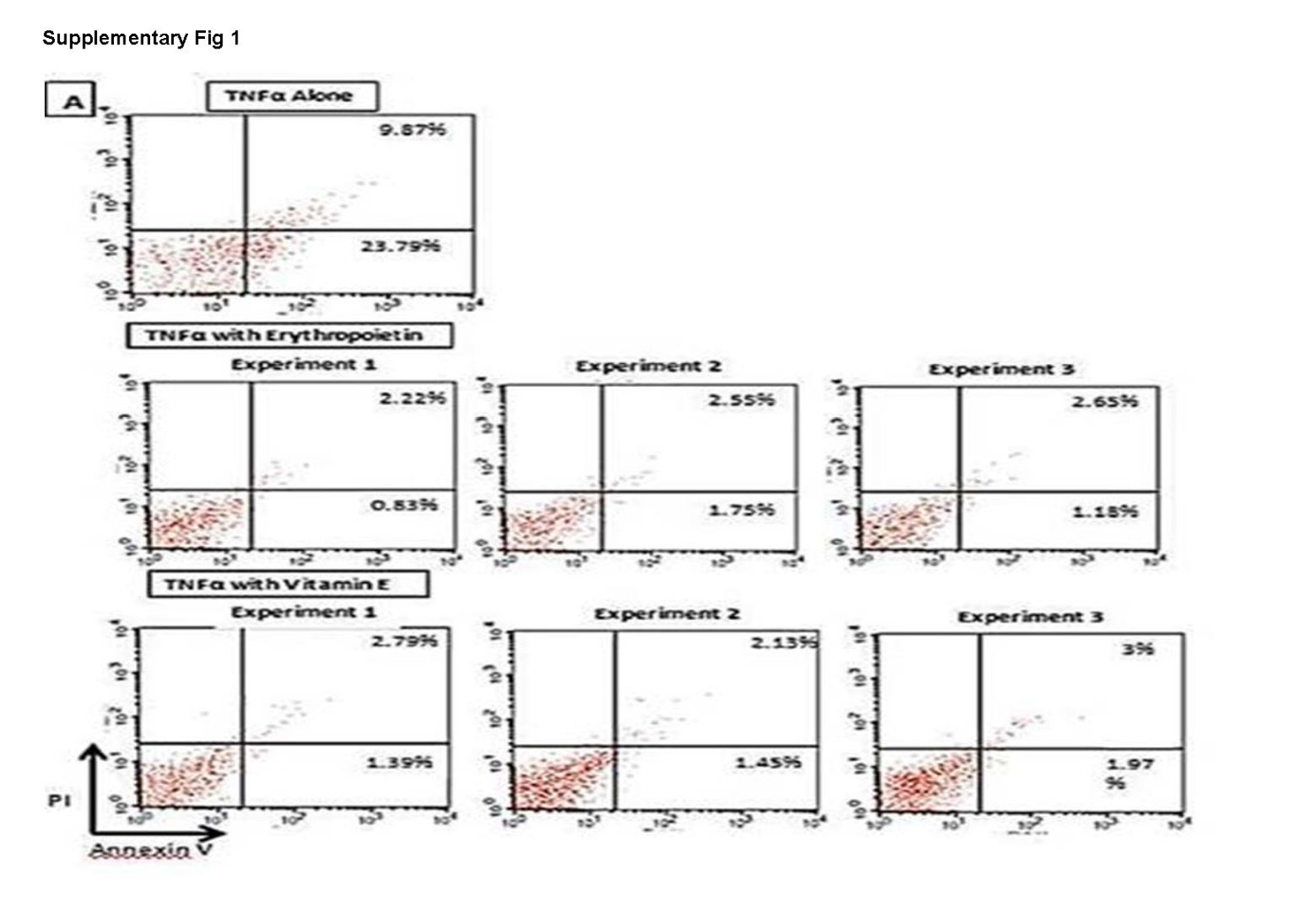
Supplementary Figure 1: Effect of vitamin E (100 µg/ mL) and EPO (100 IU/mL) on TNF-α (100 ng/mL)-induced apoptosis on CD34+-derived EPCs (reconfirmation of previous results).
Human CD34+-derived EPCs cells isolated from human PBMNCs were treated with vitamin E and/or EPO for 4 hours followed by the addition of TNF-α (100 ng/mL) in three independent experiments. Cells were then stained with annexin V-FITC and Propidium Iodide (PI) followed by analysis for early and late apoptotic cells by flow cytometry.
- Treatment of human CD34⁺-derived EPCs with vitamin E (100 µg/mL) resulted in a significant decrease in the percent cell early apoptosis to 1.60% ±0.18% (mean±SD from three independent experiments) and another significant decrease in percent cell late apoptosis to 2.6%±0.26% (mean±SD from three independent experiments).

