Appendix A
Supplementary data associated with this article can be found, in the online version, at http//…
Supplementary data 1: Alkaloids of different origins and sources: natural (N), semi-synthetic (SS), synthetic (S).
Supplementary data 2: Summary of color observations for each presumptive test performed with authentic standards. The first lane indicates color of the reagent without any standard added. Methanol (MeOH) is the color of the solution prior to addition of the reagent.
Supplementary data 3: Summary of color predictions for each presumptive test performed with authentic standards.
Supplementary data 4: Chemical structures of the cutting agents tested in this study.
Supplementary data 5: Summary of color observations for each presumptive test performed with mixtures.
Forensic chemistry of alkaloids: presumptive color tests
Supplementary data
Supplementary data associated with this article can be found, in the online version, at http//…
Supplementary data 1: Alkaloids of different origins and sources: natural (N), semi-synthetic (SS), synthetic (S).

Name | Alkaloid group | Structure | Origin | Organism producer | Sources
Morphine | Benzylisoquinoline (opiate) | 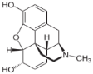 | Plant | Opium poppy | N
Codeine | Benzylisoquinoline (opiate) | 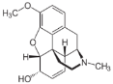 | Plant | Opium poppy | N
Thebaine | Benzylisoquinoline (opiate) | 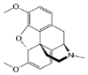 | Plant | Opium poppy | N
Berberine | Benzylisoquinoline | 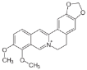 | Plant | Barberry | N
Sanguinarine | Benzylisoquinoline | 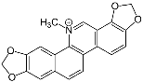 | Plant | Bloodroot | N
Papaverine | Benzylisoquinoline | 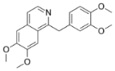 | Plant | Opium poppy | N
Ergine (LSA) | Lysergamide (indole) | 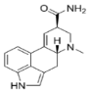 | Fungi | Ergot | N
Ergometrine | Lysergamide (indole) | 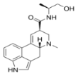 | Fungi | Ergot | N
Ephedrine | Phenylethylamine | 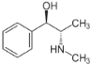 | Plant | Ephedra | N
Methylephedrine | Phenylethylamine | 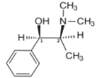 | Plant | Ephedra | N
Pseudoephedrine | Phenylethylamine | 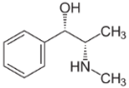 | Plant | Ephedra | N
Norephedrine (Phenylpropanolamine) | Phenylethylamine | 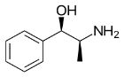 | Plant | Khat | N
Cathine (Norpseudoephedrine) | Phenylethylamine | 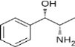 | Plant | Khat | N
Cathinone | Phenylethylamine | 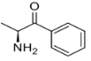 | Plant | Khat | N
Merucathine | Phenylethylamine | 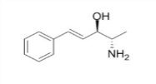 | Plant | Khat | N
Pseudomerucatine | Phenylethylamine | 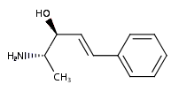 | Plant | Khat | N
Mescaline | Phenylethylamine |  | Plant | Peyote | N
Lobeline | Piperidine | 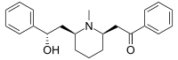  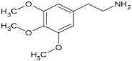 | Plant | Indian Tobacco | N
Piperidine | Piperidine | 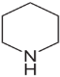 | Plant | Black pepper | N
Piperine | Piperidine | 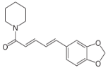 | Plant | Black pepper | N
Caffeine | Purine | 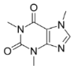 | Plant | Coffee tree | N
Theobromine | Purine | 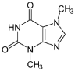 | Plant | Cocoa tree | N
Quinine | Quinoline | 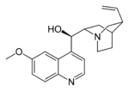 | Plant | Cinchona tree | N
Atropine | Tropane | 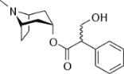 | Plant | Deadly nightshade | N
Cocaine | Tropane | 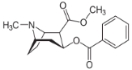 | Plant | Coca | N
Psilocine | Tryptamine (Indole) | 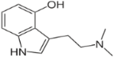 | Fungi | Magic mushroom | N
Psilocybine | Tryptamine (Indole) | 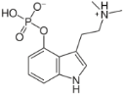 | Fungi | Magic mushroom | N
Ergine (LSA) | Lysergamide (indole) |  | Fungi | Ergot | N
Ergometrine | Lysergamide (indole) |  | Fungi | Ergot | N
Heroin | Benzylisoquinoline (opiate) | 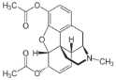 | Morphine | Opium poppy | S
Hydromorphone | Benzylisoquinoline (opiate) | 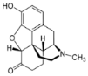 | Morphine | Opium poppy | S
Hydrocodone | Benzylisoquinoline (opiate) | 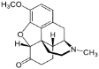 | Codeine | Opium poppy | S
Dihydrocodeine | Benzylisoquinoline (opiate) | 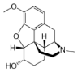 | Codeine | Opium poppy | S
Dihydrocodeine | Benzylisoquinoline (opiate) |  | Codeine | Opium poppy | S
Buprenorphine | Benzylisoquinoline (opiate) | 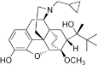 | Thebaine | Opium poppy | S
Nalbuphine | Benzylisoquinoline (opiate) | 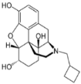 | Thebaine | Opium poppy | S
Oxycodone | Benzylisoquinoline (opiate) | 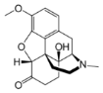 | Thebaine | Opium poppy | S
Oxymorphone | Benzylisoquinoline (opiate) | 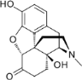 | Thebaine | Opium poppy | S
Methcathinone | Phenylethylamine | 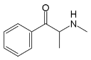 | Cathinone | Khat | S
Methamphetamine | Phenylethylamine | 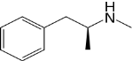 | Ephedrine | Ephedra | S
MDA  (3,4-methylenedioxyamphetamine) | Phenylethylamine | 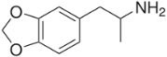 | Amphetamine | Synthesized from chemical compounds | S
MDMA  (3,4-methylenedioxymethamphetamine) | Phenylethylamine | 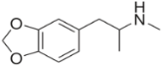 | Amphetamine | Synthesized from chemical compounds | S
Amphetamine | Phenylethylamine | 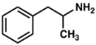 | Phenylacetone | Synthesized from chemical compounds | S
2,5-Dimethoxy-4-methylamphetamine (DOM ou STP) | Phenylethylamine | 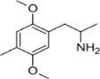 | 2,5-dimethoxytoluene | Synthesized from chemical compounds | S
Dextropropoxyphene | Phenylheptylamine | 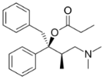 | D-oxyphene | Synthesized from chemical compounds | S
Methadone | Phenylheptylamine | 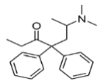 | Diphenylacetonitrile and 1-dimethylamino-2-chloropropane | Synthesized from chemical compounds | S
Cetobemidone | Phenylpiperidine | 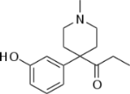 | 3-methxyphenyl acetonitrile | Synthesized from chemical compounds | S
Fentanyl | Phenylpiperidine | 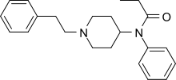 | Several compounds | Synthesized from chemical compounds | S
Tryptamine | Tryptamine (Indole) | 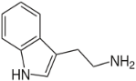 | Tryptophane | Synthesized from chemical compounds | S
Lysergic acid diethylamide (LSD) | Lysergamide (indole) | 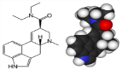 | Lysergic acid | Ergot | S

Supplementary data 2: Summary of color predictions for each presumptive test performed with authentic standards.

Alkaloid | Tests which there is possibly reaction
Caffeine | Chen
Theobromine | Chen
Papaverine | Chen, Mandelin, Marquis, Froehde
Piperidine | Chen, Mandelin, Simon
Piperine | Chen, Mandelin, Marquis, Mecke, Froehde
Lobeline | Chen, Mandelin, Marquis, Froehde
Quinine | Chen, Mandelin, Marquis, Froehde
Atropine | Chen, Mandelin, Marquis, Froehde, Cobalt
Berberine | Chen, Mandelin, Marquis, Mecke, Froehde, Cobalt
MDA | Chen, Mandelin, Marquis, Mecke, Froehde
MDMA | Chen, Mandelin, Marquis, Mecke, Froehde, Simon
Methamphetamine | Chen, Mandelin, Marquis, Froehde, Simon
Cocaine | Chen, Mandelin, Marquis, Froehde, Cobalt
Codeine | Chen, Mandelin, Marquis, Mecke, Froehde
Morphine | Chen, Mandelin, Marquis, Mecke, Froehde

Supplementary data 3: Summary of color observations for each presumptive test performed with authentic standards. The first lane indicates color of the reagent without any standard added. Methanol (MeOH) is the color of the solution prior to addition of the reagent. For example, the predictions for caffeine were made because the molecule has lots of oxygen and nitrogen atoms so it can easily react with Chen’s reagent. Also, because the reaction of the Mandelin’s reagent is not known for sure, it was predicted that most alkaloids functional group had a possibility to react with this reagent. Similarly, the Froehde’s reagent has the possibility to react with most alkaloids. The presence of aromatic ring(s) in the structure of all tested alkaloid, except for caffeine, theobromine and piperidine, should yield a positive reaction with Marquis’s test. The presence of a secondary amine in MDMA and methamphetamine allow positive reaction with Simon’s test whereas protonated tertiary amine from berberine and cocaine will react with the Cobalt’s test.

Alkaloid | MeOH | Chen | Mandelin | Marquis | Mecke | Froehde | Simon | Cobalt
 | Colorless | Light blue | Yellow | Colorless | Colorless | Colorless | Colorless | Pink
Caffeine | Colorless | Brownish green | No change | Colorless | Colorless | Colorless | Colorless | No change
Theobromine | Whitish | Brownish green | No change | Colorless | Colorless | Colorless | Colorless | No change
Papaverine | Colorless | Brownish green | Orange | Colorless | Colorless | Colorless | Colorless | No change
Piperidine | Colorless | Brownish green | No change | Colorless | Colorless | Colorless | Light purple | No change
Piperine | Yellowish | Brownish green | Dark orange | Brown orange | Brownish yellow | Brownish yellow | Colorless | No change
Lobeline | Colorless | Brownish green | No change | Colorless | Colorless | Colorless | Colorless | No change
Quinine | Colorless | Brownish green | No change | Colorless | Colorless | Colorless | Colorless | No change
Atropine | Colorless | Brownish green | No change | Colorless | Colorless | Colorless | Colorless | No change
Berberine | Yellow | Brownish green | Dark red | No change | Brownish orange | No change | No change | Green particles
MDA | Colorless | Brownish green | Blackish blue | Blackish violet | Blackish violet | Green | Colorless | No change
MDMA | Colorless | Brownish green | Dark blue | Blackish violet | Blackish violet | Dark green | Light blue | No change
Methamphetamine | Colorless | Brownish green | No change | Beige | Colorless | Colorless | Light blue | No change
Cocaine | Colorless | No change | Dark yellow | Colorless | Colorless | Colorless | Colorless | Blue
Codeine | Colorless | Brownish green | Dark blue | Violet | Aqua blue | Light blue | Colorless | No change
Morphine | Colorless | No change | No change | Light violet | Green blue | Light green | Colorless | No change

Supplementary data 4: Chemical structures of the cutting agents tested in this study.
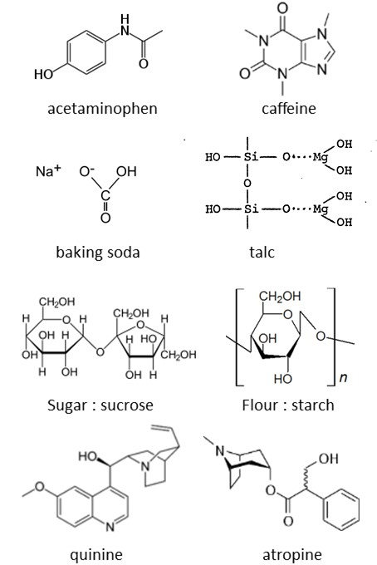

Supplementary data 5: Summary of color observations for each presumptive test performed with mixtures.
Mix | Mandelin | Marquis | Mecke | Froehde | Simon | Cobalt
MDA | Black blue | Blackish violet | Blackish violet | Green | - | -
1.1 | Yellow green | Light yellow | Light violet | Light brown | - | -
1.2 | Phases : yellow and green-blue | Violet | Violet | Brown | - | -
1.3 | Phases : yellow and green-blue | Violet | Violet | Brown | - | -
1.4 | Phases : yellow and green-blue | Violet | Violet | Brown | - | -
MDMA | Dark blue | Blackish violet | Blackish violet | Dark green | Light blue | -
2.1 | Green yellow | Light yellow | Light pink | Light brown | Very light pink | -
2.2 | Phases : yellow and green | Light grey | Light violet | Brown | Very light pink | -
2.3 | Phases : yellow and green | Light grey | Light violet | Brown | Very light pink | -
2.4 | Yellow green | Light yellow grey | Light violet | Brown | Very light pink | -
Methamphetamine | - | Beige | - | - | Light blue | -
3.1 | - | Light yellow | Light yellow | Light pink | Very light yellow | -
3.2 | - | Light yellow | Pink | Light pink | Very light yellow | -
3.3 | - | Light yellow | Pink | Light pink | Very light yellow | -
3.4 | - | Light yellow | Light pink | Pink | Very light yellow | -
Cocaine | Dark yellow | - | - | - | - | Blue
4.1 | Green yellow | - | - | Light pink | - | -
4.2 | Dark yellow | - | Light yellow brown | Light yellow | - | -
4.3 | Dark yellow | - | Light yellow brown | Light yellow | - | -
4.4 | Dark yellow | - | Light yellow brown | Light yellow pink | - | -

