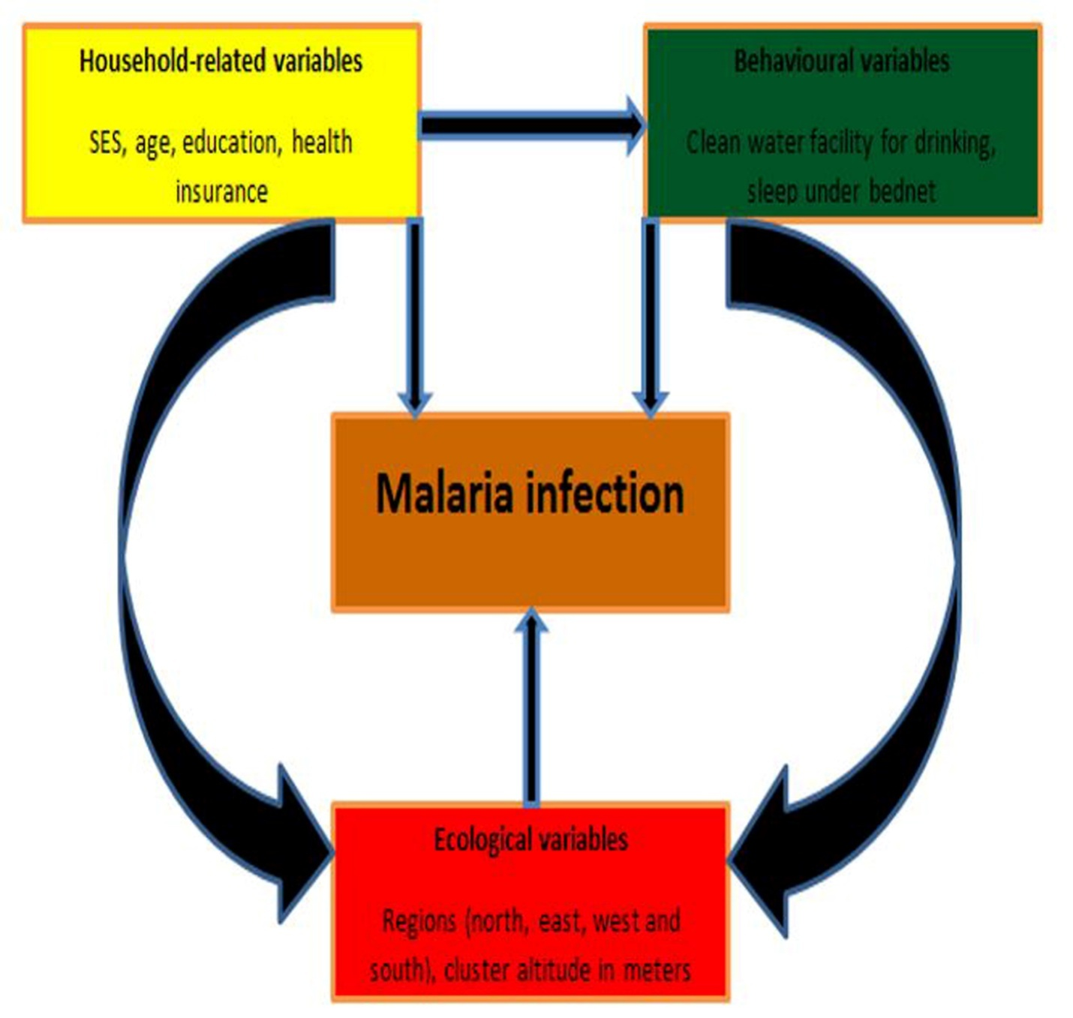
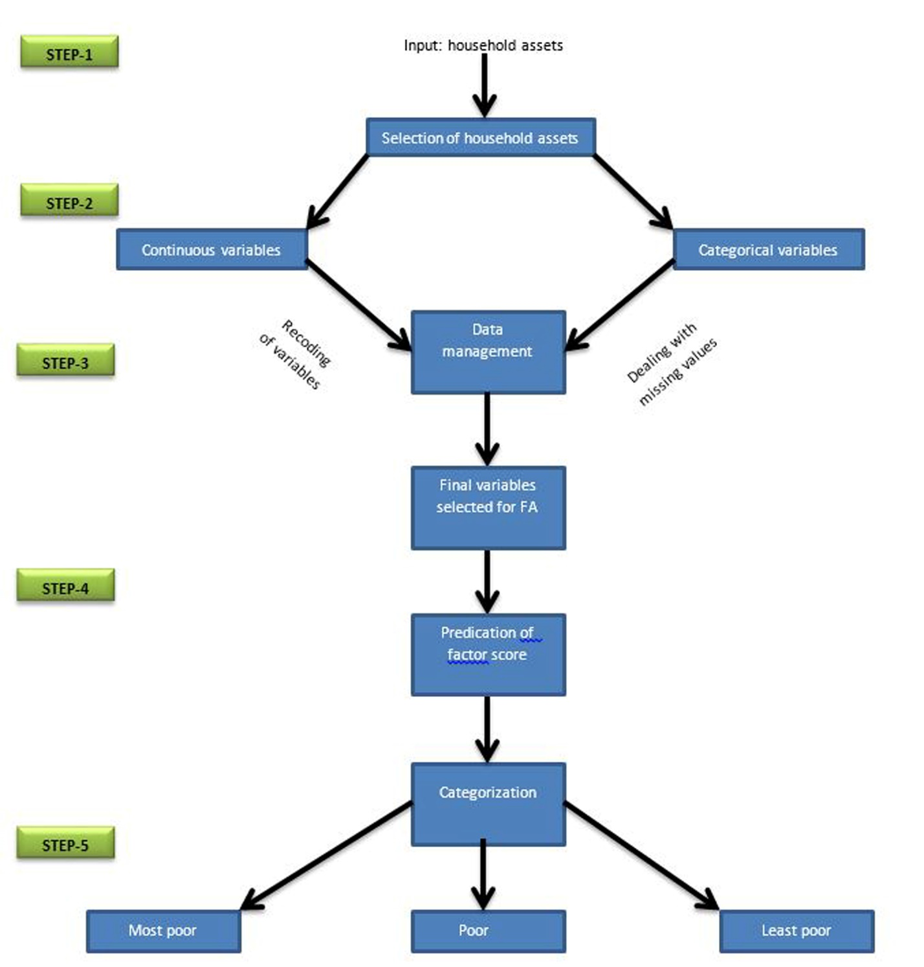
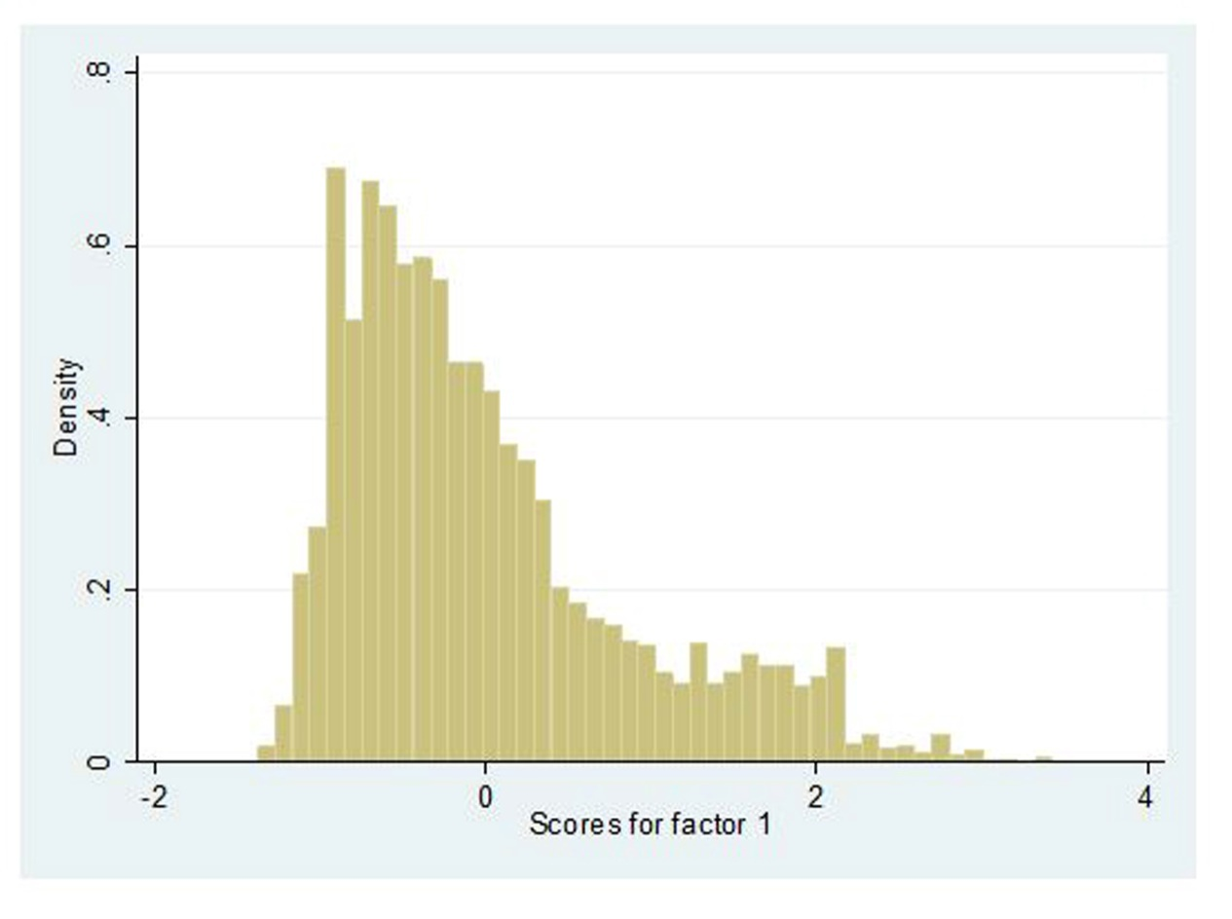

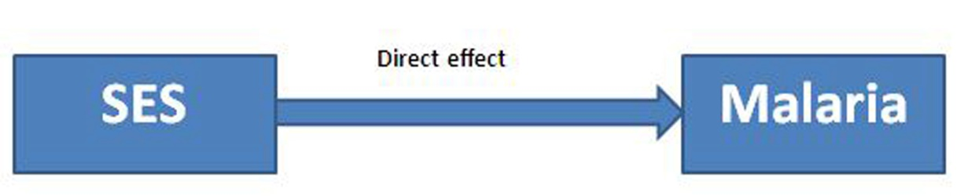

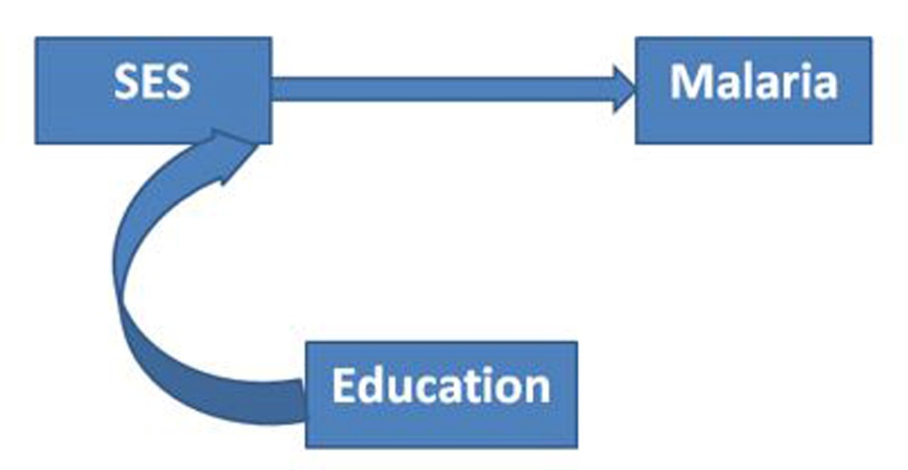

Appendix Figures
Appendix Figure 1: Conceptual frameworks for modelling malaria morbidity. The black arrows reflect a direct and indirect effect on malaria morbidity.
Appendix Figure 2: Flowchart to determine SES using factor analysis technique.
Appendix Figure 3: Appendix S2: Histogram of factor scores for the creation of socio-economic status.
Appendix Figure 4: Describes direct pathway.
Appendix Figure 5: Describes indirect pathway.

