Supplementary
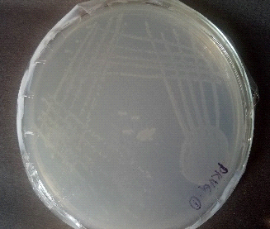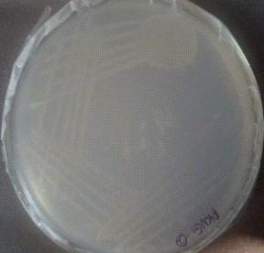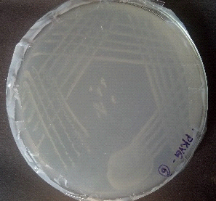
PKVG1 PKVG2 PKVG6
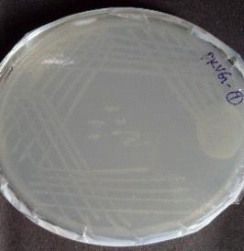
PKVG7
Pure culture of isolated bacterial strains

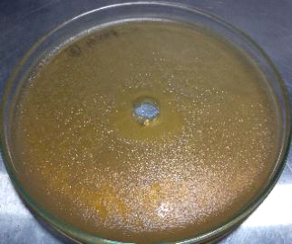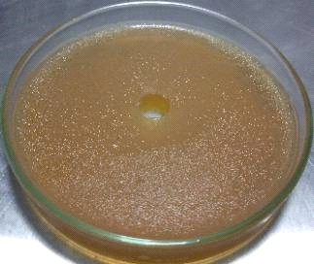
Phosphatase enzyme assay
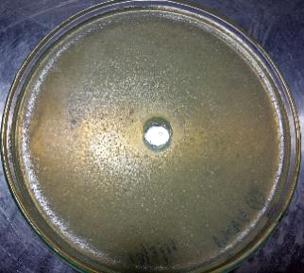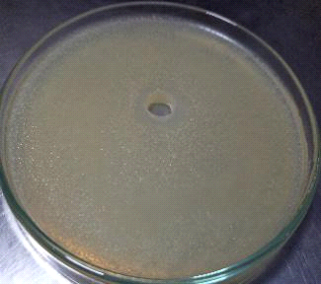
Esterase enzyme assay
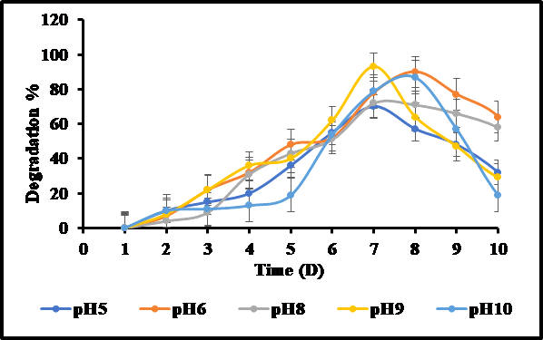
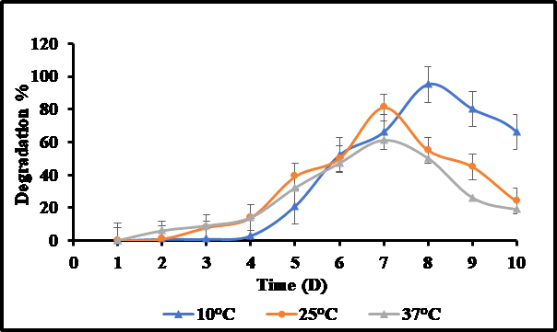
Optimization of pH and temperature - PKVG1.
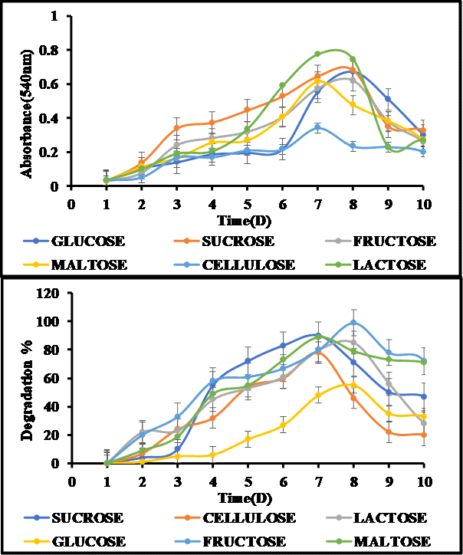
Optimization of carbon sources for PKVG1 a) Growth b) Degradation.

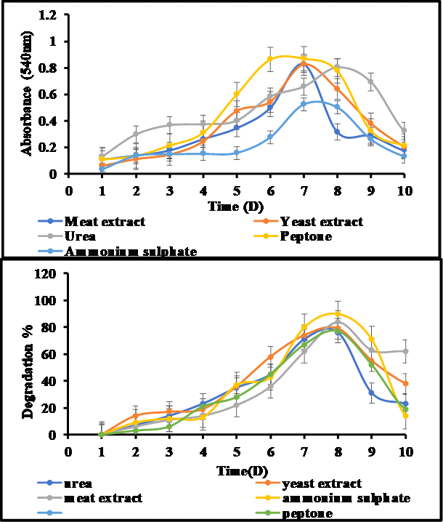
Optimization of carbon sources for PKVG1 a) Growth b) Degradation.

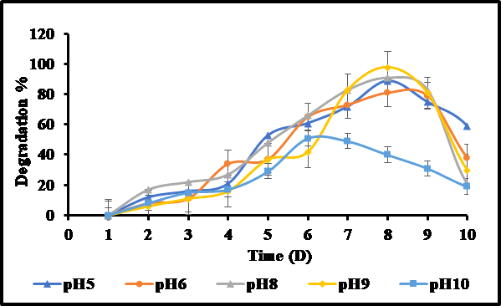

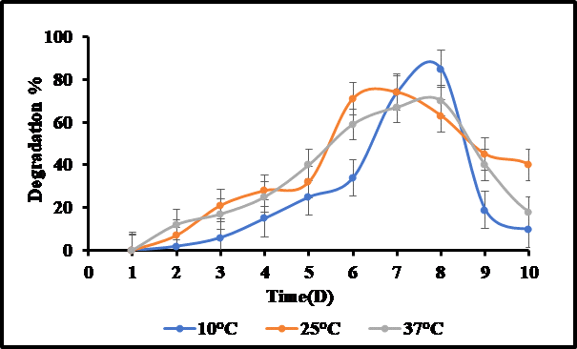
Optimization of pH and temperature - PKVG6.
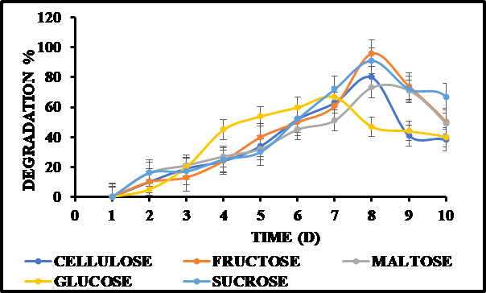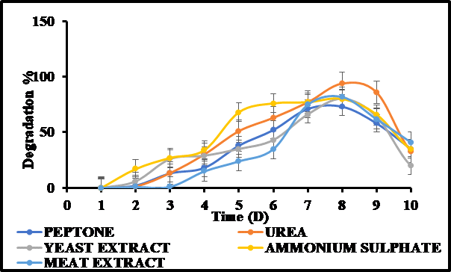
Optimization of a) Carbon b) Nitrogen Sources - PKVG6.
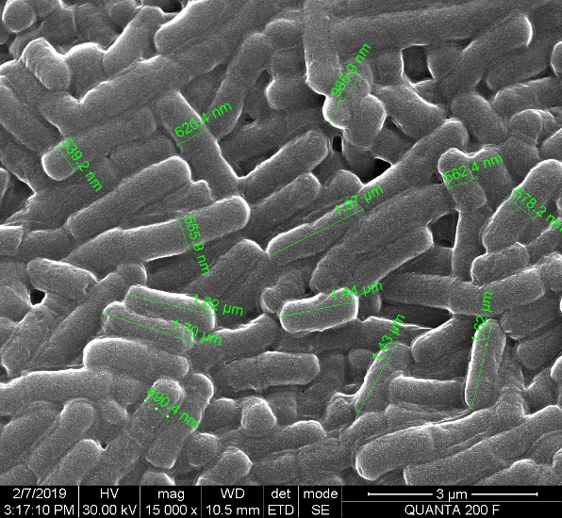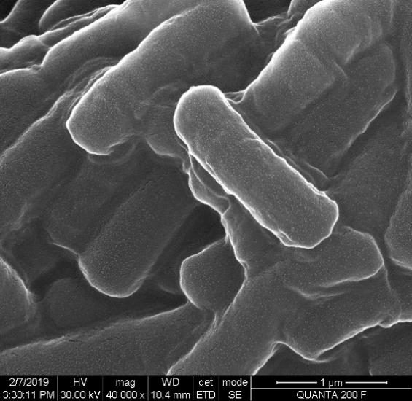
SEM Observation of PKVG1.


GEL image of PKVG1 bacteria amplified DNA.

GEL image of PKVG1 bacteria and amplified DNA.
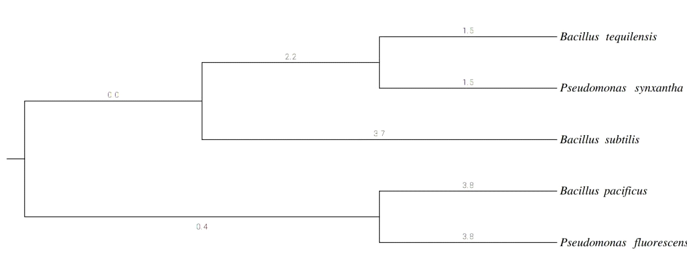
Phylogenetic tree of the bacterial strain PKVG1.
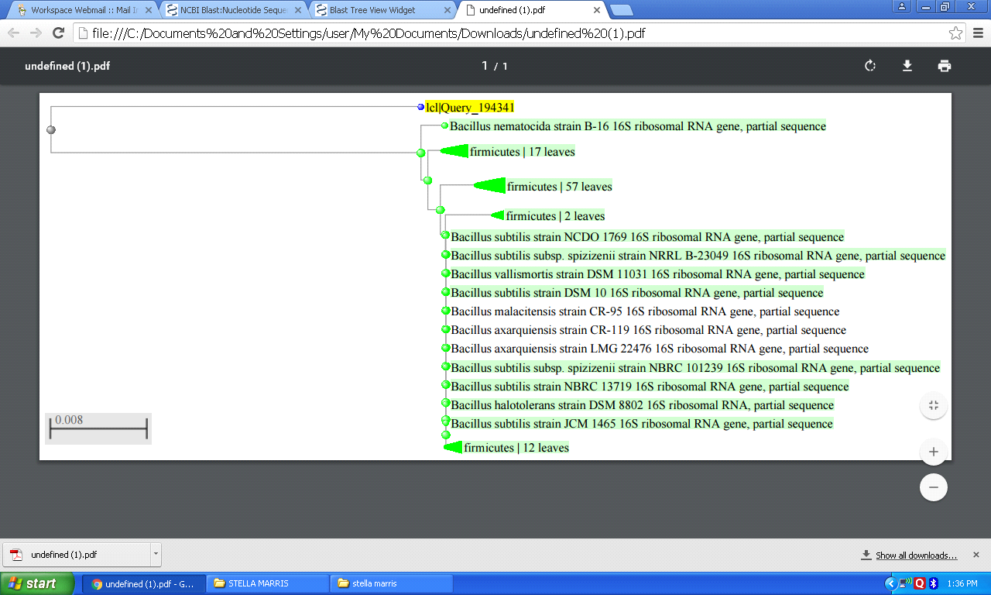
Phylogenetic tree of the bacterial strain PKV6.

