Supplementary Material
The % matrix effect (% ME) is calculated based on a multi-point approach where the slope of the standard addition calibration curve obtained for each sample extract and solvent-based calibration curve (run on same day of analysis) are compared over the same linear calibration range. In standard addition calibration different amounts of standard are added to different aliquots of the individual sample extract. The % ME for each sample is calculated as shown below:
% ME = ((slope standard addition-slope solvent-based)/slope solvent- based) ×100%
A positive % ME indicates that MS signal enhancement is observed, while negative % ME indicates that the MS signal is suppressed in the presence of the matrix. When %ME ranges from -20 to +20% soft MS signal suppression or enhancement is present and the use of internal standards in the calibration approach can compensate for the matrix effects. When % ME is either >20-50 % or <-20 to -50% moderated matrix effects are observed, and standard addition calibration should be used for quantitation. When the matrix effects are >50% or <-50% standard addition calibration curves can still be used if good linearity can be obtained over the desired calibration range.

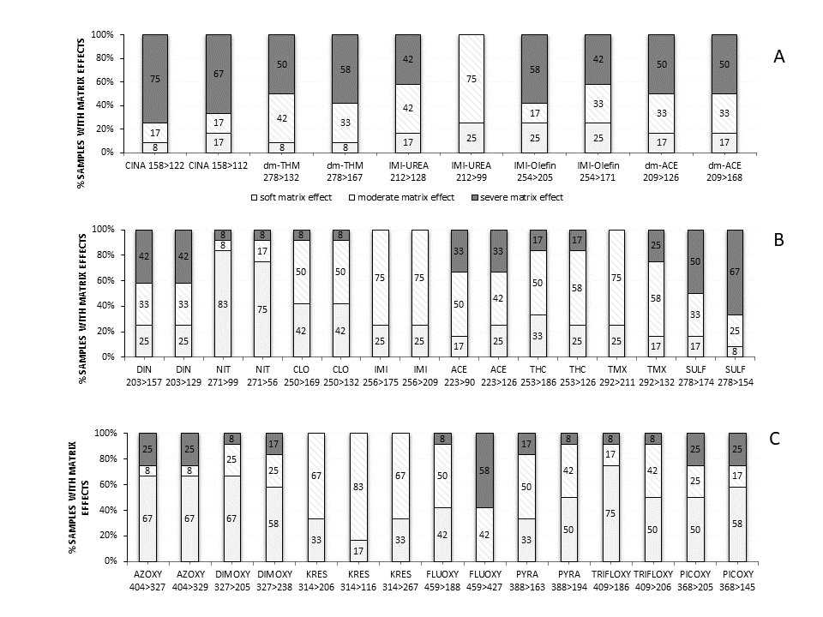

Figure 1: Percentage of samples with soft, moderate, or sever matrix effect evaluation by comparing slopes obtained from analytical calibration curves prepared in methanol and in matrix extract by standard addition calibration.
A: Metabolites of neonicotinoid insecticides;
B: neonicotinoid insecticides;
C: strobilurin fungicides. Analytes in each graph are ordered by retention time. % ME was determined for all samples analyzed in 2016.

