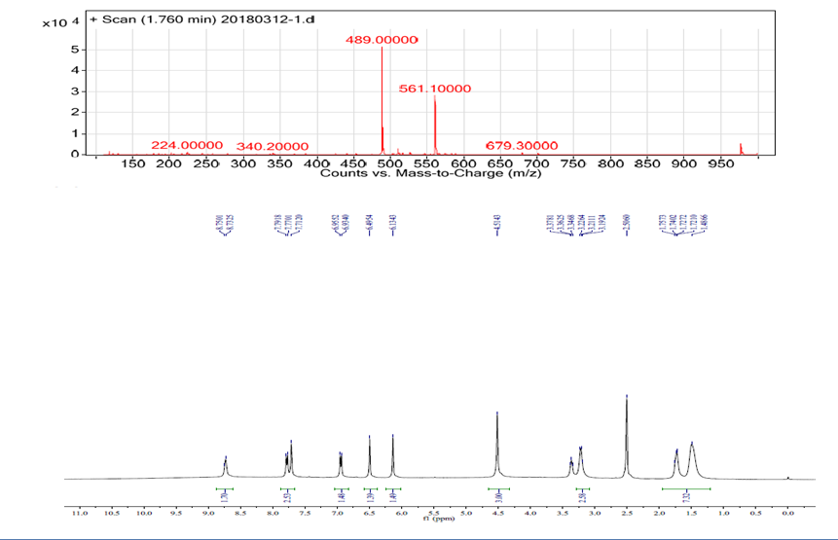
Supplementary Figure 1: Mass spectrum and NMR spectrum of compound 2.

