Supplementary Table 1: Adopted keywords and electronic search strategies.
Population | Conventional complete denture OR Conventional complete denture* OR Conventional complete denture*[tw] OR Complete denture OR Complete denture* OR Complete denture*[tw]
Intervention | Lingualized occlusion OR Lingualized occlusion* OR Lingualized occlusion*[tw]
Comparison | Balanced occlusion OR Balanced occlusion* OR Balanced occlusion*[tw] OR Bilateral balanced occlusion OR Bilateral balanced occlusion* OR Bilateral balanced occlusion*[tw]
Outcome | Patient satisfaction OR Patient satisfaction* OR Patient satisfaction*[tw]
Combined | Conventional complete denture OR Conventional complete denture* OR Conventional complete denture*[tw] OR Complete denture OR Complete denture* OR Complete denture*[tw] AND Lingualized occlusion OR Lingualized occlusion* OR Lingualized occlusion*[tw] AND Balanced occlusion OR Balanced occlusion* OR Balanced occlusion*[tw] OR Bilateral balanced occlusion OR Bilateral balanced occlusion* OR Bilateral balanced occlusion*[tw] AND Patient satisfaction OR Patient satisfaction* OR Patient satisfaction*[tw]

Supplementary Table 2: COCHRANE TOOL checklist to assess the quality of included studies.
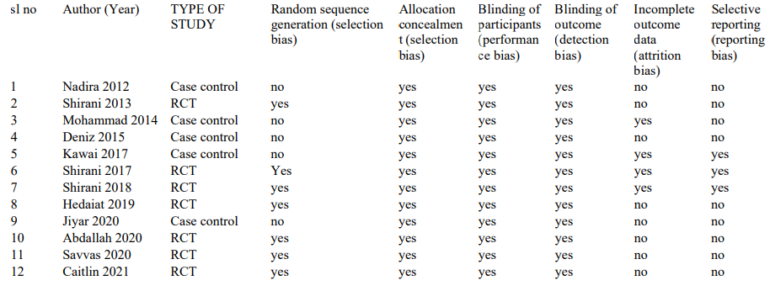
Supplementary Table 3: Characteristics of studies included.
