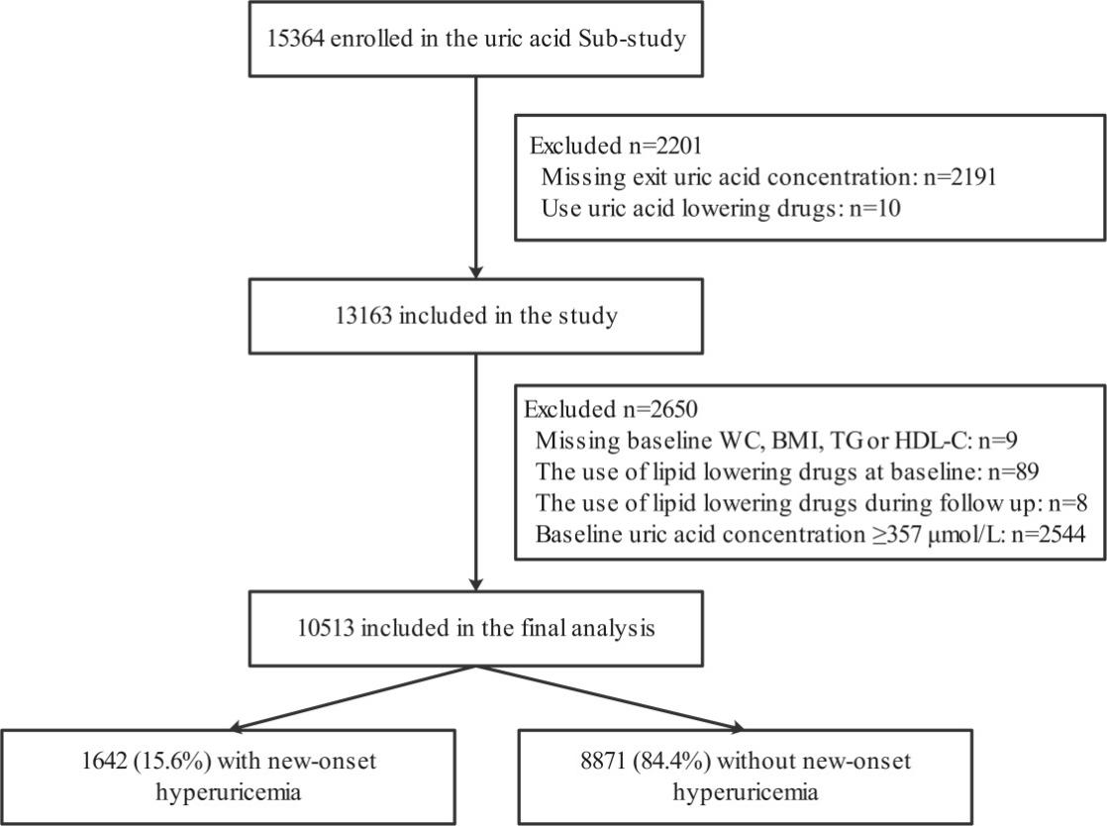

Supplementary Figure 1: Flow chart of study participants.

Supplementary Table 1: Concomitant medication usage during the treatment period according to the quartiles of baseline VAI.

Medication, n (%) | Visceral adiposity index |  |  |  | P value
Medication, n (%) | Q1 (<1.18) | Q2 (1.18-<1.87) | Q3 (1.87-<2.98) | Q4 (≥2.98) | P value
Anti-hypertension drugs
Calcium channel blockers | 2103 (80.0) | 2087 (79.4) | 2109 (80.3) | 2154 (81.9) | 0.121
Diuretics | 1562 (59.4) | 1591 (60.5) | 1560 (59.4) | 1617 (61.5) | 0.333
Glucose-lowering drugs | 22 (0.8) | 24 (0.9) | 21 (0.8) | 5 (0.2) | 0.005
Antiplatelet drugs | 19 (0.7) | 31 (1.2) | 59 (2.2) | 78 (3.0) | <0.001

Regular concomitant medication was defined as 180 or more cumulative days of taking the drug of interest.

Supplementary Table 2: The association between baseline VAI and new-onset hyperuricemia when UA concentrations <417 μmol/L for male and <357 μmol/L for female at baseline were included the analysis

Visceral adiposity index | Events/N (%) | Model 1 |  | Model 2 |  | Model 3
Visceral adiposity index | Events/N (%) | OR (95%CI) | P value | OR (95%CI) | P value | OR (95%CI) | P value
Quartiles
Q1 (<1.15) | 385/2884 (13.3) | ref. |  | ref. |  | ref.
Q2 (1.15-<1.83) | 459/2884 (15.9) | 1.09 (0.93, 1.28) | 0.279 | 1.13 (0.96, 1.33) | 0.146 | 1.05 (0.89, 1.25) | 0.537
Q3 (1.83-<2.92) | 534/2884 (18.5) | 1.22 (1.04, 1.43) | 0.012 | 1.27 (1.08, 1.50) | 0.004 | 1.14 (0.95, 1.36) | 0.151
Q4 (≥2.92) | 645/2885 (22.4) | 1.42 (1.21, 1.66) | <0.001 | 1.52 (1.28, 1.80) | <0.001 | 1.31 (1.07, 1.61) | 0.008
P for trend |  | <0.001 |  | <0.001 |  | 0.006
Categories
Q1-Q3 (<2.92) | 1378/8652 (15.9) | ref. |  | ref. |  | ref.
Q4 (≥2.92) | 645/2885 (22.4) | 1.26 (1.12, 1.42) | <0.001 | 1.31 (1.16, 1.48) | <0.001 | 1.20 (1.04, 1.38) | 0.013
Model 1: Adjusted for age, sex and uric acid (UA) at baseline.
Model 2: Adjusted for age, sex, UA, fasting glucose, total cholesterol (TC), total homocysteine (tHcy), estimated glomerular filtration rate (eGFR), systolic blood pressure (SBP), smoking and drinking status, use of antihypertensive drugs at baseline, treatment group, and mean SBP during the treatment period.
Model 3: Adjusted for the variables in model 2 plus body mass index (BMI), waist circumference (WC), TG/HDL-C ratio.

Supplementary Table 3: The association between baseline VAI and change in uric acid concentrations when UA concentrations <417 μmol/L for male and <357 μmol/L for female at baseline were included the analysis.
Visceral adiposity index | UA change, μmol/L, Mean ± SD | Model 1 |  | Model 2 |  | Model 3
Visceral adiposity index | UA change, μmol/L, Mean ± SD | β (95%CI) | P value | β (95%CI) | P value | β (95%CI) | P value
Quartiles
Q1 (<1.15) | 37.8 ± 65.8 | ref. |  | ref. |  | ref.
Q2 (1.15-<1.83) | 39.3 ± 65.2 | 5.80 (1.63, 8.43) | 0.004 | 6.42 (3.03, 9.81) | <0.001 | 4.19 (0.71, 7.67) | 0.018
Q3 (1.83-<2.92) | 40.1 ± 65.7 | 8.10 (4.61, 11.59) | <0.001 | 10.06 (6.55, 13.57) | <0.001 | 5.93 (2.12, 9.75) | 0.002
Q4 (≥2.92) | 41.6 ± 67.9 | 12.24 (8.64, 15.84) | <0.001 | 15.45 (11.72, 19.18) | <0.001 | 9.21 (4.52, 13.90) | <0.001
P for trend |  | <0.001 |  | <0.001 |  | <0.001
Categories
Q1 (<1.15) | 37.8 ± 65.8 | ref. |  | ref. |  | ref.
Q2-Q4 (≥1.15) | 40.3 ± 66.3 | 8.00 (5.08, 10.92) | <0.001 | 9.75 (6.79, 12.70) | <0.001 | 4.99 (1.77, 8.21) | 0.002

*Change in uric acid concentrations was defined as the uric acid concentration at the exit visit minus that at baseline;
Model 1: Adjusted for age, sex, and uric acid (UA) at baseline.
Model 2: Adjusted for age, sex, UA, fasting glucose, total cholesterol (TC), total homocysteine (tHcy), estimated glomerular filtration rate (eGFR), systolic blood pressure (SBP), smoking and drinking status, use of antihypertensive drugs at baseline, treatment group, and mean SBP during the treatment period.
Model 3: Adjusted for the variables in model 2 plus body mass index (BMI), waist circumference (WC), TG/HDL-C ratio.

Supplemental Table 4: Association between baseline VAI and new-onset hyperuricemia with further adjustment for the use of glucose-lowering drugs and antiplatelet drugs during the treatment period.
Visceral adiposity index | Events/N (%) | Model 1 |  | Model 2
Visceral adiposity index | Events/N (%) | OR (95%CI) | P value | OR (95%CI) | P value
Quartiles
Q1 (<1.18) | 276/2628 (10.5) | ref. |  | ref.
Q2 (1.18-<1.87) | 365/2628 (13.9) | 1.10 (0.91, 1.32) | 0.327 | 1.10 (0.91, 1.32) | 0.33
Q3 (1.87-<2.98) | 447/2628 (17.0) | 1.18 (0.97, 1.43) | 0.106 | 1.18 (0.97, 1.43) | 0.103
Q4 (≥2.98) | 554/2629 (21.1) | 1.33 (1.06, 1.65) | 0.012 | 1.33 (1.07, 1.66) | 0.011
P for trend |  | 0.01 |  | 0.009
Categories
Q1-Q3 (<2.98) | 1088/7884 (13.8) | ref. |  | ref.
Q4 (≥2.98) | 554/2629 (21.1) | 1.17 (1.01, 1.36) | 0.039 | 1.17 (1.01, 1.36) | 0.037

Model 1: Adjusted for age, sex, UA, fasting glucose, total cholesterol (TC), total homocysteine (tHcy), estimated glomerular filtration rate (eGFR), systolic blood pressure (SBP), smoking and drinking status, use of antihypertensive drugs at baseline, treatment group, and mean SBP during the treatment period, body mass index (BMI), waist circumference (WC), TG/HDL-C ratio.
Model 2: Model 1 plus glucose-lowering drugs and antiplatelet drugs during the treatment period.

