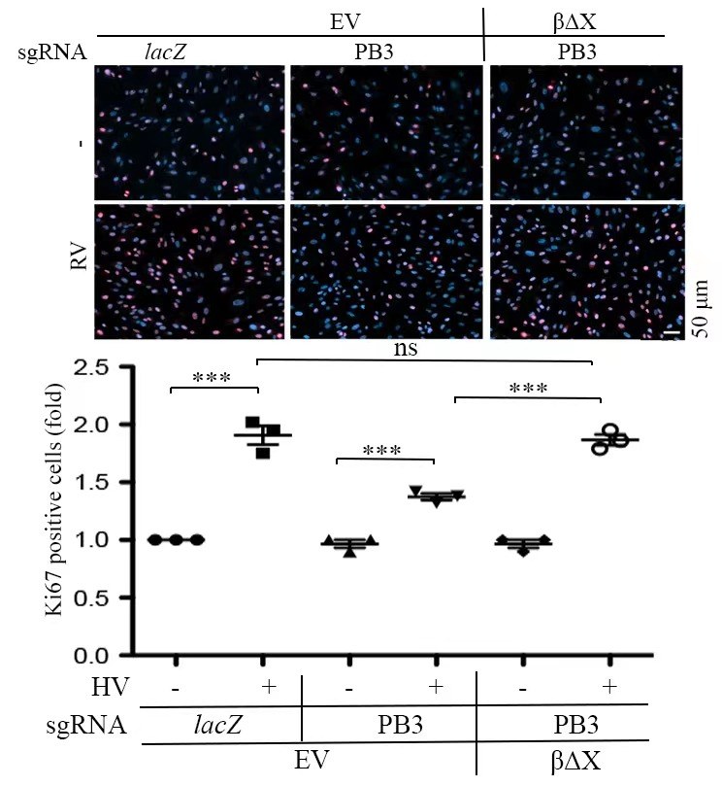
Supplemental Figure 1: Vitreous induces cell proliferation via the truncated PDGFRβ.
Characterized RPEM cells in 24-well plates were treated with DMEM/F12 or vitreous diluted in DMEM/F12 (1:3). 24 hours later, the cells were stained with Ki67 for analyzing proliferation. The top panel: representative images of Ki67 staining. Scale bar: 50μm; the bottom panel: Histogram of Ki67 expression ratio. The mean ± SD of three independent experiments is shown; *** denotes 0.001, using paired t test and ns stands for not significant. EV: Empty Vector (pLXSHD), βΔx: a truncated PDGFRβ lacking the PDGF-binding domain.

