Supplementary Material Legends
Supplementary Table 1: Test results of all items in paramedics group: comparison before vs. after education program.
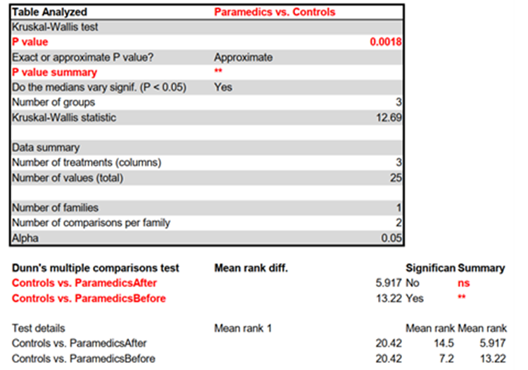

Supplementary Table 2: Test results of all items: comparison of control group with paramedics before and after education program.
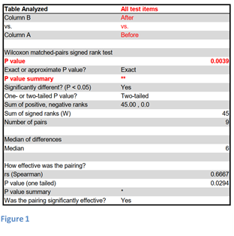

Supplementary Table 3: Test results of TCD interpretation items: comparison of control group with paramedics before and after education program.
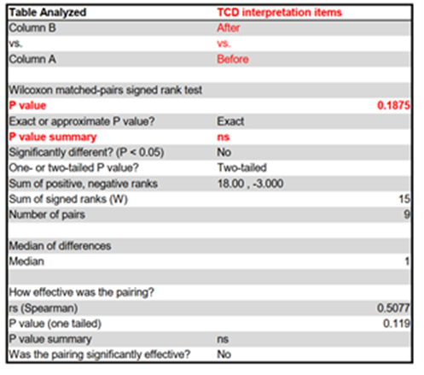

Supplementary Table 4: Test results of stroke pathophysiology items: comparison of control group with paramedics before and after education program.
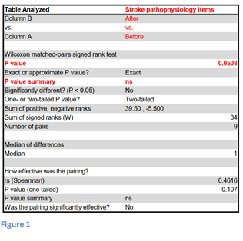

Supplementary Table 5: items Test results of preclinical stroke management items: comparison of control group with paramedics before and after education program.
