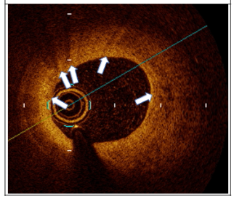
Figure S1: Macrophage Signal.
Macrophage signal accumulation was defined as high-intensity, signal-rich linear regions with sharp attenuation
Signals of macrophages were semi-quantitatively graded follows:
Grade 0, no macrophage;
Grade 1, localized macrophage accumulation;
Grade 2, clustered accumulation <1 quadrant;
Grade 3, clustered accumulation ≥1 quadrant but <3 quadrants;
Grade 4, clustered accumulation ≥3 quadrant.

