Appendix
Experimental Case 1
Experimental condition
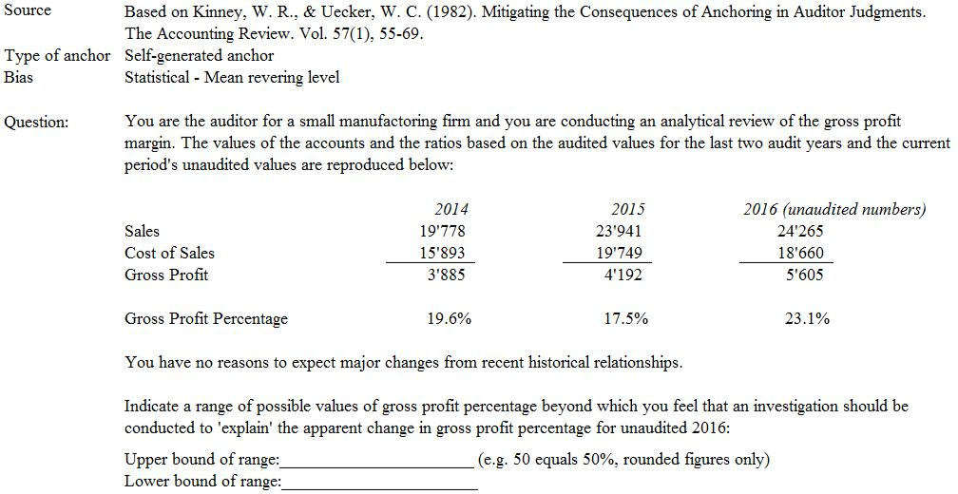

Control condition
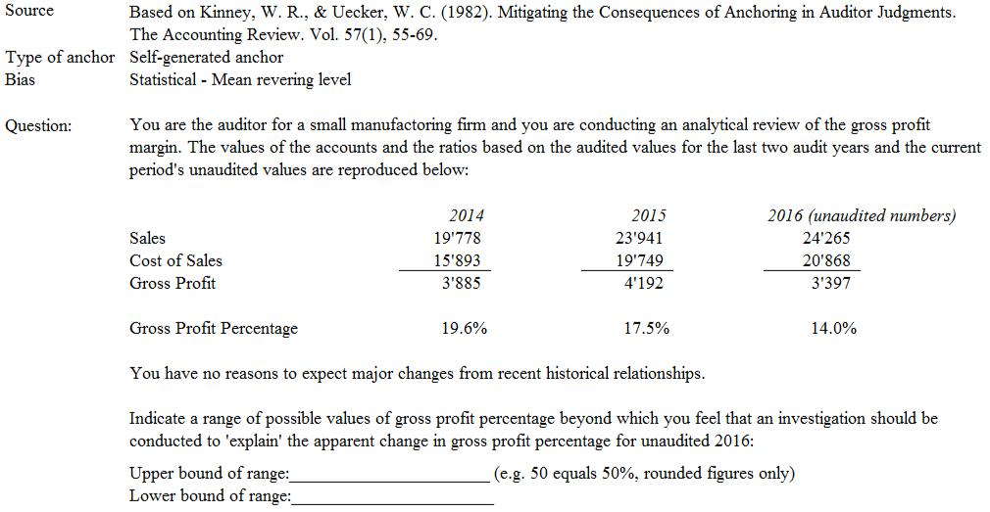

Experimental Case 2
Experimental condition
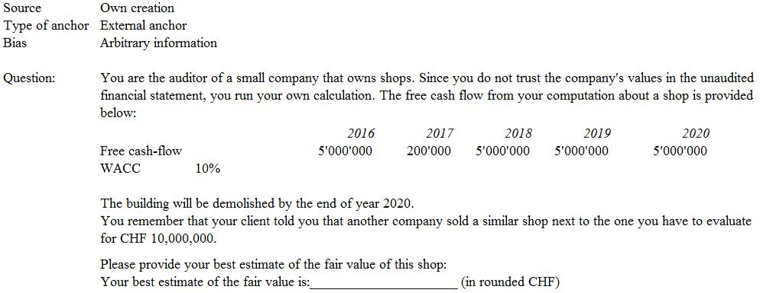

Control condition
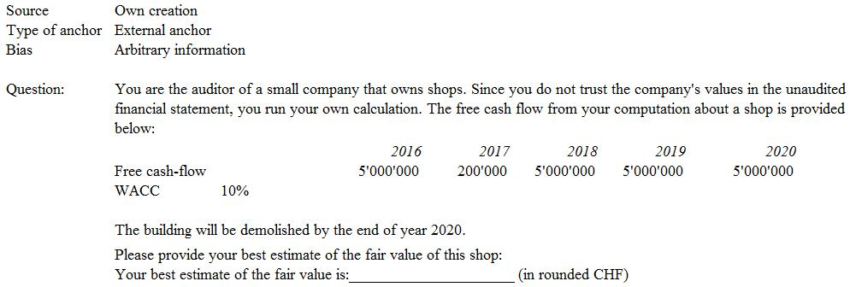
Experimental Case 3
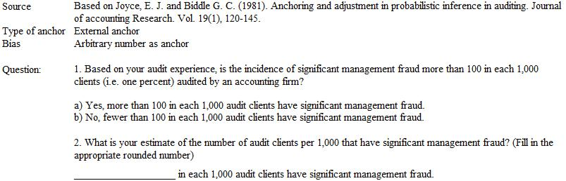
Experimental condition

Control condition
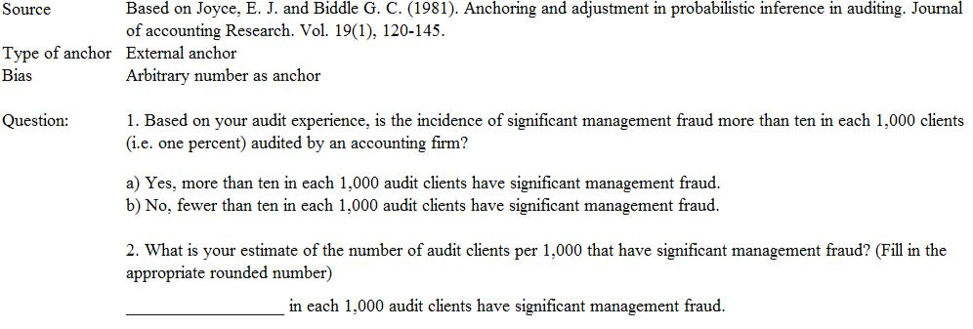
Experimental Case 4
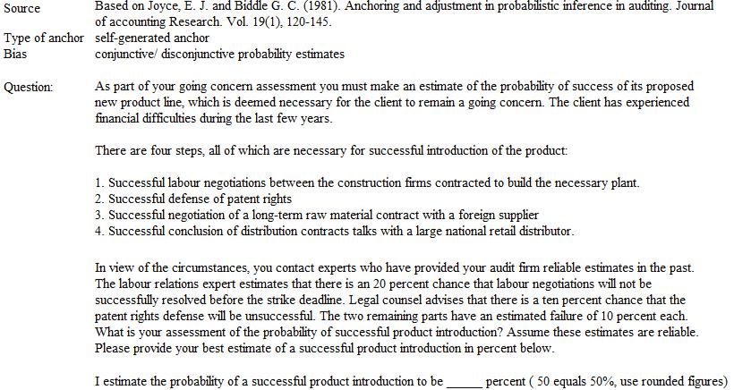
Experimental condition

Control condition
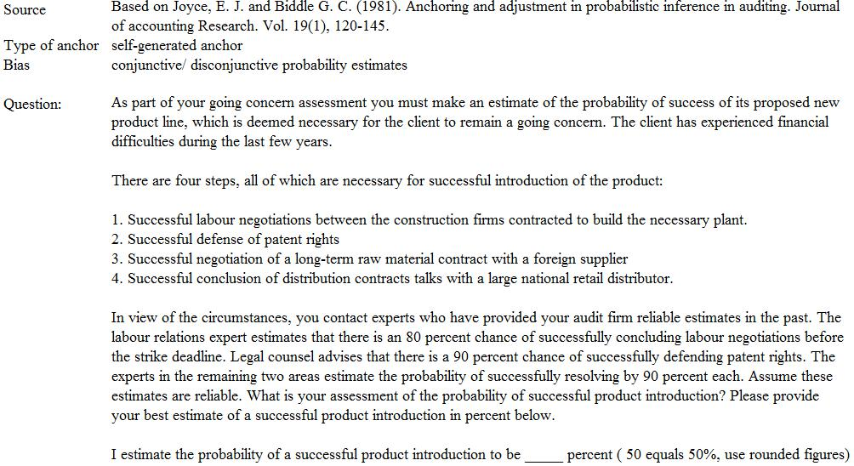
Experimental Case 5
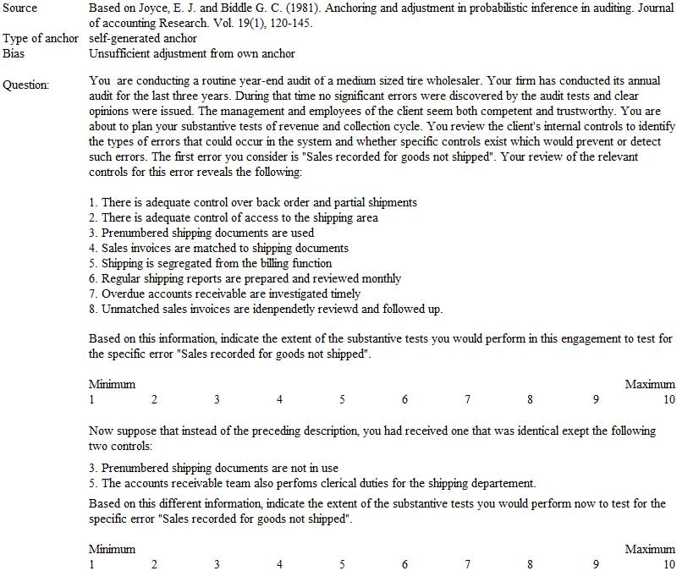
Experimental condition

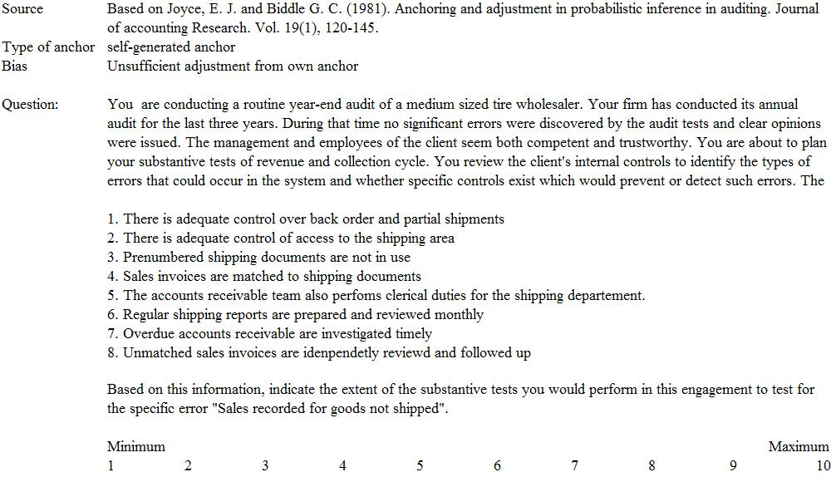
Control condition

Post Experimental Questions
Question 1: Have you ever been influenced by information received from the client that hindered you from judging objectively?
Question 1.1: If so, how often you think that did happen?
One time | Rarely | Sometimes | Often | Very often
1 time | 2-5 times | 6-15 times | 16-30 times | >30 times

Question 2: Have you ever felt unsure about how and what to do to complete your task?
Question 2.1: If so, did you make use of prior year audit work or files of similar clients in order to understand your task?
Question 2.2: If so, on a scale of 1 to 10, by how much have you been influenced by making use of prior year audit work or files of similar clients?
No influence |  |  |  |  |  |  |  |  | Highly influenced
1 | 2 | 3 | 4 | 5 | 6 | 7 | 8 | 9 | 10

Question 3: Have you ever encountered time or budget constraints that impeded appropriate client information assessment?
Question 3.1: If so, how often do you think that did happened?
One time | Rarely | Sometimes | Often | Very often
1 time | 2-5 times | 6-15 times | 16-30 times | >30 times

Question 3.2: On a scale of 1 to 10, how big is the difference that you have thereby come to a different conclusion?
No different |  |  |  |  |  |  |  |  | Totally different
1 | 2 | 3 | 4 | 5 | 6 | 7 | 8 | 9 | 10

Question 4: Sex
Age
Audit Firm
Position
Years of working experience in audit

