Supplementary materials:
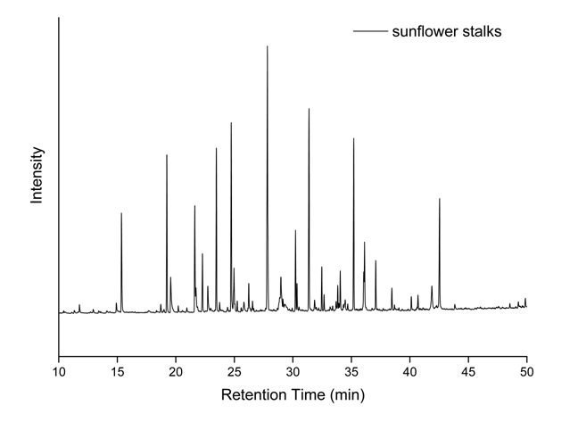
Figure S1: Soda-lignin from Sunflower stalks.
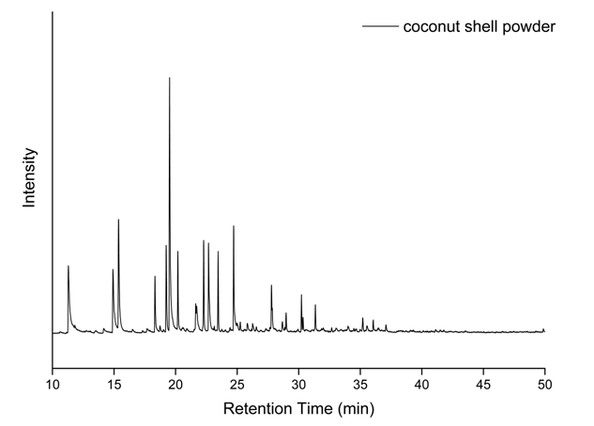
Figure S2: Soda-lignin from coconut shell powder.
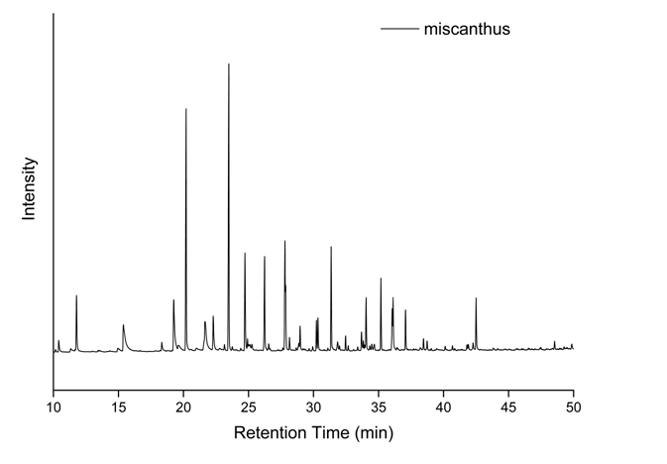
Figure S3: Soda-lignin from miscanthus.
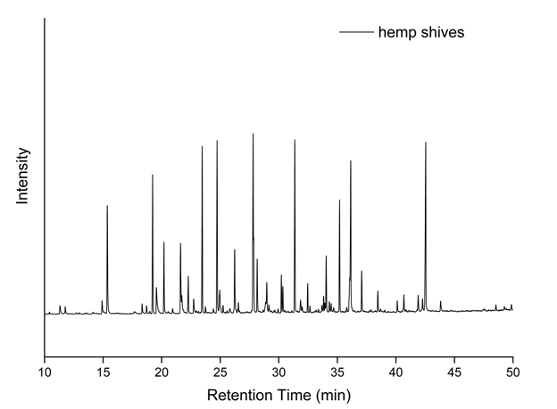
Figure S4: Soda-lignin from hemp shives.
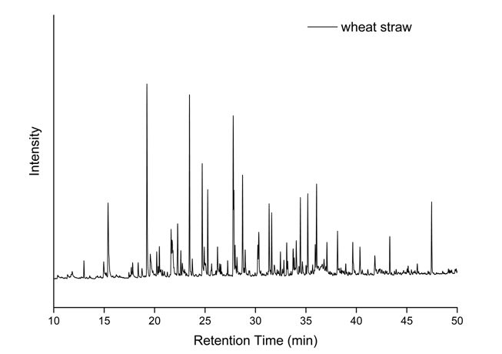
Figure S5: Soda-lignin from wheat straw.
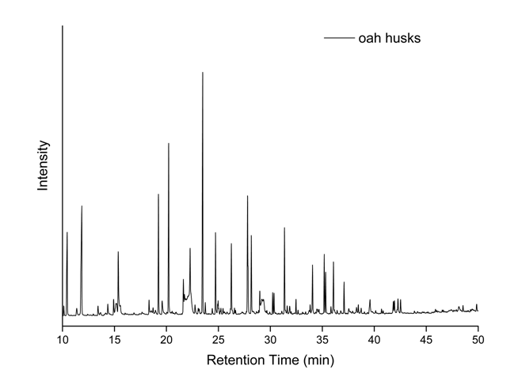
Figure S6: Soda-lignin from oat husks.
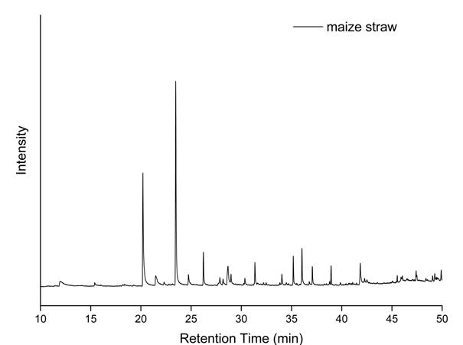
Figure S7: Soda-lignin from maize straw.
Table S1: Soda-lignin from Sunflower stalks.
Pyrolysis product | classification | Retention time
Phenol | H | 11,3
p-Cresol | H | 15,0
Phenol, 2-methoxy- | G | 15,4
Phenol, 4-ethyl | H | 18,3
Creosol | G | 19,3
Catechol | G | 19,6
Benzofuran, 2,3-dihydro | G | 20,2
3,5-Dimethoxytoluene | S | 20,9
1,2-Benzenediol, 3-methoxy- | S | 21,6
1,2-Benzenediol, 3-methyl | S | 21,7
Phenol, 4-ethyl-2-methoxy | G | 22,3
1,2-Benzenediol, 4-methyl | G | 22,7
p-Isopropenylphenol | H | 23,2
2-Methoxy-4-vinylphenol | G | 23,5
2-Methoxy-6-methylphenol | G | 23,7
Phenol, 4-(2-Propenyl) | H | 24,4
Phenol, 2,6-dimethoxy | S | 24,7
Eugenol | G | 24,9
Benzaldehyd, 4-hydroxy- | H | 25,1
Phenol, 4-propyl | H | 25,4
4-Ethylcatechol | G | 25,8
Vanillin | G | 26,2
3,5-Dimethoxy-4-hydroxytoluene | S | 27,8
trans-Isoeugenol | G | 27,9
Phenol, 2-methoxy-4-propyl | G | 28,2
Apocynin | G | 29,0
4-Methyl, 2,6-dimethoxybenzaldehyd | S | 29,6
Benzoic acid, 4-hydroxy-3-methoxy, methyl ester | G | 29,8
Benzoicacid, 4-hydroxy-3-methoxy | G | 29,9
5-tert-Butylpyrogallol | S | 30,2
2-Propanone, 1-(4-hydroxy-3-methoxyphenyl)- | G | 30,3
Homovannillicalcohol | G | 30,3
Benzoicacid, 4-hydroxy-3-propyl- | H | 31,9
Butyrovanillone | G | 32,0
Phenol, 2,6-dimethoxy-4-(2-propenyl)- | S | 32,5
Homovannilicacid | G | 33,7
(E)-2,6-Dimethoxy-4-(prop-1-en-1-yl)phenol | S | 33,8
Benzaldehyde, 4-hydroxy-3,5-dimethoxy | S | 34,0
7-Methoxybenzofuran-2-carboxylic acid | G | 34,4
4-Hydroxystilbene | H | 34,5
(E)-2,6-Dimethoxy-4-(prop-1-en-1-yl)phenol | S | 35,2
β-(4-Hydroxy-3-methoxyphenyl)propionic acid | G | 35,8
Coniferylaldehyde | G | 36,0
Ethanone, (1-(4-hydroxy-3,5-dimethoxyphenyl)- | S | 36,1
4-(1-Hydroxyallyl)-2-methoxyphenol | G | 36,1
4-((1E)-3-Hydroxy-1-propenyl)-2-methoxyphenol | G | 36,2
2-Propenoic acid, 3-(2,4-dimethoxyphenyl) | S | 36,6
3,5-Dimethoxy-4-hydroxyphenylacetic acid | S | 37,1
p-Coumaricacid | H | 37,5
4-Acetyl-2,6-dimethoxyphenyl acetate | S | 38.1
Benzoicacid, 4-hydroxy-3,5-dimethoxy-, | S | 38,3
2-Propenoic acid, 3-(4-hydroxy-3-methoxyphenyl)-, methylester | G | 38,7
4-(3-Hydroxypropyl)2,6-dimethoxyphenol | S | 40,1
3,5-Dimethioxy-4-hydroxy-cinnamalaldehyd | S | 42,3
trans-Sinapylalkohol | S | 42,5
4,4'-Methylenebis(2,6 dimethoxyphenol) | S | 46,5
(E)-1-(4-Hydroxy-3-methoxyphenyl)-dec-3-en-5-one | G | 49,9
Table S2: Soda-lignin from coconut shell powder.
RT (min) | Compound | CAS | Quality
15.3632 | Phenol, 2-methoxy- | 000090-05-1 | 94
19.2353 | Creosol | 000093-51-6 | 97
19.5605 | Catechol | 000120-80-9 | 97
21.6248 | 1,2-Benzenediol, 3-methoxy- | 000934-00-9 | 96
21.7186 | 1,2-Benzenediol, 3-methyl- | 000488-17-5 | 94
22.2816 | Phenol, 4-ethyl-2-methoxy- | 002785-89-9 | 91
22.7383 | 1,2-Benzenediol, 4-methyl- | 000452-86-8 | 96
23.4702 | 2-Methoxy-4-vinylphenol | 007786-61-0 | 91
24.74 | Phenol, 2,6-dimethoxy- | 000091-10-1 | 97
24.9715 | Eugenol | 002033-89-8 | 86
26.235 | Vanillin | 000621-59-0 | 97
27.8302 | 3,5-Dimethoxy-4-hydroxytoluene | 006638-05-7 | 94
28.9812 | Apocynin | 000498-02-2 | 96
30.2322 | 5-tert-Butylpyrogallol | 020481-17-8 | 72
30.3573 | 2-Propanone, 1-(4-hydroxy-3-methoxyphenyl)- | 002503-46-0 | 91
31.3832 | not identified
32.4717 | Phenol, 2,6-dimethoxy-4-(2-propenyl)- | 006627-88-9 | 99
33.8416 | (E)-2,6-Dimethoxy-4-(prop-1-en-1-yl)phenol | 020675-95-0 | 96
34.0543 | Benzaldehyde, 4-hydroxy-3,5-dimethoxy- | 000134-96-3 | 96
35.2053 | (E)-2,6-Dimethoxy-4-(prop-1-en-1-yl)phenol | 020675-95-0 | 97
36.056 | Ethanone, 1-(4-hydroxy-3,5-dimethoxyphenyl)- | 002478-38-8 | 98
36.1248 | (E)-4-(3-Hydroxyprop-1-en-1-yl)-2-methoxyphenol | 032811-40-8 | 80
37.0881 | 3,5-Dimethoxy-4-hydroxyphenylacetic acid | 004385-56-2 | 68
38.4643 | not identified
41.8798 | n-Hexadecanoicacid | 000057-10-3 | 99
42.5366 | trans-Sinapylalcohol | 020675-96-1 | 96
Table S3: Soda-lignin from miscanthus.
RT (min) | Compound | CAS | Quality
11.2974 | Phenol | 000108-95-2 | 91
14.9193 | Phenol, 2-methyl- | 000095-48-7 | 96
15.3697 | Phenol, 2-methoxy- | 000090-05-1 | 97
18.3285 | Phenol, 4-ethyl- | 000123-07-9 | 95
19.2418 | Creosol | 000093-51-6 | 97
19.517 | Catechol | 000120-80-9 | 97
20.1863 | Benzofuran, 2,3-dihydro- | 000496-16-2 | 83
21.6376 | 1,2-Benzenediol, 3-methoxy- | 000934-00-9 | 95
21.7127 | 1,2-Benzenediol, 3-methyl | 000488-17-5 | 86
22.2819 | Phenol, 4-ethyl-2-methoxy- | 002785-89-9 | 90
22.6822 | 1,2-Benzenediol, 4-methyl- | 000452-86-8 | 97
23.4579 | 2-Methoxy-4-vinylphenol | 007786-61-0 | 91
24.7152 | Phenol, 2,6-dimethoxy- | 000091-10-1 | 97
27.7929 | 3,5-Dimethoxy-4-hydroxytoluene | 006638-05-7 | 97
27.8555 | Phenol, 2-methoxy-4-(1-propenyl)- | 000097-54-1 | 98
28.9752 | Apocynin | 000498-02-2 | 97
30.2262 | Ethanone, 1-(2,6-dihydroxy-4-methoxyphenyl)- | 007507-89-3 | 59
30.3514 | 2-Propanone, 1-(4-hydroxy-3-methoxyphenyl)- | 002503-46-0 | 90
31.3522 | not identified
35.2055 | not identified
Table S4: Soda-lignin from hemp shives.
RT (min) | Compound | CAS | Quality
15.3883 | Phenol, 2-methoxy- | 000090-05-1 | 97
18.3409 | Phenol, 4-ethyl- | 000123-07-9 | 95
19.2541 | Creosol | 000093-51-6 | 97
19.6232 | Catechol | 000120-80-9 | 94
20.205 | Benzofuran, 2,3-dihydro- | 000496-16-2 | 87
21.6625 | 1,2-Benzenediol, 3-methoxy- | 000934-00-9 | 96
22.2943 | Phenol, 4-ethyl-2-methoxy- | 002785-89-9 | 91
23.1513 | p-Isopropenylphenol | 004286-23-1 | 94
23.489 | 2-Methoxy-4-vinylphenol | 007786-61-0 | 91
24.7339 | Phenol, 2,6-dimethoxy- | 000091-10-1 | 97
24.9278 | Phenol, 2-methoxy-3-(2-propenyl)- | 001941-12-4 | 98
25.0028 | Phenol, 3,4-dimethoxy- | 002033-89-8 | 76
25.1154 | Benzaldehyde, 3-hydroxy- | 000100-83-4 | 94
25.2593 | Phenol, 2-methoxy-4-propyl- | 002785-87-7 | 76
26.2352 | Benzaldehyde, 3-hydroxy-4-methoxy- | 000621-59-0 | 97
26.5604 | trans-Isoeugenol | 005932-68-3 | 98
27.8053 | 3,5-Dimethoxy-4-hydroxytoluene | 006638-05-7 | 95
27.8616 | Phenol, 2-methoxy-4-(1-propenyl)-, (Z)- | 005912-86-7 | 98
28.1556 | Phenol, 2-methoxy-4-propyl- | 002785-87-7 | 87
28.9688 | Apocynin | 000498-02-2 | 97
29.9446 | Benzoic acid, 4-hydroxy-3-methoxy-, methyl ester | 003943-74-6 | 93
30.2261 | 5-tert-Butylpyrogallol | 020481-17-8 | 72
30.345 | 2-Propanone, 1-(4-hydroxy-3-methoxyphenyl)- | 002503-46-0 | 91
31.3646 | not identified
31.8525 | benzoicacid, 4-hydroxy-3-propyl- | 1000404-83-5 | 64
32.0026 | Butyrovanillone | 064142-23-0 | 95
32.4718 | (E)-2,6-Dimethoxy-4-(prop-1-en-1-yl)phenol | 020675-95-0 | 98
33.3976 | 1,2-Dimethoxy-4-(2-methoxyethenyl)benzene | 1000313-34-2 | 72
33.6916 | Homovanillicacid | 000306-08-1 | 76
33.8355 | (E)-2,6-Dimethoxy-4-(prop-1-en-1-yl)phenol | 020675-95-0 | 97
33.9293 | 1,4-benzenediol, 2,5-dimethoxy- | 1000404-57-7 | 45
34.0482 | Benzaldehyde, 4-hydroxy-3,5-dimethoxy- | 000134-96-3 | 96
34.3296 | 4-((1E)-3-Hydroxy-1-propenyl)-2-methoxyphenol | 1000297-95-5 | 99
34.4798 | not identified
35.1866 | (E)-2,6-Dimethoxy-4-(prop-1-en-1-yl)phenol | 020675-95-0 | 97
36.0561 | Ethanone, 1-(4-hydroxy-3,5-dimethoxyphenyl)- | 002478-38-8 | 98
36.1187 | 4-((1E)-3-Hydroxy-1-propenyl)-2-methoxyphenol | 1000297-95-5 | 94
37.082 | 3,5-Dimethoxy-4-hydroxyphenylacetic acid | 004385-56-2 | 76
38.4644 | not identified
38.7397 | 2-Propenoic acid, 3-(4-hydroxy-3-methoxyphenyl)-, methyl ester | 002309-07-1 | 99
40.1284 | 5-(3-Hydroxypropyl)-2,3-dimethoxyphenol | 063543-12-4 | 83
40.6851 | trans-Sinapylalcohol | 020675-96-1 | 96
41.8048 | n-Hexadecanoicacid | 000057-10-3 | 99
42.274 | 3,5-Dimethoxy-4-hydroxycinnamaldehyde | 087345-53-7 | 98
42.5054 | trans-Sinapylalcohol | 020675-96-1 | 97
48.5419 | not identified
49.8618 | (E)-1-(4-Hydroxy-3-methoxyphenyl)dec-3-en-5-one | 863913-65-9 | 64
Table S5: Soda-lignin from wheat straw.
RT (min) | Compound | CAS | Quality
11.3161 | Phenol | 000108-95-2 | 91
14.9192 | p-Cresol | 000106-44-5 | 95
15.3633 | Phenol, 2-methoxy- | 000090-05-1 | 94
18.3346 | Phenol, 4-ethyl- | 000123-07-9 | 95
18.7162 | Phenol, 4-methoxy-3-methyl- | 014786-82-4 | 87
19.2291 | Creosol | 000093-51-6 | 97
19.5544 | Catechol | 000120-80-9 | 97
20.1987 | Benzofuran, 2,3-dihydro- | 000496-16-2 | 87
20.9431 | 3,4-Dimethoxytoluene | 000494-99-5 | 97
21.6187 | 1,2-Benzenediol, 3-methoxy- | 000934-00-9 | 96
21.7188 | 1,2-Benzenediol, 3-methyl- | 000488-17-5 | 94
22.2755 | Phenol, 4-ethyl-2-methoxy- | 002785-89-9 | 91
22.7321 | 1,2-Benzenediol, 4-methyl- | 000452-86-8 | 96
2.3464 | 2-Methoxy-4-vinylphenol | 007786-61-0 | 91
23.7455 | 3-Methoxy-5-methylphenol | 003209-13-0 | 98
24.7339 | Phenol, 2,6-dimethoxy- | 000091-10-1 | 97
24.9653 | Phenol, 3,4-dimethoxy- | 002033-89-8 | 87
25.2468 | Phenol, 2-methoxy-4-propyl- | 002785-87-7 | 87
26.2352 | Benzaldehyde, 3-hydroxy-4-methoxy- | 000621-59-0 | 97
26.5542 | trans-Isoeugenol
27.8115 | 3,5-Dimethoxy-4-hydroxytoluene | 006638-05-7 | 94
28.1618 | Phenol, 2-methoxy-4-propyl- | 002785-87-7 | 86
28.8875 | D-Allose | 002595-97-3 | 53
2.8975 | Apocynin | 000498-02-2 | 96
29.1564 | not identified
30.2198 | 5-tert-Butylpyrogallol | 020481-17-8 | 80
3.0345 | 2-Propanone, 1-(4-hydroxy-3-methoxyphenyl)- | 002503-46-0 | 91
31.3708 | not identified
31.8525 | benzoicacid, 4-hydroxy-3-propyl- | 1000404-83-5 | 68
32.0026 | Butyrovanillone | 064142-23-0 | 96
32.4655 | Phenol, 2,6-dimethoxy-4-(2-propenyl)- | 006627-88-9 | 98
32.6657 | 4-Propyl-1,1'-diphenyl | 010289-45-9 | 64
33.6916 | Benzenepropanol, 4-hydroxy-3-methoxy- | 002305-13-7 | 98
33.8355 | (E)-2,6-Dimethoxy-4-(prop-1-en-1-yl)phenol | 020675-95-0 | 98
33.9355 | 2,4,6,(1H,3H,5H)-Pyrimidinetrione, 5-acetyl- | 058713-02-3 | 49
34.0544 | Benzaldehyde, 4-hydroxy-3,5-dimethoxy- | 000134-96-3 | 96
34.3171 | 4-((1E)-3-Hydroxy-1-propenyl)-2-methoxyphenol | 1000297-95-5 | 98
35.1929 | (E)-2,6-Dimethoxy-4-(prop-1-en-1-yl)phenol | 020675-95-0 | 96
35.7997 | 2-Propanone, 1-hydroxy-3-(4-hydroxy-3-methoxyphenyl)- | 004899-74-5 | 90
36.0561 | Ethanone, 1-(4-hydroxy-3,5-dimethoxyphenyl)- | 002478-38-8 | 97
36.1437 | 4-(1-Hydroxyallyl)-2-methoxyphenol | 112465-50-6 | 83
3.7082 | 3,5-Dimethoxy-4-hydroxyphenylacetic acid | 004385-56-2 | 76
38.4582 | not identified
40.1159 | 4-(3-Hydroxypropyl)-2,3-dimethoxyphenol | 063543-12-4 | 83
40.6788 | trans-Sinapylalcohol | 020675-96-1 | 99
41.9049 | Benzeneacetic acid, .alpha.-phenyl-, methyl ester | 003469-00-9 | 64
4.2274 | 3,5-Dimethoxy-4-hydroxycinnamaldehyde | 087345-53-7 | 96
4.2543 | trans-Sinapylalcohol | 020675-96-1 | 96
49.8618 | Homovanillylalcohol | 002380-78-1 | 70
Table S6: Soda-lignin from oat husks.
RT (min) | Compound | CAS | Quality
14.9567 | p-Cresol | 000106-44-5 | 96
15.3883 | Phenol, 2-methoxy- | 000090-05-1 | 97
19.2416 | Creosol | 000093-51-6 | 97
19.5731 | Catechol | 000120-80-9 | 95
20.2112 | Benzofuran, 2,3-dihydro- | 000496-16-2 | 83
21.6374 | 1,2-Benzenediol, 3-methoxy- | 000934-00-9 | 96
21.725 | 1,2-Benzenediol, 3-methyl- | 000488-17-5 | 91
22.288 | Phenol, 4-ethyl-2-methoxy- | 002785-89-9 | 94
22.7571 | 1,2-Benzenediol, 4-methyl- | 000452-86-8 | 96
23.464 | 2-Methoxy-4-vinylphenol | 007786-61-0 | 91
23.7392 | 3-Methoxy-5-methylphenol | 003209-13-0 | 98
24.7213 | Phenol, 2,6-dimethoxy- | 000091-10-1 | 97
24.9278 | Eugenol | 000097-53-0 | 98
26.2414 | Vanillin | 000121-33-5 | 96
27.799 | 3,5-Dimethoxy-4-hydroxytoluene | 006638-05-7 | 95
27.8616 | trans-Isoeugenol | 005932-68-3 | 98
28.1681 | Phenol, 2-methoxy-4-propyl- | 002785-87-7 | 87
28.9812 | Apocynin | 000498-02-2 | 97
31.3583 | not identified
31.6085 | 3,5-Dimethoxy-4-hydroxytoluene | 006638-05-7 | 78
31.865 | 2,4'-Dihydroxy-3'-methoxyacetophenone | 018256-48-9 | 55
32.4718 | Phenol, 2,6-dimethoxy-4-(2-propenyl)- | 006627-88-9 | 98
33.0973 | Phenol, 2-methoxy-4-propyl- | 002785-87-7 | 86
33.7416 | Benzene, 1,2,3-trimethoxy-5-methyl- | 006443-69-2 | 49
33.8417 | (E)-2,6-Dimethoxy-4-(prop-1-en-1-yl)phenol | 020675-95-0 | 97
34.0481 | Benzaldehyde, 4-hydroxy-3,5-dimethoxy- | 000134-96-3 | 98
34.5549 | 4-Hydroxystilbene | 003839-46-1 | 43
35.0115 | 2-Propanone, 1-(4-hydroxy-3-methoxyphenyl)- | 002503-46-0 | 80
35.1866 | (E)-2,6-Dimethoxy-4-(prop-1-en-1-yl)phenol | 020675-95-0 | 98
35.6683 | Phenol, 2,6-dimethoxy-4-(2-propenyl)- | 006627-88-9 | 93
35.931 | 3,5-Dimethoxy-4-(acetyl)oxybenzaldehyde | 1000395-81-2 | 98
36.0561 | Ethanone, 1-(4-hydroxy-3,5-dimethoxyphenyl)- | 002478-38-8 | 98
36.8005 | Tetradecanoicacid | 000544-63-8 | 96
37.0883 | 3,5-Dimethoxy-4-hydroxyphenylacetic acid | 004385-56-2 | 70
38.1392 | 4-Acetyl-2,6-dimethoxyphenyl acetate | 1000385-76-7 | 95
38.9524 | not identified
41.8361 | n-Hexadecanoicacid | 000057-10-3 | 99
42.5167 | trans-Sinapylalcohol | 020675-96-1 | 97
46.046 | not identified
47.4597 | not identified
Table S7: Soda-lignin from maize straw.
RT (min) | Compound | CAS | Quality
10.4528 | not identified
11.8603 | not identified
14.9191 | p-Cresol | 000106-44-5 | 95
15.3695 | Phenol, 2-methoxy- | 000090-05-1 | 94
18.3346 | Phenol, 4-ethyl- | 000123-07-9 | 95
19.2354 | Creosol | 000093-51-6 | 97
20.2174 | Benzofuran, 2,3-dihydro- | 000496-16-2 | 87
21.6374 | 1,2-Benzenediol, 3-methoxy- | 000934-00-9 | 96
21.7375 | 1,2-Benzenediol, 3-methyl- | 000488-17-5 | 91
22.2817 | Phenol, 4-ethyl-2-methoxy- | 002785-89-9 | 87
23.4953 | 2-Methoxy-4-vinylphenol | 007786-61-0 | 91
24.7339 | Phenol, 2,6-dimethoxy- | 000091-10-1 | 97
26.2539 | Benzaldehyde, 3-hydroxy-4-methoxy- | 000621-59-0 | 97
27.8115 | 3,5-Dimethoxy-4-hydroxytoluene | 006638-05-7 | 94
28.1743 | Phenol, 2-methoxy-4-propyl- | 002785-87-7 | 78
28.9875 | Apocynin | 000498-02-2 | 96
30.2261 | not identified
30.3512 | 2-Propanone, 1-(4-hydroxy-3-methoxyphenyl)- | 002503-46-0 | 91
31.3646 | not identified
32.4718 | Phenol, 2,6-dimethoxy-4-(2-propenyl)- | 006627-88-9 | 98
34.0606 | Benzaldehyde, 4-hydroxy-3,5-dimethoxy- | 000134-96-3 | 98
35.1866 | (E)-2,6-Dimethoxy-4-(prop-1-en-1-yl)phenol | 020675-95-0 | 98
36.0811 | Ethanone, 1-(4-hydroxy-3,5-dimethoxyphenyl)- | 002478-38-8 | 97
37.0945 | 3,5-Dimethoxy-4-hydroxyphenylacetic acid | 004385-56-2 | 76
39.5966 | 2-Propenoic acid, 3-(4-hydroxy-3-methoxyphenyl)- | 001135-24-6 | 98
42.2802 | 3,5-Dimethoxy-4-hydroxycinnamaldehyde | 087345-53-7 | 97
Table S8: Soda-lignin from oat husks.
RT (min) | Compound | CAS | Quality
11.3108 | Phenol | 000108-95-2 | 94
14.973 | p-Cresol | 000106-44-5 | 91
20.1986 | Benzofuran, 2,3-dihydro- | 000496-16-2 | 87
23.4702 | 2-Methoxy-4-vinylphenol | 007786-61-0 | 91
24.74 | Phenol, 2,6-dimethoxy- | 000091-10-1 | 95
26.2225 | Benzaldehyde, 3-hydroxy-4-methoxy- | 000621-59-0 | 97
28.6747 | D-Allose | 002595-97-3 | 90
28.9749 | Apocynin | 000498-02-2 | 95
31.3582 | not identified
34.0418 | Benzaldehyde, 4-hydroxy-3,5-dimethoxy- | 000134-96-3 | 95
35.1803 | (E)-2,6-Dimethoxy-4-(prop-1-en-1-yl)phenol | 020675-95-0 | 98
36.0435 | Ethanone, 1-(4-hydroxy-3,5-dimethoxyphenyl)- | 002478-38-8 | 97
38.946 | not identified
41.8485 | n-Hexadecanoicacid | 000057-10-3 | 99
47.4096 | not identified
49.9004 | (E)-1-(4-Hydroxy-3-methoxyphenyl)dec-3-en-5-one | 863913-65-9 | 81

