Appendix

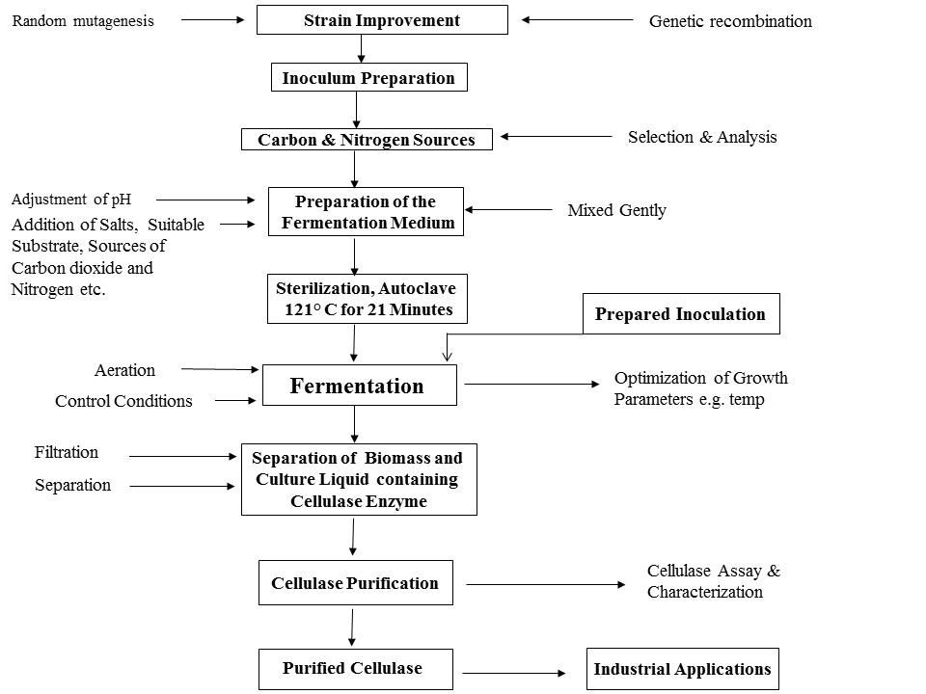

Figure 1: Flow sheet for biotechnological production of cellulase.

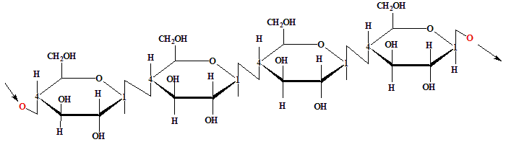

Figure 2: Diagram showing the β-1, 4 linkages of glucose units in cellulose.
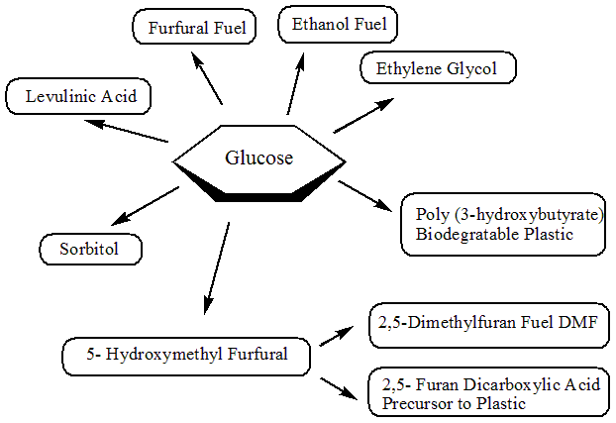

Figure 3: Fuels & chemicals derived from glucose.

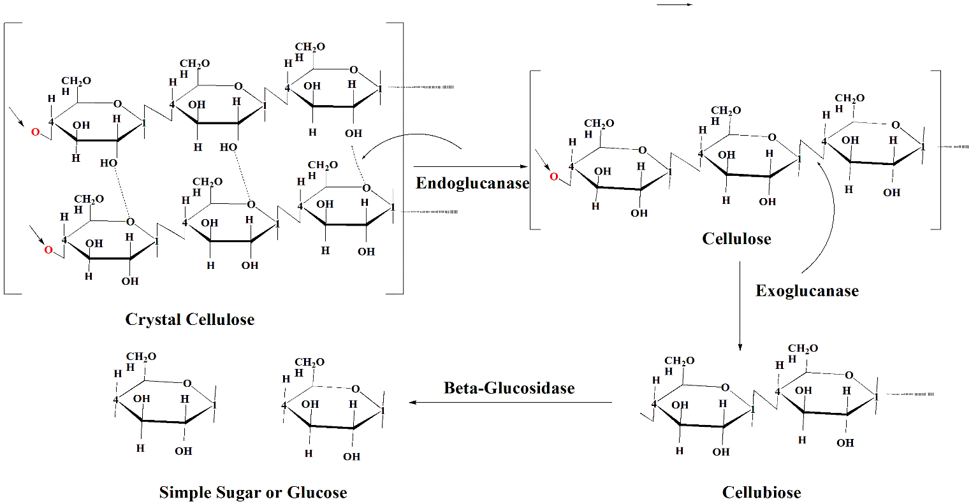

Figure 4: The hydrolysis mechanism of cellulose by cellulase.

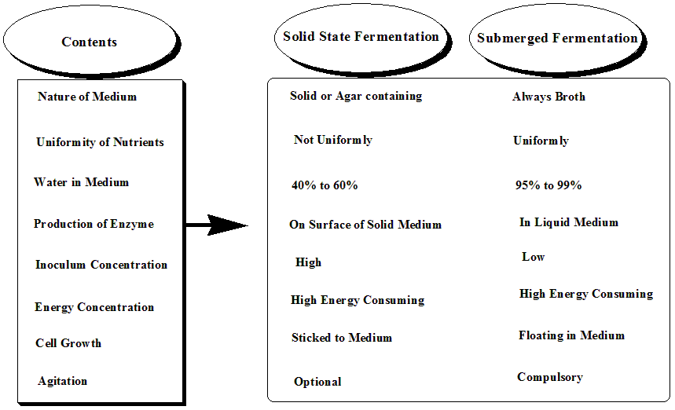

Figure 5: Comparison of physical and chemical conditions in solid state and submerged fermentation.

