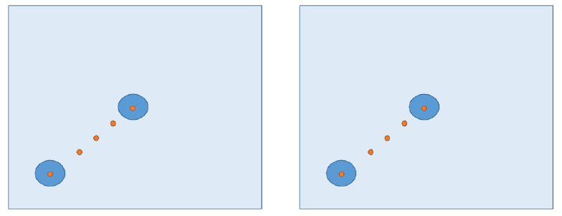

Supplementary Figure 1: Attenuation (dB) of the vibratory stimulus of two frequencies (2000 and 8000 Hz) after transmission by an acrylic plate and Petri dishes distributed on the plate. The air pressures from a loudspeaker reproducing an 80 dB signal-to-noise ratio sound of each pure frequency generated the vibrations in the acrylic plate when it was placed above the loudspeaker. Attenuation (in dB) was measured considering, as a reference, the vibratory intensity of the loudspeaker membrane. CPD: Central Petri Dish, Petri dish placed in the middle of the acrylic plate, EPD: Extreme Petri Dish, Petri dish placed at the edge of the acrylic plate (13 cm from the central point, A: Acrylic, CP: the central point of the acrylic plate. The red point indicates the points where the intensity of vibrations was measured in a diagonal line from the CP.

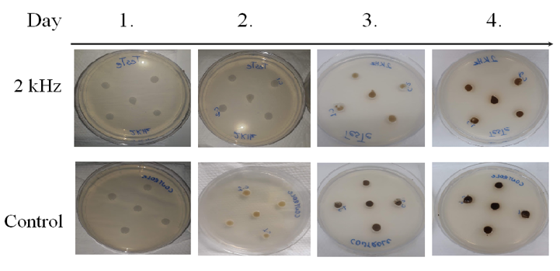
Supplementary Figure 2: C. neoformans melanization is slightly delayed by 2 kHz frequency. C. neoformans strain H99 cells were grown overnight and washed 3 times, and 10⁶ yeast were spotted on a solid minimal medium supplemented with L-DOPA. The colonies were followed visually for melanin production for 4 days. We observed that on the second day, in the control group, the melanin’s dark color started to accumulate, but not in the test group. By the fourth day, the plateau was reached and there was a slightly darker color in the control colonies compared to the 2 kHz group.

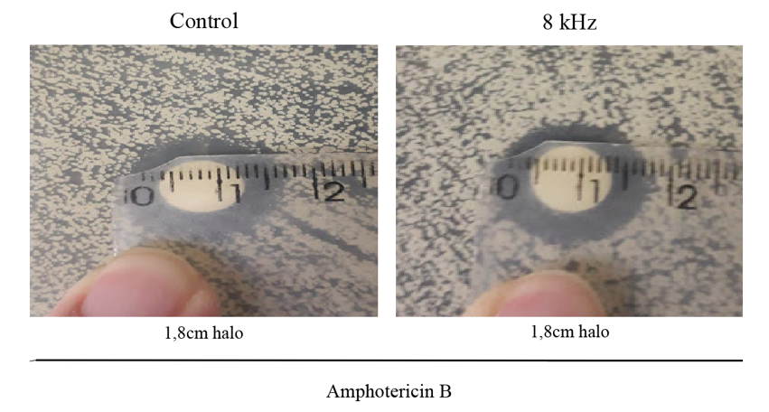
Supplementary Figure 3: Amphotericin B disk diffusion halo assays. Disks containing Amphotericin B were placed over the solidified top agar. Cells were incubated for 48 h at 37ºC. The 8 kHz frequency did not present a difference between the inhibition haloes (A-1.8 cm; B-1.8 cm).

