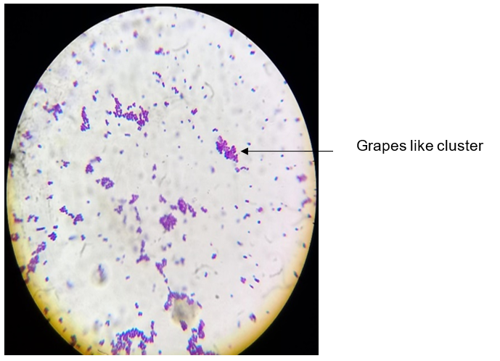
Figure S1: Morphological characteristics of Staphylococcus haemolyticus via Gram’s Staining method (100x).

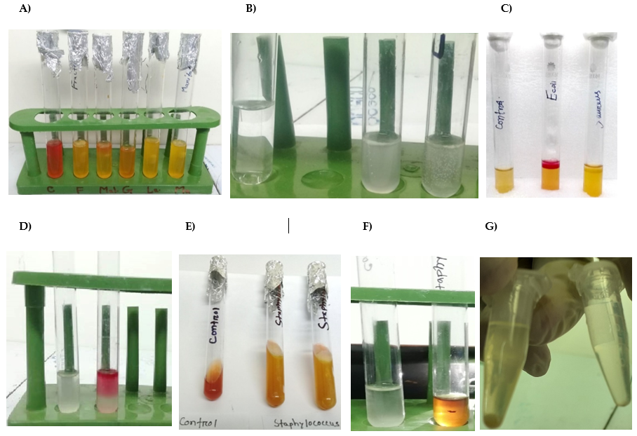
Figure S2: Biochemical characterization of Staphylococcus haemolyticus isolated from urine samples of patients with UTI using different tests. Almost all the Staphylococcus haemolyticus isolates A) fermented dextrose, maltose, lactose, sucrose and mannitol with acid production but no gas production, B) Catalase positive, C) Indole negative, D) Methyl Red positive, E) Yellow slant and butt with gas were noted in reactions in TSI agar slant, F) VP test positive (Development of bright orange color), G) Coagulase negative.
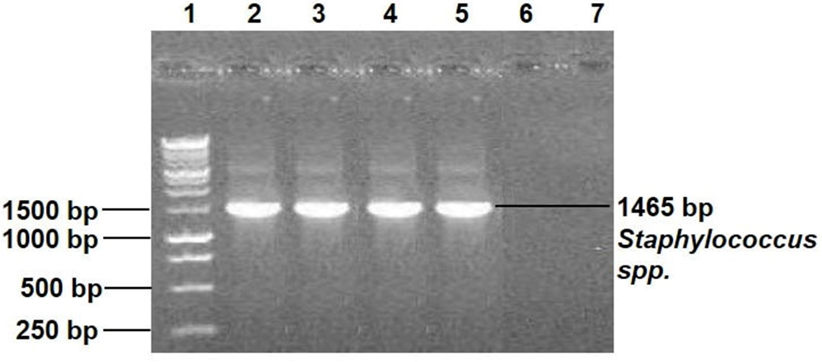
Figure S3: PCR amplification of the 16S rRNA gene of Staphylococcus haemolyticus. Representative amplified PCR products of 16S rRNA gene in 1.5% agarose gel. 16S rRNA gene present in all the samples (Lane 2-5) except the water (Lane 6) and negative control (Lane 7). 1 kb DNA ladder was used for comparison (Lane 1).

Figure S4: Phylogenetic tree of the 16S rRNAs of various bacterial species indicating the isolate in this study belonged to the species Staphylococcus haemolyticus.

