**Electronic Supplementary Material:**

**Interaction of *Pseudobombax marginatum* Robyns Stem Bark Extract on The Cell Surface of *Bacillus cereus* and *Staphylococcus aureus***

**Santos ECG1*, Donnici CL2,Camargos ERS3, Araújo-Silva G4,Xavier-Junior FH5,Farias LM6,Corrêa LA2, Luz JRD1,Carvalho MAR6 and Almeida MG4**

**1** Postgraduate program in Health Sciences, Federal University of Rio Grande do Norte, Brazil

**2** Department of Chemistry, Federal University of Minas Gerais, Brazil

**3** Department of Morphology and Microscopy Center, Federal University of Minas Gerais, Brazil

**4** Department of Clinical and Toxicological Analysis, Federal University of Rio Grande do Norte, Brazil

**5** Department of Pharmacy, Federal University of Rio Grande do Norte, Brazil

**6** Department of Microbiology Federal University of Minas Gerais, Brazil

**\*Corresponding author:** Santos ECG, Postgraduate program in Health Sciences, Federal University of Rio Grande do Norte, Brazil

**Supplementary Data**

**Figure S1:** Electrophoretic profiles of *B*. *cereus* and *S*. *aureus* proteins treated with HAEPMB and BF, for 24h.

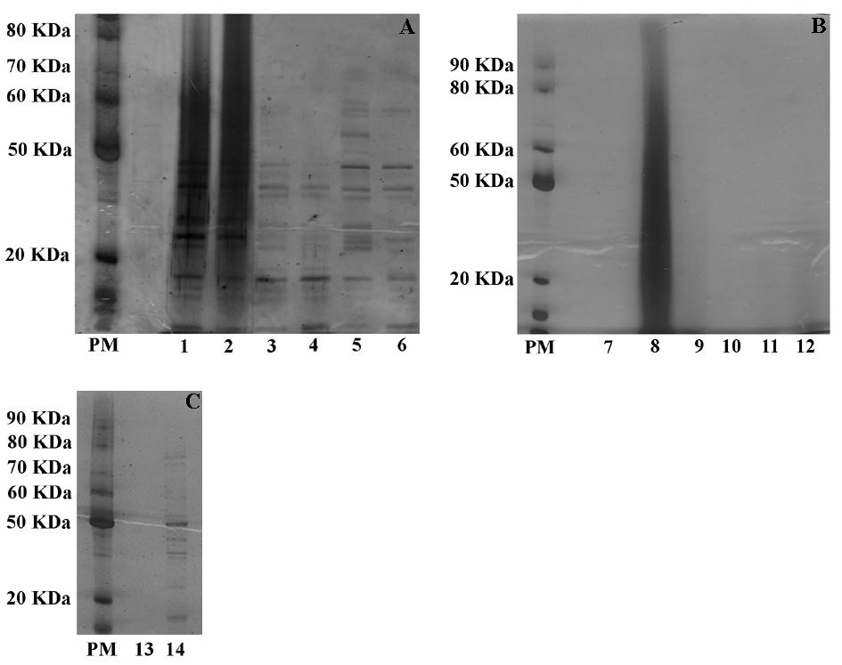

*B*. *cereus* treated with HAEPMB at 0.5mg/mL and 1.0mg/mL (lines 1-2), BF at 0.512mg/mL and 1.024mg/mL (lines 3-4), 4mg/mL vancomycin (line 5), and 6.4mM SDS (line 6) (A); *S*. *aureus* treated with HAEPMB at 0.5mg/mL, 1.0mg/mL and 2.0mg/mL (lines 7-9), and BF at 0.512mg/mL, 1.024mg/mL and 2.048mg/mL (lines 10-12) (B); *S*. *aureus* treated with 0.5mg/mL vancomycin (line 13) and 6.4mM SDS (line 14) (C). PM: Protein Marker.

**Figure** **S2:** Infrared (IR) absorption spectrum of HAEPMB.



IR (KBr) υmax cm-1: 3600-3100, 2960, 2930, 1605, 1519, 1442, 1350, 1281, 1205, 1152, 1105, 1067, 905, 857, 818, 780-770.

**Figure** **S3:** Fingerprint of the HAEPMB.

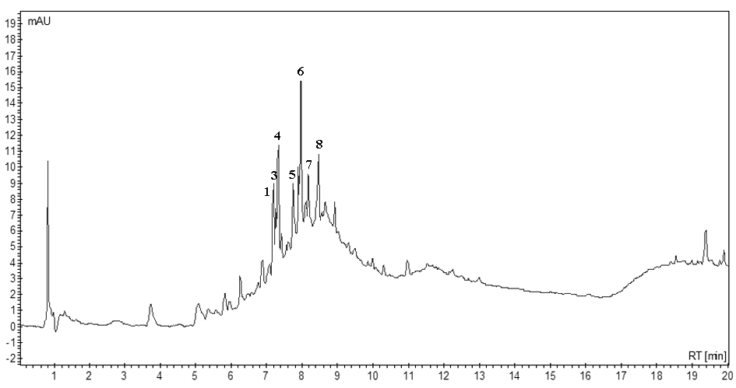

**Figure S4:** Fingerprint of the butanolic fraction.

