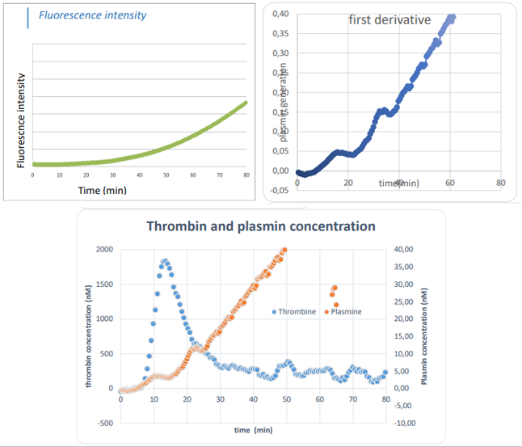
Figure S1: Descriptive SGTPA technical validation.

