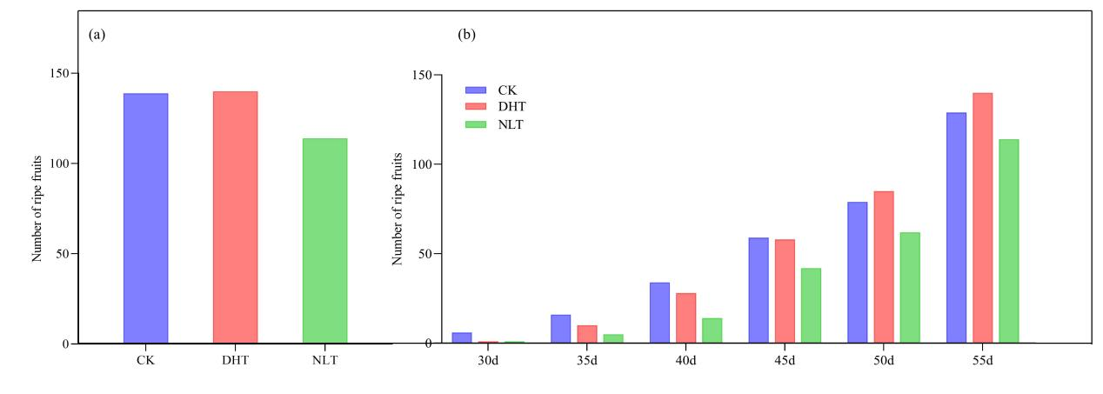
Supplementary Figure 1: Changes in the yield of strawberry fruit after three sets of temperature treatments. (a) After three groups of temperature treatment, the number of all mature strawberry fruits was counted; (b) After three groups of temperature treatment, strawberry fruits were collected at 30,35,40,45,50 and 55 days after treatment, and the number of mature fruits was counted. The mean ± SD was calculated by 3 independent experiments and 10 biological replicates. ANOVA test (*P<0.05, **P<0.01, P***<0.001) was used to evaluate the significant difference.

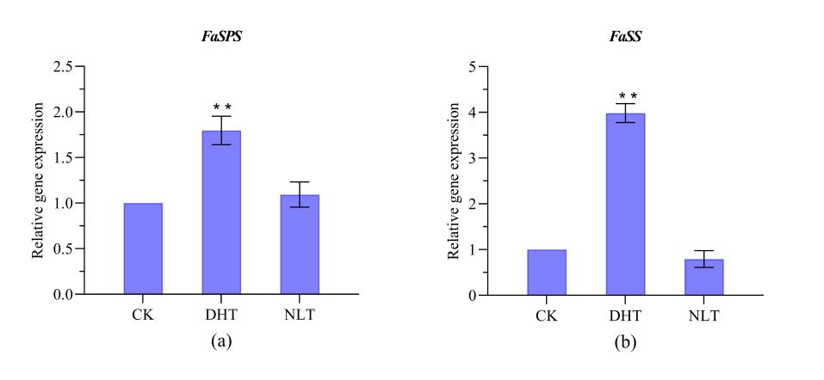
Supplementary Figure 2: RT-PCR was used to analyze the transcription levels of sucrose metabolism-related genes in mature fruits of leaves under different temperature treatments. Abbreviation: Fa SPS, Fa SS, DHT, NTL and CK, * and * * were significantly different from CK at P < 0.05 and P < 0.01 levels, respectively. Each point represents the mean ± SE of three biological replicates. Based on single factor ANOVE analysis.

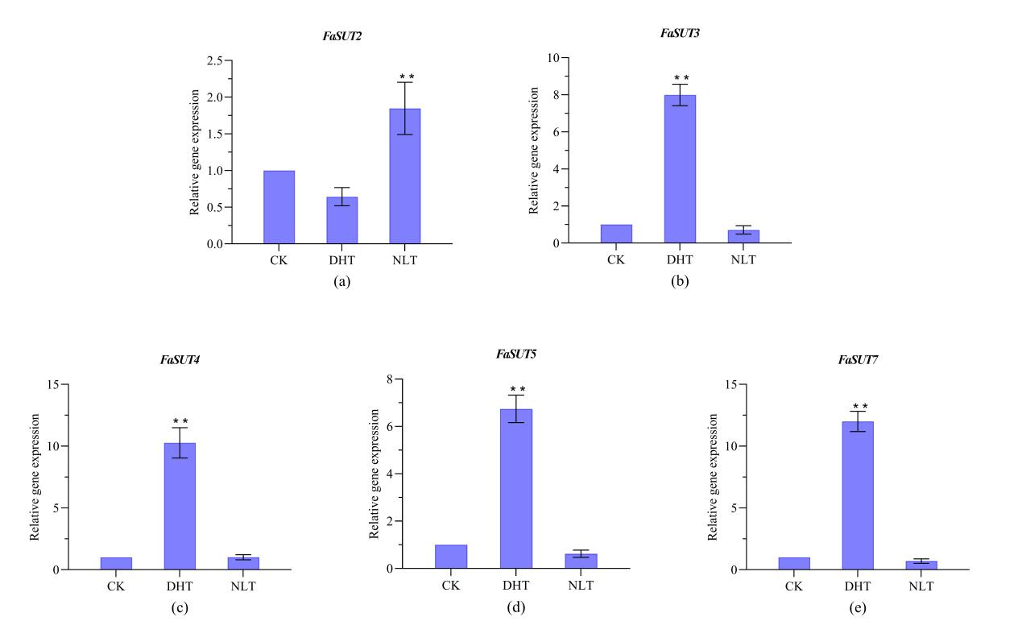
Supplementary Figure 3: RT-PCR was used to analyze the transcription levels of sucrose metabolism-related genes in mature fruits of leaves under different temperature treatments. Abbreviations: Fa SUT2, Fa SUT3, Fa SUT4, Fa SUT7, DHT, NTL and CK, * and * * indicated significant differences from CK at P<0.05 and P<0.01 levels, respectively. Each point represents the mean ± SE of three biological replicates. Based on single factor ANOVE analysis.

