PMMoV-HP1(KJ631123.1) -----S---------------------------N---TQ-------Q---
PMMoV-17.1(MK746126) -----S---------------------------D---TQ-------Q---
PMMoV-Huludao(MG515725.1) -----S---------------------------N---TQ-------Q---
PMMoV-J47(KX399389.1) -----S---------------------------N---TQ-------Q---
PMMoV-pMG(KX063611.1)-P12 -----S---------------------------N---TQ-------Q---
PMMoV-C1421(AB069853.1) -----S---------------------------N---TQ-------Q---
PMMoV-16.10(MK746122) -----S---------------------------N---TQ-------Q---
PMMoV-VE(KU312319.1) -----S---------------------------N---TQ-------Q---
PMMoV-17.3(MK746128) -----S---------------------------N---TQ-------Q---
PMMoV-Is(EF434393.1)-P12 -----S---------------------------N---TQ-------Q---
PMMoV-17.2(MK746127) -----S---------------------------N---TQ-------Q---
PMMoV(LC082099.1)-P12 -----S---------------------------N---TQ-------Q---
PMMoV-16.1(MK746113) -----S---------------------------N---TQ-------Q---
PMMoV-16.2(MK746114) -----S---------------------------N---TQ-------Q---
PMMoV-16.3(MK746115) -----S---------------------------N---TQ-------Q---
PMMoV-16.12(MK746124) -----S---------------------------N---TQ-------Q---
PMMoV-16.14(MK746125) -----S---------------------------N---TQ-------Q---
PMMoV-16.9(MK746121) -----S---------------------------N---TQ-------Q---
PMMoV-16.11(MK746123) -----S---------------------------N---TQ-------Q---
PMMoV-16.7(MK746119) -----S---------------------------N---TQ-------Q---
PMMoV-16.8(MK746120) -----S---------------------------N---TQ-------Q---
PMMoV-16.4(MK746116) -----S---------------------------N---TQ-------Q---
PMMoV-16.5(MK746117) -----S---------------------------N---TQ-------Q---
PMMoV-BL21(MH063882.1) -----S---------------------------N---TQ-------Q---
PMMoV-L4BV(AB276030.1)-P1234 -----S---------------------------N---TQ-------R---
PMMoV-16.6(MK746118) -----S---------------------------N---TQ-------Q---
PMMoV-TRF1(HE963027.1)-P123 -----T---------------------------N---SQ-------Q---
PMMoV-Is(EF432637.1)-P123 -----T---------------------------N---TQ-------L---
PMMoV(AJ308228.1)-P123 -----T---------------------------N---TQ-------Q---
PMMoV-TRF5(HE963026.1)-P123 -----T---------------------------N---TQ-------Q---
PMMoV(EF422083.1)-P1234 -----T---------------------------N---TQ-------Q---
PMMoV-TRF2(HE963028.1)-P123 -----T---------------------------N---TH-------Q---
*****:***************************:***::******* ***

PMMoV-HP1(KJ631123.1) ----------V-----------------------LGA---R---------
PMMoV-17.1(MK746126) ----------V-----------------------LGA---R---------
PMMoV-Huludao(MG515725.1) ----------V-----------------------LGA---R---------
PMMoV-J47(KX399389.1) ----------V-----------------------LGA---R---------
PMMoV-pMG(KX063611.1)-P12 ----------V-----------------------LGA---R---------
PMMoV-C1421(AB069853.1) ----------V-----------------------LGA---R---------
PMMoV-16.10(MK746122) ----------V-----------------------LGA---K---------
PMMoV-VE(KU312319.1) ----------V-----------------------LGA---R---------
PMMoV-17.3(MK746128) ----------V-----------------------LGA---R---------
PMMoV-Is(EF434393.1)-P12 ----------V-----------------------LGA---R---------
PMMoV-17.2(MK746127) ----------V-----------------------LGA---R---------
PMMoV(LC082099.1)-P12 ----------V-----------------------LGA---R---------
PMMoV-16.1(MK746113) ----------V-----------------------LGA---R---------
PMMoV-16.2(MK746114) ----------V-----------------------LGA---R---------
PMMoV-16.3(MK746115) ----------V-----------------------LGA---R---------
PMMoV-16.12(MK746124) ----------V-----------------------LGA---R---------
PMMoV-16.14(MK746125) ----------V-----------------------LGA---R---------
PMMoV-16.9(MK746121) ----------V-----------------------LGA---R---------
PMMoV-16.11(MK746123) ----------V-----------------------LGA---R---------
PMMoV-16.7(MK746119) ----------V-----------------------LGA---R---------
PMMoV-16.8(MK746120) ----------V-----------------------LGA---R---------
PMMoV-16.4(MK746116) ----------V-----------------------LGA---R---------
PMMoV-16.5(MK746117) ----------V-----------------------LGA---R---------
PMMoV-BL21(MH063882.1) ----------V-----------------------LGA---R---------
PMMoV-L4BV(AB276030.1)-P1234 ----------V-----------------------LKA---R---------
PMMoV-16.6(MK746118) ----------V-----------------------LGA---R---------
PMMoV-TRF1(HE963027.1)-P123 ----------V-----------------------LGA---R---------
PMMoV-Is(EF432637.1)-P123 ----------V-----------------------LGA---R---------
PMMoV(AJ308228.1)-P123 ----------I-----------------------LGA---R---------
PMMoV-TRF5(HE963026.1)-P123 ----------V-----------------------LGA---R---------
PMMoV(EF422083.1)-P1234 ----------V-----------------------LGG---R---------
PMMoV-TRF2(HE963028.1)-P123 ----------V-----------------------FGP---R---------
**********:***********************: ***:*********

PMMoV-HP1(KJ631123.1) ----T-------------TV---------M---V----MY---L-E-A--
PMMoV-17.1(MK746126) ----T-------------TV---------M---V----MY---L-E-A--
PMMoV-Huludao(MG515725.1) ----T-------------TV---------M---V----MY---L-E-A--
PMMoV-J47(KX399389.1) ----T-------------TV---------M---V----MY---L-E-A--
PMMoV-pMG(KX063611.1)-P12 ----T-------------TV---------M---V----MY---L-E-A--
PMMoV-C1421(AB069853.1) ----T-------------TV---------M---V----MY---L-E-A--
PMMoV-16.10(MK746122) ----T-------------TV---------M---V----MY---L-E-A--
PMMoV-VE(KU312319.1) ----T-------------TV---------M---V----MY---L-E-A--
PMMoV-17.3(MK746128) ----T-------------TV---------M---V----MY---L-E-A--
PMMoV-Is(EF434393.1)-P12 ----T-------------TV---------M---V----MY---L-E-A--
PMMoV-17.2(MK746127) ----T-------------TV---------M---V----MY---L-E-A--
PMMoV(LC082099.1)-P12 ----T-------------TV---------M---V----MY---L-E-A--
PMMoV-16.1(MK746113) ----T-------------TV---------M---V----MY---L-E-A--
PMMoV-16.2(MK746114) ----T-------------TV---------M---V----MY---L-E-A--
PMMoV-16.3(MK746115) ----T-------------TV---------M---V----MY---L-E-A--
PMMoV-16.12(MK746124) ----T-------------TV---------M---V----MY---L-E-A--
PMMoV-16.14(MK746125) ----T-------------TV---------M---V----MY---L-E-A--
PMMoV-16.9(MK746121) ----T-------------TV---------M---V----MY---L-E-A--
PMMoV-16.11(MK746123) ----T-------------TV---------M---V----MY---L-E-A--
PMMoV-16.7(MK746119) ----T-------------TV---------M---V----MY---L-E-A--
PMMoV-16.8(MK746120) ----T-------------TV---------M---V----MY---L-E-A--
PMMoV-16.4(MK746116) ----T-------------TV---------M---V----MY---L-E-A--
PMMoV-16.5(MK746117) ----T-------------TV---------M---V----MY---L-E-A--
PMMoV-BL21(MH063882.1) ----T-------------TV---------M---V----MY---L-E-A--
PMMoV-L4BV(AB276030.1)-P1234 ----T-------------TV---------M---V----MY---L-E-A--
PMMoV-16.6(MK746118) ----A-------------TV---------M---V----MY---L-E-A--
PMMoV-TRF1(HE963027.1)-P123 ----S-------------TL---------M---V----NY---L-E-V--
PMMoV-Is(EF432637.1)-P123 ----T-------------TV---------M---V----NY---L-E-V--
PMMoV(AJ308228.1)-P123 ----T-------------TV---------M---A----NY---L-E-V--
PMMoV-TRF5(HE963026.1)-P123 ----T-------------TV---------M---V----NY---L-E-V--
PMMoV(EF422083.1)-P1234 ----T-------------TV---------M---V----NY---L-E-V--
PMMoV-TRF2(HE963028.1)-P123 ----T-------------PV---------R---V----NS---W-G-V--
****:*************.:********* ***.**** *** * *.**

PMMoV-HP1(KJ631123.1) -----T-
PMMoV-17.1(MK746126) -----T-
PMMoV-Huludao(MG515725.1) -----T-
PMMoV-J47(KX399389.1) -----T-
PMMoV-pMG(KX063611.1)-P12 -----T-
PMMoV-C1421(AB069853.1) -----T-
PMMoV-16.10(MK746122) -----T-
PMMoV-VE(KU312319.1) -----T-
PMMoV-17.3(MK746128) -----T-
PMMoV-Is(EF434393.1)-P12 -----T-
PMMoV-17.2(MK746127) -----T-
PMMoV(LC082099.1)-P12 -----T-
PMMoV-16.1(MK746113) -----T-
PMMoV-16.2(MK746114) -----T-
PMMoV-16.3(MK746115) -----T-
PMMoV-16.12(MK746124) -----T-
PMMoV-16.14(MK746125) -----T-
PMMoV-16.9(MK746121) -----T-
PMMoV-16.11(MK746123) -----T-
PMMoV-16.7(MK746119) -----T-
PMMoV-16.8(MK746120) -----T-
PMMoV-16.4(MK746116) -----T-
PMMoV-16.5(MK746117) -----T-
PMMoV-BL21(MH063882.1) -----T-
PMMoV-L4BV(AB276030.1)-P1234 -----T-
PMMoV-16.6(MK746118) -----T-
PMMoV-TRF1(HE963027.1)-P123 -----T-
PMMoV-Is(EF432637.1)-P123 -----T-
PMMoV(AJ308228.1)-P123 -----T-
PMMoV-TRF5(HE963026.1)-P123 -----T-
PMMoV(EF422083.1)-P1234 -----T-
PMMoV-TRF2(HE963028.1)-P123 -----T-
*******

Figure S1: Multiple alignment of amino acid sequence of CP gene of present isolates along with the P₁₂, P₁₂₃ and P₁₂₃₄ PMMoV pathotypes avalaible at NCBI database.

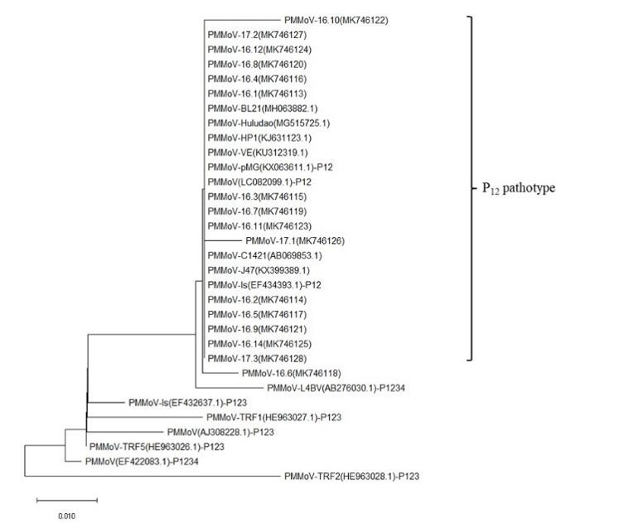
Figure S2: Phylogenetic tree constructed using amino acid sequences of PMMoV-CP of present isolates along with P₁₂, P₁₂₃ and P₁₂₃₄ PMMoV pathotypes.

Table S1: Detection of PMMoV through DAS-ELISA in diseased samples collected from different areas of H.P.
S.No. | District | Total Number of samples | No. of positive samples | Absorbance at 405nm of positive samples | No. of negative samples | Absorbance at 405nm of negative samples | Percentage of Positive Samples (%)
1 | Kangra | 22 | 6 | 0.6228-1.0973 | 16 | 0.1726-0.3456 | 27.28
2 | Bilaspur | 11 | 7 | 0.8205-2.4714 | 4 | 0.3241-0.4001 | 63.64
3 | Hamirpur | 14 | 6 | 2.0320-3.8912 | 8 | 0.2618-0.4104 | 42.86
4 | Kullu | 18 | 16 | 1.6854-2.1983 | 2 | 0.1365-0.1709 | 88.89
5 | Mandi | 14 | 11 | 0.6675-1.1107 | 3 | 0.2101-0.3947 | 78.57
6 | Shimla | 12 | 8 | 0.7273-0.7793 | 4 | 0.1326-0.1655 | 66.67
7 | Solan | 6 | 0 | - | 6 | 0.1293-0.1949 | 0
Total |  | 97 | 54 |  | 43

Table S2: Different isolates and their place of collection along with accession number included in the present study
S.No. | District | Location | Crop and Situation | Designation of Isolates | Accession Number
1 | Mandi | Satoh-1, Rajgarh | Capsicum (Polyhouse) | PMMoV-16.1 | MK746113
2 | Mandi | Satoh-2, Rajgarh | Capsicum (Polyhouse) | PMMoV-16.4 | MK746116
3 | Mandi | Dodhwan-1, Sundernagar | Capsicum (Polyhouse) | PMMoV-16.5 | MK746117
4 | Mandi | Dodhwan-2, Sundernagar | Capsicum (Polyhouse) | PMMoV-16.7 | MK746119
5 | Mandi | Kalohad,Sundernagar | Capsicum (Polyhouse) | PMMoV-16.8 | MK746120
6 | Kullu | Shamshi | Capsicum (Polyhouse) | PMMoV-16.2 | MK746114
7 | Kullu | Nagwain-1, Bajuara | Capsicum (Polyhouse) | PMMoV-16.6 | MK746118
8 | Kullu | Nagwain-2 | Capsicum (Open Field) | PMMoV-16.9 | MK746121
9 | Kullu | Nagwain-3 | Capsicum (Polyhouse) | PMMoV-16.10 | MK746122
10 | Bilaspur | Berthin | Capsicum (Open Field) | PMMoV-16.3 | MK746115
11 | Bilaspur | Bilaspur | Capsicum (Polyhouse) | PMMoV-16.12 | MK746124
12 | Bilaspur | Bilaspur | Capsicum (Polyhouse) | PMMoV-16.14 | MK746125
13 | Kangra | Harjana | Capsicum (Polyhouse) | PMMoV-17.2 | MK746127
14 | Kangra | Vegetable Farm, CSKHPKV | Capsicum (Polyhouse) | PMMoV-16.11 | MK746123
15 | Hamirpur | Bada | Capsicum (Polyhouse) | PMMoV-17.1 | MK746126
16 | Shimla | NBPGR, Phagli | Capsicum (Open Field) | PMMoV-17.3 | MK746128

