Disease severity assessment
The bacterial wilt disease assessments began with the appearance of leaf symptoms and continued at daily intervals until the plant had died or the symptoms no longer progressed and classified was assessed using the following scale, as referred the study of Godiard et al.
0 = no symptoms of wilting; 1= one yellow or wilted leaf or a faded stem with green streaks covering less than one-third of the plant’s height; 2=> 2 yellow or wilted leaves, >3 healthy leaves at the top of the plant, or a faded stem with green streaks covering one-third to one-half of the plant’s height; 3= 1 to 3 healthy leaves at the top of the plant or a faded stem with green streaks covering one-half to two-thirds of the plant’s height; 4= all leaves wilted, plant death, or a faded stem with green streaks covering two-thirds of the plant’s height.
Then, the disease incidence, disease index, and control efficacy were calculated every third day after inoculation was calculated using the following equations:
Disease incidence (%) = Number of diseased plants/ total number of plants × 100
Disease index = [Σ (Number of diseased plants × severity class)/(total number of plants × representative value of the highest grade)] × 100
Control efficacy (%) = (Disease index of the control – disease index of the treatment)/disease index of the control × 100

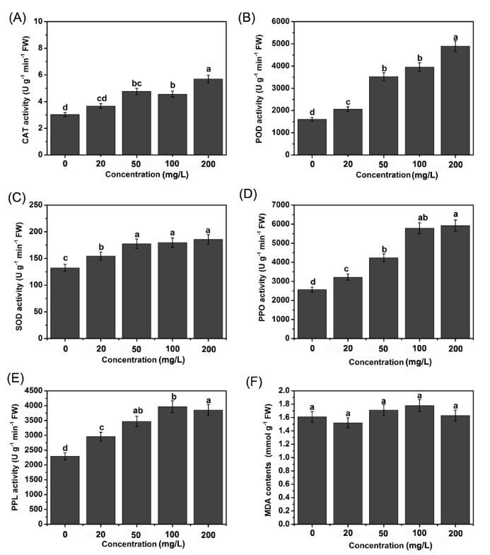
Figure S1: Effects of application of Mo alone on the activity of resistance-related enzymes and MDA content in healthy tobacco (Yunyan87) plants. A-F: Show the effects of different treatments on POD, CAT, SOD, PPO and PAL activity and MDA content in infected tobacco plants, respectively. The values are means ± standard deviations of three replicates. Significant differences (P<0.05) among treatments are indicated by different letters above the bars.

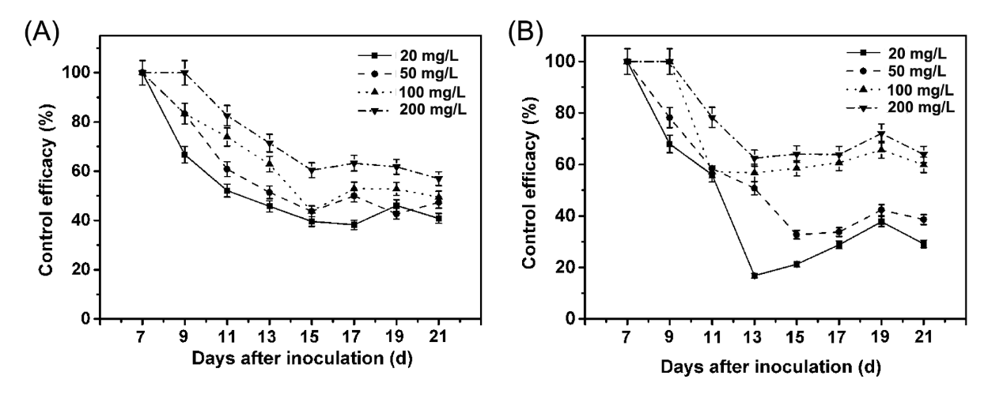
Figure S2: Control efficacy of Mo on bacterial wilt A, Yuanyan 87; B, Nanjiang 3 under greenhouse condition. Values are the mean and standard errors with three replicates.

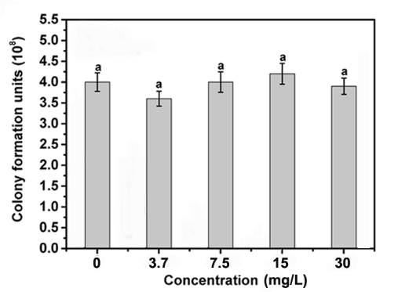
Figure S3: Viability of R. solanacearum cells after treatments with different concentrations of NH₄NO₃.

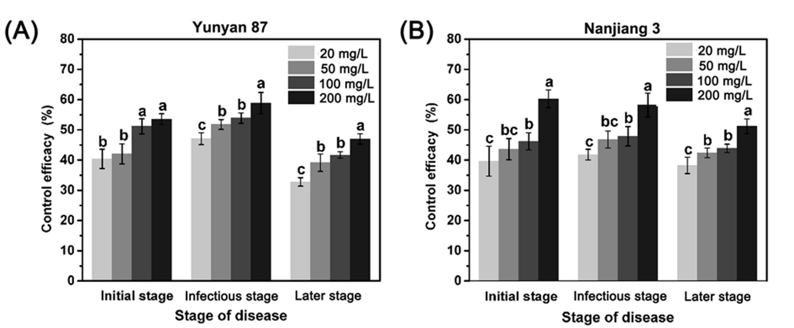
Figure S4: Control efficacy of Mo on bacterial wilt A, Yuanyan 87; B, Nanjiang 3 under field condition. Values are the mean and standard errors with three replicates. Significant differences (P<0.05) among treatments are indicated by different letters above the bars.

Table S1: Experiment information, tobacco growth period and investigation date for the field experiment in Qianjiang during tobacco-growing seasons.
Cultivar | Tobacco growth period |  |  | Disease incidence investigation^{y}
Cultivar | Planting date | Harvest start date^{x} | Harvest end date | The onset date^{Z} | The middle date | The ending date
Yunyan 87 | 8-May | 29-Jul | 17-Sep | 22-Jun | 22-Jul | 8-Aug
Nanjiang 3 | 17-May | 1-Aug | 20-Sep | 2-Jul | 2-Aug | 17-Aug

^{x}Harvest start date means that from that day, tobacco is at ripe stage, and the farmer began to pick the lower leaves. Generally, the lower leaves are picked first, then the middle leaves, and finally the upper leaves. Harvest end date means that at that day, tobacco leaves were all harvested.
^{y}The onset date, the middle date and the ending date of disease incidence investigation mean that the initial, infectious and later stages of disease respectively.
^{z}The onset date was also the beginning of the experiment.

Table S2: Physicochemical property of rhizospheric soil collected from experimental plot in Qianjiang.
Parameter | Content
Soil moisture | 26.90%
pH | 5.5
organic matter | 18.7mg/kg
available N | 98.4mg/kg
available P | 45.6mg/kg
available K | 103.9mg/kg
Mo | 0.07mg/kg
Ca | 1128.4mg/kg
Fe | 76.0mg/kg

Table S3: Average Mo content of rhizosphere soil in typical tobacco growing areas in Chongqing.
 | Tobacco planting areas
 | Pengshui | Qianjiang | Wulong | Fengdu | Shizhu | Youyang
Average active Mo content (mg/kg) | 0.198±0.09 | 0.068±0.05 | 0.111±0.03 | 0.098±0.04 | 0.139±0.03 | 0.081±0.02

Table S4: Effect of different Mo treatments on tobacco morphological characteristics at 45 days after transplanting.
Year | Treatment (mg/L) | Plant height (cm) | Length of largest leaf (cm) | Width of largest leaf (cm) | Stem diameter (cm) | Number of productive Leaves | Area of largest leaf (cm²)
Yuanyan  87 | 200 | 37.6±1.0^{x}a | 48.7±0.8a^{y} | 24.8±0.6a | 7.1±0.0a | 12.0±0.2a | 768.1±32.4a
Yuanyan  87 | 100 | 37.5±5.5a | 47.9±1.0ab | 24.4±0.5ab | 6.8±0.4ab | 12.0±0.7a | 742.6±22.8ab
Yuanyan  87 | 50 | 32.9±4.5a | 47.8±0.9ab | 23.5±0.3abc | 6.4±0.4b | 11.2±0.3a | 714.8±12.1b
Yuanyan  87 | 20 | 34.8±5.4a | 46.2±1.2b | 23.0±0.8bc | 6.4±0.4ab | 11.5±0.5a | 673.6±10.9c
Yuanyan  87 | CK | 32.0±2.4a | 46.3±1.4b | 22.5±1.2c | 6.±0.4b | 11.2±0.4a | 659.7±20.6c
Nanjiang  3 | 200 | 46.9±1.8a | 55.8±1.3a | 25.3±0.7a | 7.4±0.1a | 13.6±0.7a | 842.3±7.7a
Nanjiang  3 | 100 | 43.4±4.5b | 55.3±0.4ab | 24.5±0.3ab | 7.3±0.1ab | 13.2±0.4a | 802.4±21.7b
Nanjiang  3 | 50 | 39.9±1.0bc | 53.9±1.9b | 24.1±0.1b | 7.1±0.3b | 12.8±1.0a | 756.8±42.8bc
Nanjiang  3 | 20 | 38.8±3.0c | 53.3±1.7b | 23.6±1.6c | 6.8±0.1bc | 12.5±0.2a | 734.8±40.5c
Nanjiang  3 | CK | 38.5±2.4c | 52.1±1.3b | 23.1±1.5c | 6.8±0.3c | 12.0±0.5a | 727.6±83.1c

^{x}The values are means ± standard deviations (SD).
^{y}Values with the same uppercase letter in the same row did not differ significantly at P<0.05 according to Fisher’s protected least significant different test.

