Appendix A
This appendix will help health care providers to assess clients’ awareness about diabetes and its management.
Name: Today's date:
Address:
Telephone: home ( ) Date of birth:
Sex: 􀁔 Female 􀁔 Male
Awareness Questions Sheet
What do you know about your diabetes?
How do you manage your diabetes?
What are the complications that could be caused by ignoring diabetes management?
Do you exercise? How many times?
What do you eat? How much do you eat? How many meals do have a day?
How do you motivate yourself to change a habit in your life?
What is the favor learning style you prefer to learn?
Do you prefer to learn and ask questions in a group or individually? Why?
Appendix B
Blood Glucose Targets help clients with diabetes to know how to manage their diabetes and what their goals for each test reading.
Goals | ADA Goals | ACE Goals
A1C | Less than 7.0% or as close to normal as possible. | 6.5% or lower.
Blood Glucose Before Meals | 90-130 mg/dl. | Less than 110 mg/dl
Blood Glucose 2 Hours After the Start of Meals. | Less than 180 mg/dl. | Less than 140 mg/dl
Note. Adopted from “Blood glucose targets” by Norman Regional Health System, 2014.

Appendix C
The Differences between Hyperglycemia and Hypoglycemia are very important for the clients to know how recognize these aspects early and avoid them of happening.
 | Hyperglycemia | Hypoglycemia
Known As | High Blood Sugar | Low Blood Sugar
Test Result | Blood Sugar >140 mg/dl | Blood Sugar < 70 mg/dl
Signs and Symptoms | Happen slowly over several days.  - Increase thirsty and urination.  - Ketones in urine.  - Weakness, stomach pain, and general aches.  - Heavy, labored breathing.  - Loss of appetite, nausea, and vomiting.  - Fatigue.  - Blurred vision. | Happen quickly.  - Cold sweat, faintness, dizziness.  - Headache.  - Pounding of heart, nervousness.  - Shakiness.  - Hunger.  - Irritability.  - Not able to awaken.
Causes | The causes could be:  - Not enough insulin.  - Too much food.  - Infection, fever, illness.  - Emotional stress. | The causes could be:  - Too much insulin.  - Not eating enough food or delayed meal.  - Unusual amount or increased exercise.
Controlling | The controlling could be:  - Drink fluid without sugar if able to swallow.  - Test blood sugar frequently.  - Test urine for ketones if blood sugar is > 240 mg/dl.  - If ketones are positive – trace to small, call physician.  - If ketones are positive – moderate to large, call physician and/or go to ER.  - If using insulin pump, change infusion set, reservoir and insulin. | The controlling could be:  - Check blood sugar, of possible.  - Use 15/15 Rule – take 15 grams of carb such as: 3-4 glucose tablets, ½ c fruit juice, or 1 c low fat milk.  - Wait 15 minutes, then check blood sugar.  - After treating low blood sugar using 15/15 Rule, follow up with snacks or meal containing of carb and protein.  - Do not give anything by mouth if not conscious.  - If unconscious, give glucagon according to package directions and call emergency medical services.  - If experiencing two or more low blood sugar per week, call physician to report.
Note. Adopted from “Blood glucose targets” by Norman Regional Health System, 2014.
Appendix D
This table will help clients to record their glucose reading and food diary. By this way, the clients will draw a base line for their glucose level and their dietary habits.
Client Name:
Day/Date | Meals | Food Diary | Blood Glucose
 |  |  | Before | After
 | Breakfast
 | Lunch
 | Dinner
 | Exercise | Exercise duration was ( )mins.
Day/Date | Meals | Food Diary | Blood Glucose
 |  |  | Before | After
 | Breakfast
 | Lunch
 | Dinner
 | Exercise | Exercise duration was ( )mins.
Day/Date | Meals | Food Diary | Blood Glucose
 |  |  | Before | After
 | Breakfast
 | Lunch
 | Dinner
 | Exercise | Exercise duration was ( )mins.
Day/Date | Meals | Food Diary | Blood Glucose
 |  |  | Before | After
 | Breakfast
 | Lunch
 | Dinner
 | Exercise | Exercise duration was ( )mins.
Day/Date | Meals | Food Diary | Blood Glucose
 |  |  | Before | After
 | Breakfast
 | Lunch
 | Dinner
 | Exercise | Exercise duration was ( )mins.
Day/Date | Meals | Food Diary | Blood Glucose
 |  |  | Before | After
 | Breakfast
 | Lunch
 | Dinner
 | Exercise | Exercise duration was ( )mins.

Appendix E
Insulin Action Basic Information helps clients to understand how long the insulin need to be effective inside their bodies.
Insulin Types | Onset | Peak Time | Duration
Rapid-acting insulin | 15 minutes after injection. | About 1 hour. | 2 to 4 hours
Regular or Short-acting insulin | 30 minutes after injection. | 2 to 3 hours after injection. | Approximately 3 to 6 hours
Intermediate-acting insulin | About 2 to 4 hours after injection. | 4 to 12 hours later. | About 12 to 18 hours.
Long-acting insulin | Several hours after injection | Tends to lower glucose levels. | over a 24-hour period
Note. Adopted from “Insulin basic” by American Diabetes Association, 2014. Copy right 2014 by Convio company, Inc.

Appendix F
Plate Planner helps clients to create their meals with choosing the recommended food to stay healthy and manage their diabetes.
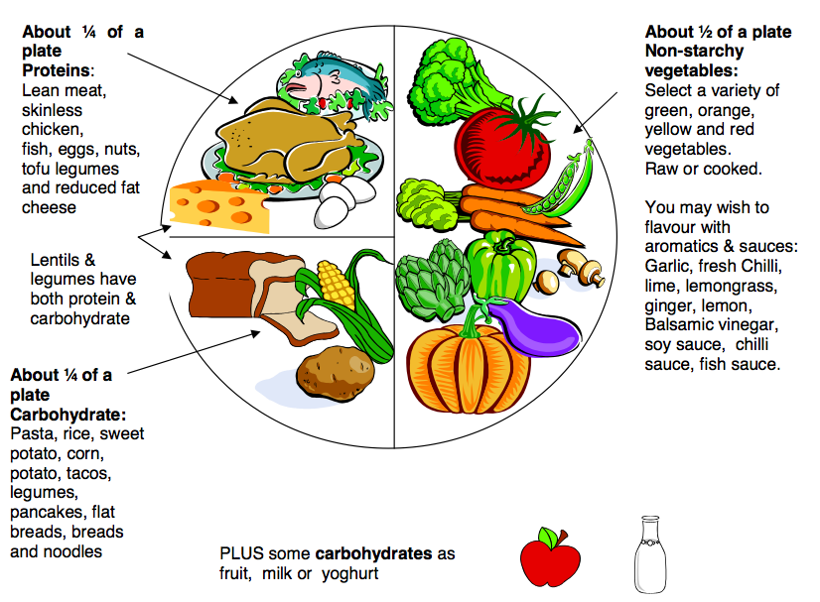
Note. Adapted from "Diabetic diet" by Word Press Themes, 2014.

